

# Paper and books

What is paper?

Paper consists of cellulose fibre, often derived from cotton or wood pulp. Paper products range from poor quality ground-wood newsprint to high quality cotton rag papers. Newspaper is particularly unstable due to the large percentage of acidic ground wood pulp used in its manufacture. Some papers are dyed. Paper has an invisible layer of ‘size’ on the surface made from gelatine, starch, rosin or alum, to ensure that ink does not bleed into the paper. Ink or paint is applied by hand or machine.

**What are** books**?**

Books are mechanical structures in which paper is bound together with cotton or linen stitching and adhesive (animal glue or synthetic). Books have a board on the front and back (usually made of cardboard) which is covered with adhered leather, or cloth impregnated with starch or adhesive.

Examples

Service records, letters, certificates, newspapers, discharge papers, tickets, drawings, watercolours, maps, diaries, ration books.

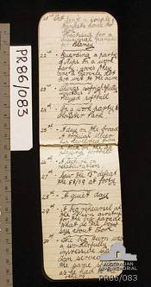

This World War I diary is an example of a bound paper book which should be stored with acid-free alkaline buffered materials to help to prolong its life.

*Photo courtesy Australian War Memorial.*

What are the main threats to paper and books?

* fluctuating humidity and dampness
* light (sunlight, artificial light, being on display for too long)
* high levels of heat
* dust
* acidity from mounts and/or generated within the object by its wood pulp content
* degradation of the chemicals in inks
* skin oils and sweat
* leather dressings
* neglect and careless handling
* incorrect attempts at repair or cleaning
* insects and mould
* incorrect storage and display materials
* theft and loss
* disasters both large (fires, floods) and small (roof leaks, coffee spills).

Safely store your originals.

Put copies on display.

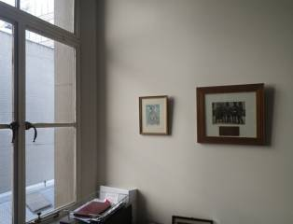

Avoid displaying paper and documents near windows.

Daylight is very damaging and will cause fading relatively quickly.

Put good quality copies on display – nobody will know the difference!

How do these threats damage paper and books?

* Water will stain and weaken paper.
* Damp will promote mould growth, foxing (age-related spots and brown patches) and insect attack (silverfish eat the invisible mould that grows on the surface of paper).
* Insects can eat all the components of paper and books – paper, size, paint, adhesive or leather.
* Household products such as bleach will seriously weaken paper and ultimately accelerate yellowing and must never be used.
* Mounted or unmounted paper objects stored loose in a drawer can crush, abrade or scratch each other’s surfaces.
* Dust can sink into porous paper causing irretrievable staining.
* Light will fade colours, accelerate ageing and cause yellowing and weakness.
* Acidity causes paper to become yellow or brown and brittle. Eventually the paper may break into many small fragments.
* The acidity from the inner layers of window mounts will cause ‘mat burn’ (dark brown staining).
* Hand grease, hand cream and sticky mounting materials such as Blu Tack will leave greasy or oily stains on paper.
* Repeated rolling or carrying a flat item by one corner can cause tears, or creases which will eventually tear.
* Holding or displaying a book open without support can cause the spine to break.
* The adhesive from transparent and masking tapes and lamination film will cause brittleness and dark brown staining of the paper.
* Staples will cause holes, and if the staple corrodes this will cause rust staining.
* Ink may flake, fade or change colour.
* Ink can be removed from printed paper by PVC sleeves.
* PVC gives off a mild acid and sticky plasticiser which damage objects.
* Acidity from timber and plywood will accelerate the deterioration of paper.
* Ink from biros and felt tip pens is not easily removable – only use pencil to label paper and books.
* Leather dressing will stain paper and not preserve leather.

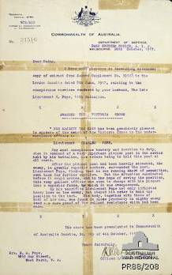

**Should I repair items with sticky tape?**

This image illustrates the dangers of using sticky tape for repairs. It will eventually leave dark adhesive residues.

Do not use sticky tape – it is always better to leave a page torn than to repair it with this damaging product. Store all the pieces of a torn document together.

*Photograph courtesy Australian War Memorial*

**Pests and storage areas**

This image shows extensive rodent damage. Mice and rats are attracted to environments that are dark, wet, cluttered and dirty. They particularly like sheds and garages where material has been carelessly packed and stored. The only way to stop rodents is to clean up such environments.

**Eating in storage areas**

Food will attract pests which will attack your collection. Do not eat in your collection storage area.

*Photo courtesy State Library of Victoria*

REMEMBER

* Before you do ANYTHING, consult a paper conservator.
* Before you start, ALWAYS look at the list of resources at the end of this fact sheet. There will be detailed information already available.
* Never give up – something that looks ‘hopeless’ can often be recovered.
* All objects will age – it is the speed at which this happens that you can influence.
* It is no disgrace for an object to look its age and reflect its history.
* Excessive or aggressive cleaning and commercial adhesives can cause an enormous amount of harm.
* The majority of paper made since the 1840s will be acidic due to the presence of wood pulp and bleach residues from manufacture.
* This acidity will attack the cellulose of the paper, causing it to yellow and weaken.
* Good care of paper objects involves slowing down and mitigating the effects of acid on paper.
* Alkaline buffered papers and boards contain sodium bicarbonate that will soak up the acidity from the paper and prolong its life.
* The original frames and mats may have historic importance and should not be discarded.

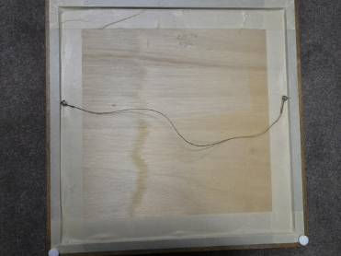

**Framing documents and artworks**

This image shows an incorrect way to frame documents. Do not use materials such as plywood or masking tape, as these are very acidic and the acid will attack the paper. Always have documents framed by a professional framer with archival quality materials. Masking tape and glue should never be used.

General care

**DO**

* Dust your books and papers using a soft hair brush and a vacuum cleaner with a HEPA filter, as dust can encourage mould growth. Do not brush the image area of artworks.
* Keep paper, books and framed items away from heaters or other sources of heat.

**DON’T**

* Laminate originals. It is irreversible and will yellow and buckle over time.
* Use tape, glue, paper clips, pins, Blu Tack or staples. The damage caused by these items over time is difficult, if not impossible, to repair.
* Automatically remove items from albums or disassemble albums made by service people, even when these are damaging. These arrangements have importance and need to be documented.

**Handling**

**DO**

* Always wash your hands before handling paper objects and books. Wash them often, especially if the items are dirty, as it is very easy to transfer dirt.
* Open books carefully without forcing them, as the spine and paper may have become weak over time.
* Support books when on display to protect the spine (see instructions in Resources below).
* Use pencils rather than pens near paper and books to avoid ink stains.
* Use white vinyl erasers when you are removing light surface dirt and marks from paper and books.

**DON’T**

* Pick up larger items by one edge – fully support items for transport, using a sheet of card or trolley if necessary.

Pests

**DO**

* Implement an integrated pest management approach to insects.

**DON’T**

* Assume that pests will not attack your books and paper!

**Storage**

**DO**

* Store paper and books in boxes off the ground in case of flood.
* Attempt to store all paper items flat to provide support and protection.
* Store paper items in housings made from safe archival materials, as this will prolong their life. Housings may be folders, sleeves, boxes or frames.
* Make digital copies and back ups of all photographic, AV and digital materials. Store copies off site.

**DON’T**

* Store paper and books in damp places (such as attics or basements), on external walls, near windows, or in kitchens.
* Overcrowd books on shelves or allow them to slump. If large they may be better laid flat but not too many in a pile as covers can be scraped when they are moved.
* Roll items into a small tight roll. If you cannot store them flat, instead roll them onto a large tube covered in acid-free paper and interleave with acid-free tissue.

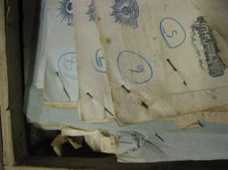

**Pins can damage paper**

Never use metal fasteners such as pins or paper clips as the rust will damage the paper, and metal can also cause paper to tear. Instead place papers in envelopes or use plastic paper clips. If you find old pins in historical documents, remove if possible and put the document in an archival envelope or use plastic paper clips.

**Display**

**DO**

* Place colour copies of originals on display. Your originals can be preserved in the dark! Depending on the context you can acknowledge the display of copies.
* Use a conservator or a certified picture framer to frame paper objects.
* Specify archival quality materials when framing works on paper. Check that the framer uses Filmoplast or Japanese tissue to hinge artworks – some framers use masking tape which is very damaging and can’t be seen once the artwork is sealed in its frame.
* Use curtains and blinds to keep light out of rooms where paper and books are stored and displayed.

**DON’T**

* Display paper, artworks or books for a lengthy period of time, as they will fade and go yellow.

**What are buffered and unbuffered archival products?**

Most historic paper is acidic which is caused by lignin from the wood pulp used to make the paper. This acidity attacks the paper fibres and leads to yellowing and brittleness.

All archival tissues, papers and boards are made from materials that are naturally low in acid such as cotton or highly purified wood pulp. Buffered products have an alkaline material (chalk) added. This is very beneficial because it soaks up the acidity given off by degrading paper and helps it to last longer.

But the alkaline buffer can be harmful to materials made from protein such as silk, wool, and gelatine and albumin photographic emulsions. For these it is better to use unbuffered products. These products are also known as pH neutral.

Buffered and unbuffered products can be purchased from archival suppliers.

SAFE archival storage and display materials

* plastics – low density polyethylene (LDPE), high density polyethylene (HDPE), polypropylene (PP), polyester, mylar, melinex, oven bags
* plastic sleeves – labelled ‘copy safe’, polypropylene
* paper – acid-free, alkaline buffered paper or 100% cotton rag paper, board and tissue
* cardboard – acid-free, alkaline buffered or 100% cotton rag mount board, cardboard and corrugated cardboard
* folders – polypropylene, acid-free cardboard
* albums – ring binders made from archival materials
* boxes – acid-free cardboard, polypropylene, fluted polypropylene (Corplast, Corflute etc).

UNSAFE storage and display materials

* plastics – PVC, bubble pack, glad wrap, lamination film
* plastic sleeves – PVC, not labelled ‘copy safe’, lamination pockets
* paper – standard paper, glassine paper, grease proof paper, brown and kraft paper, coloured and standard tissue paper
* cardboard – standard cardboard and mount board
* folders – cardboard covered with vinyl
* albums – sticky albums, coloured or black non-archival paper
* boxes – standard cardboard boxes.
* boards – masonite, chipboard, plywood, unvarnished timber

DOCUMENTS IN PLASTIC BOXES AND SLEEVES – CAUTION ADVISED

If your storage environment is damp or not well controlled, it is safer **not** to use plastic boxes and sleeves to store paper objects. Condensation can occur even inside archival plastic boxes and sleeves, and may cause documents to stick to the plastic. It can also cause mould growth. Instead use non buffered acid-free paper sleeves, envelopes and boxes with a copy of the image on the outside.

In a more stable environment it is possible to store documents in plastic sleeves and boxes, provided some precautions are taken. When acidic papers and books are stored in plastic sleeves and boxes, acidity can build up. This can make the documents deteriorate faster than they would have outside the plastic sleeve, even when archival plastics are used. To prevent this, a sheet of acid-free **alkaline buffered** paper should always be put into a plastic sleeve behind the document, to absorb the acidity it gives off.

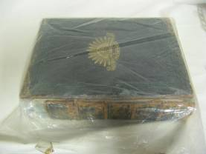

If your storage area is at all damp (such as an external wall, garage, external area or basement) do not use plastic to store books and documents. They may be at risk of mould growth because the plastic traps moisture. Placing a piece of acid-free cardboard into the package may reduce this risk somewhat. *Photo (right) courtesy Michele Summerton*

Repairing paper and books

Cleaning and repairing paper documents and books should generally be left to a professional conservator. **Attempting to mend paper and books can damage them**. The adhesive in sticky tape seeps into the paper leaving a dark brown residue. Glue will also damage paper. Neschen Filmoplast P and Filmoplast P90 adhesive tapes (available from conservation suppliers) are generally safe for simple repairs on less important documents. Important documents and artworks should always be cleaned and repaired by a conservator. NEVER put any adhesive tapes on the surface of photographs.

How can I get assistance ?

Conservators at the State Library of Victoria can provide advice about preserving books, newspapers, photographs, works on paper and documents. Call 03 8664 7359 (Melbourne) or 1800 999 735 (outside Melbourne).

Where can I buy acid-free boxes and other museum quality products?

Museums Australia (Victoria) has compiled a Museum Suppliers list. This contains the contact details of speciality suppliers which sell materials for the proper storage and display of heritage items. www.mavic.asn.au

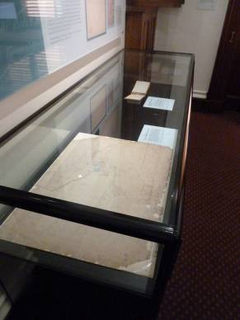

**Displaying a delicate old map - best practice**

This delicate old map has been given a new backing by the conservators at the Public Record Office Victoria. This protects and strengthens its fragile edges. Note the strips of clear polyester film (Mylar® or Melinex®) which gently hold the map onto an acid free support board. The Mylar® is attached to the back of the board with archival double sided tape (3M #415) so no adhesive touches the map. The showcase also protects the map.

**Displaying old and fragile books – best practice**

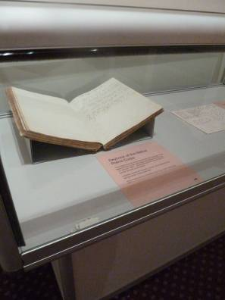

Book spines and covers can easily weaken if they are displayed open and flat. Here, both covers and the pages of this book are supported by folded corrugated acid free board shapes. These supports act like ‘pillows’ and ensure that the covers do not tear away from the pages. The background of the display is a similar colour to the boards so that the supports are less visible.

RESOURCES

There is a large amount of information for small museums on the care of paper and books.

* ‘A Simple Mount for Photos and Documents’, Powerhouse Museum

www.powerhousemuseum.com/pdf/preservation/a_simple_mount_for_photos_and_documents.pdf

* ‘How to Make a Book Support for Display’, Powerhouse Museum

www.powerhousemuseum.com/pdf/preservation/how_to_make_a_book_support_for_display.pdf

* The State Library of Victoria has a number of useful guides: www.slv.vic.gov.au/explore/conservation-guides
* The National Archives of Australia has a large amount of useful information: [www.naa.gov.au/collection/family-history/family-archive/index.aspx](http://www.naa.gov.au/collection/family-history/family-archive/index.aspx) and www.naa.gov.au/records-management/agency/preserve/physical-preservation/index.aspx
* ‘Scanning Photographs’ (also relevant to paper items), Powerhouse Museum

www.powerhousemuseum.com/pdf/research/dress_register/ADR14.1_scanning_photographs.pdf

* ‘Digitising Records’, National Archives of Australia

www.naa.gov.au/records-management/agency/create-capture-describe/physical-records/index.aspx

* ‘reCollections: Caring for Collections Across Australia’ [www.collectionsaustralia.net/sector_info_item/3](http://www.collectionsaustralia.net/sector_info_item/3)
* The Australian Newspaper Plan:

www.nla.gov.au/anplan/about/preserve.html

Specialists

* Australian Institute for the Conservation of Cultural Materials (AICCM) www.aiccm.org.au/index.php?option=com_content&view=article&id=37&Itemid=36
* Professional Picture Framers Association (PPFA) www.pmai.org/PPFAContent.aspx?id=20484

Suppliers of archival materials

* ‘Products and Suppliers List’**,** Powerhouse Museum [www.powerhousemuseum.com/pdf/preservation/products_and_suppliers.pdf](http://www.powerhousemuseum.com/pdf/preservation/products_and_suppliers.pdf)
* ‘Specialist Services and Suppliers’, Australian War Memorial www.awm.gov.au/collection/conservation/suppliers/
* ‘Preserving Physical Records’, National Archives of Australia

[www.naa.gov.au/records-management/agency/preserve/physical-preservation/index.aspx](http://www.naa.gov.au/records-management/agency/preserve/physical-preservation/index.aspx)

Where can I get this and other fact sheets? The DPC Preserving war heritage and memorabilia fact sheets provide information about the care and conservation of a range of heritage material. They can be downloaded at **www.dpc.vic.gov.au/veterans/factsheets**

**Disclaimer** The material contained in this guide is for general reference only and should not be relied upon as the sole basis for heritage conservation or restoration. A professional conservator or conservation architect should be consulted before any conservation or restoration is undertaken. The Victorian State Government does not warrant the accuracy or completeness of the information and disclaims all liability for any loss or damage that may be caused by reliance upon it. Provision of names of suppliers or websites does not imply that a supplier is endorsed or approved by Heritage Victoria or the Department of Premier and Cabinet.