General Principles

How can I preserve war-related heritage?
It is important to adopt a cautious approach to preserving memorabilia, memorials, honour rolls and heritage places:
- Do only what is necessary.
- Retain and repair the authentic fabric.
- Use reversible techniques and non-damaging materials.
- Retain cultural heritage significance (don’t scrub away the history).
- Use appropriately experienced and skilled contractors.

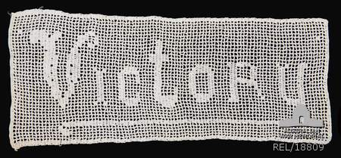All artefacts deteriorate as they interact with the environment, but the rate is dependent on many factors. Many of these variables can be controlled by adopting certain practices which minimise and slow down deterioration.

RIGHT: This patriotic crochet cloth from 1918-19 should be stored flat or rolled with acid-free tissue paper. Do not use pins or nails to display textiles as they can damage the fabric.
Photo courtesy Australian War Memorial

Preventive conservation
Preventive conservation – also known as ‘preservation’ – is action undertaken to prevent the deterioration of cultural materials. It includes managing the conditions of storage, handling, movement, display and use with the intention of maintaining the artefact in a stable state.
Preservation does not mean restoring items to their original condition. Heritage material is old – it is not realistic to make items appear ‘as new’. In some instances, inappropriate repairs can even erase the history of a monument or object.
The first step to heritage preservation is research. Once you understand the history and original appearance or use of an object, you can honour the original intent of the maker and user, its construction and unique story – that is what preventive conservation is all about.
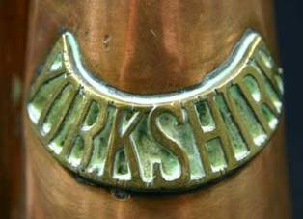
RIGHT: What’s wrong with this picture?
The polish residues left from abrasive cleaners can be very difficult to remove and harbour corrosive chemicals. This image shows brass lettering which has these ugly residues (the greenish-white stains visible in the crevices).
The Australian War Memorial recommends against using Brasso and other commercial polishes on medals and other metal objects.

Storage
Most deterioration occurs while material is in storage. Storage should not mean ‘out of sight, out of mind’ – you need to be vigilant at all times. You are unlikely to see silverfish eating your precious documents unless you actually look in your stored boxes.
One of the most practical storage systems for small community groups is standard sized prefabricated steel shelving units. These are typically finished with powder-coat baked enamel. You can place dust covers (made of old sheets or unbleached cotton) over shelving or large objects. Specific storage methods for particular material (such as textiles) are discussed in other fact sheets in this series.
DO
- Organise your storage area neatly.
- Ensure that it is free from clutter and hazards.
- Use the best quality materials you can purchase (archival bags, boxes, shelving, padded coat hangers etc.).
- Cover or box everything.
- Clean all storage areas once a month.
- Monitor regularly for pest activity.
- Maintain the building and attend quickly to maintenance issues.

DON’T
- Put material against external walls.
- Place material on the floor.
- Store material near light (natural or otherwise).
- Leave any food or drink in storage areas.
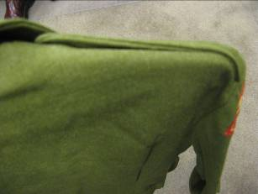

RIGHT: Should I use wire coat hangers?
Wire hangers should not be used because they concentrate the weight and stress on a very small area, causing distortion and tears. The shoulders of the uniform (left) have been permanently stretched out of shape. It is preferable to use padded coat hangers or store uniforms flat in a box.

Handling
Wear white cotton gloves (readily available and inexpensive) when handling any precious article. This stops the oil and salt in the sweat from your hands affecting the item. For extra dexterity you can wear latex gloves. White cotton gloves can be purchased at archival suppliers, some pharmacies, cleaning suppliers, hardware stores and independent living outlets.

Damage during display
Heritage material is easily damaged during the display process. It can be damaged by:
- light
- humidity
- pests
- temperature
- damaging display materials such as wire coat hangers and Blu Tack
- accidents that can occur when being moved to/from/within a display area
- being stolen while on display.

The dangers of wooden display systems
Wood is the most damaging material commonly used to construct storage and display systems. It releases organic acid vapours which are harmful to heritage material. This varies according to wood type.
All wood used in museum displays should be sealed with several coats of shellac, low Volatile Organic Compound (VOC) acrylic paint or polyurethane varnish to reduce acid vapours. Freshly coated wood must be allowed to air for at least three months before the objects are installed. If a display area is painted and other display materials (such as fabrics, plastics, adhesives, paper and board) are used, these should also be selected with museum standards in mind.
Woods and boards to avoid: Chipboard, plywood, MDF, Masonite, Formica, particle board, most hardwoods (particularly Oak, Douglas Fir, Oregon Pine and Jarrah).
Suitable woods and boards: Kauri Pine, hoop pine, hoop pine plywood, low Volatile Organic Compound (VOC), emission or low formaldehyde boards such as E0 (E-zero boards have low formaldehyde emission).
All wood used in museum displays should be sealed with several coats of shellac, low Volatile Organic Compound (VOC) acrylic paint or polyurethane varnish to reduce acid vapours. Freshly coated wood must be allowed to air for at least three months before the objects are installed. If a display area is painted and other display materials (such as fabrics, plastics, adhesives, paper and board) are used, these should also be selected with museum standards in mind.

Lighting
Light, especially UV light, can cause irreparable damage to heritage materials. One of the most significant causes of collection damage in RSLs, community museums and local historical societies is the long-term display of material under lights. Attractive displays need good lighting but it does not have to be bright.
- Do not display any objects, documents, books or photographs permanently– displays are much more interesting when the content is changed regularly.
- Use low UV, low wattage globes and fluorescent tubes, UV filtering Perspex or UV filters on fluorescent lights.
- Do not shine light directly on material.
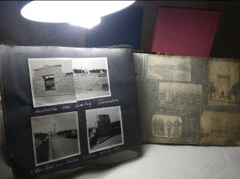

RIGHT: Light damage
The lighting for this display is too strong and too close to the photograph album.
Such lighting will cause permanent damage to these photographs. Incorrect lighting is one of the most common problems in RSLs and community museums but fortunately it is easily remedied.

Dealing with pests
Paper, books, textiles and other materials are an appetising source of food for a wide variety of pests. Rats, mice, silverfish, moths, termites, cockroaches and carpet beetle larvae will all feed on organic material and can do significant damage to valuable heritage collections.
Mice and rats are attracted to environments that are dark, wet, cluttered and dirty – does this sound like your storage area? They particularly like sheds and garages where material has been carelessly packed and stored. The only way to stop rodents is to clean up such environments: if you kill one group of rodents, others will return in their place.
Insects are also attracted to dark environments and like to eat papers, books, textiles and photographs. Due to their small size they can live inside books, in the folds of newspapers, in cardboard boxes and in garments. Silverfish and carpet beetle larvae are two of the biggest problems and can cause irreversible damage. The pests may not be visible but their frass (droppings) or bodies are often found.
Insects such as silverfish or a mouldy smell can be the first indication of a damp problem in a building e.g. rising damp or roof leaks. Rectifying building damp problems is the best way to discourage insects.
If evidence of pests is sighted, the following should be undertaken:
- Isolate infested material. If in doubt, treat all material as if affected.
- Take material outside and dust it thoroughly page by page, section by section, to remove hidden eggs. See instructions on brush vacuuming in the Wooden Objects flyer.
- Remove and clean all coverings such as dust jackets, plastic covers and garment protectors.
- Discard waste and vacuum cleaner bags in a sealed receptacle.
- Dust and vacuum storage site including shelves, rugs and carpets.
- Replace material after checking and cleaning.
- Keep the environment clean and unappealing to rodents and insects.
- Do not store or consume food and drink near heritage material.
- Sticky traps can be used to monitor insect activity. Those without baits or attractants are best.

Insecticides can damage collections (and custodians) and are generally not recommended but if an infestation cannot be eradicated by the above measures they may be needed. Insecticides should never be applied directly to objects.
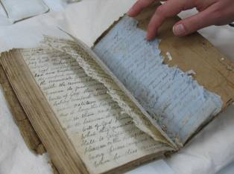

RIGHT: Pests and storage areas
This image shows extensive rodent damage. Mice and rats are attracted to environments that are dark, wet, cluttered and dirty. They particularly like sheds and garages where material has been carelessly packed and stored. The only way to stop rodents is to clean up such environments.
Do you eat morning tea or lunch in your storage area?
All pests like food. Some pests eat food remains and some eat the bodies of other insects. Then they move into the collection for more food.
Photo courtesy State Library of Victoria

Conservation plan
A conservation plan is the preparation of a strategy for the long-term care of collections by a conservator. It involves identifying the conservation needs of collections, prioritising them and allocating resources to deal with them. There is no one way to undertake a conservation plan, and all conservators will take a slightly different approach. However, they should all develop answers to the following questions:
- What does your organisation have in its collection?
- What risks is the collection exposed to?
- What practices are in place to care for your collection?
- What are the priorities?

This information should then be collated together to determine a three to five year plan that identifies what actions need to be taken, in what order, by who and at what cost.
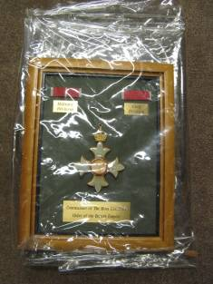

RIGHT: Is PVC good for storage?
Do not store heritage material in PVC.
It produces corrosive and acidic by-products which attack artefacts.

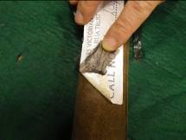

RIGHT: Should I put labels on objects?
This leather sword sheath has been permanently damaged by a sticky label applied for cataloguing purposes. Label an object by tying a tag onto it.

Monitoring
Monitoring your memorials and heritage material is the key to preventing deterioration. Don’t wait until it’s too late – spot the signs of deterioration and damage first!

What should I look for?
- evidence of pest activity such as frass (excreta of insects) and holes
- water damage
- warping of cardboard or timber
- splitting and cracking of timber, wood or stone
- tarnish, rust or corrosion of metals
- mould, moss, lichen
- discolouration, fading, yellowing
- dirt, dust and staining.

How often should I monitor?
- Memorials, monuments and honour rolls – do a thorough check every six months.
- Memorabilia collections – monitor your collection every month.
- Regular monitoring will help you work out if damage is active (getting worse) or stable.

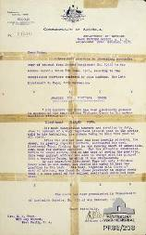
RIGHT: Should I repair items with sticky tape?
This image illustrates the dangers of using sticky tape for repairs. It will eventually dry and peel off, leaving dark adhesive stains.
Do not use sticky tape - it is always better to leave a page torn than to repair it with this damaging product. Store all the pieces of a torn document together.
Photograph courtesy Australian War Memorial

Regular monitoring is essential to
caring for your heritage.

Good quality conservation work
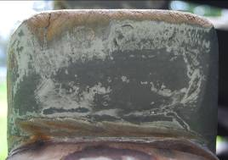It is essential that conservation work is well planned and of a high quality so that it will preserve your collections for the future. All conservation works – including repairs and cleaning – should be documented for future reference. As well as a written record, it is helpful to have ‘before’ and ‘after’ photos.

RIGHT: Damaging ‘repairs’
Careless sanding and filler has obliterated the original lettering on this cannon carriage.
These letters once conveyed important information about the origins of the cannon. They have now been destroyed.

What else should we be doing?
Good collection management involves more than preservation. There are many other skills that you may like to think about:
- Acquisition – Why are you collecting in the first place?
- Donation – Do you have to accept everything that is offered to you?
- Cataloguing – How do you keep track of what’s in your collection?
- Significance Assessment – What are the most important items in your collection?
- Display and interpretation – How do you create interesting displays and exhibitions?
- Security and insurance – How far should you go to protect precious items?
- Access – Who visits your collection? Can you put images and information online?

Information on these aspects of collections management can be found at the Museums Australia (Victoria) website. See www.mavic.asn.au/resources

Where can I buy conservation supplies?
The following Australian organisations have lists of suppliers of conservation materials on their conservation resources pages:
- ‘Products and Suppliers List’, Powerhouse Museum www.powerhousemuseum.com/pdf/preservation/products_and_suppliers.pdf
- ‘Specialist Services and Suppliers’, Australian War Memorial www.awm.gov.au/collection/conservation/suppliers/
- ‘Preserving Physical Records’, National Archives of Australia
- www.naa.gov.au/records-management/agency/preserve/physical-preservation/index.aspx

Where can I get this and other fact sheets? The DPC Preserving war heritage and memorabilia fact sheets provide information about the care and conservation of a range of heritage material. They can be downloaded at www.dpc.vic.gov.au/veterans/factsheets
Disclaimer The material contained in this guide is for general reference only and should not be relied upon as the sole basis for heritage conservation or restoration. A professional conservator or conservation architect should be consulted before any conservation or restoration is undertaken. The Victorian State Government does not warrant the accuracy or completeness of the information and disclaims all liability for any loss or damage that may be caused by reliance upon it. Provision of names of suppliers or websites does not imply that a supplier is endorsed or approved by Heritage Victoria or the Department of Premier and Cabinet.

