Building Superstructure

About this technical note
This technical note was prepared by Joe Spano (Ingegnaria Consultants) in collaboration with Heritage Victoria in response to the 2022 Victorian floods.
The building’s superstructure performance refers to the post flood performance of the building’s structural elements above the footing level including floor framing and slabs, masonry walls and timber wall framing, cast iron and wrought iron columns, and roof framing.

Flood events result in water inundation of some of the building structural elements. The source of the flood water can be from rising river and flood plain water levels, and / or the accumulation of runoff overloading the building and site’s drainage system. High intensity storms associated with flood events can also result in overflows to the building’s roof drainage system which can result in water ingress at roof level. Older buildings typically have undersized roof drainage components such as box gutters, eaves gutters, downpipes and underground drains servicing the downpipes. Refer to Floods and Heritage: Flood Management of Roof and Rainwater Goods.

The building’s structural performance response to the water inundation will depend on the existing conditions of the building, the time which the building elements are inundated, and the drying time of those elements. Therefore, in general, building structures with pre‐existing moisture related defects subject to long inundation periods and slow drying out periods, will experience more significant post flood defects or a magnification of existing defects.
The following issues are typical post flood defects to various building elements:
The following issues are typical post flood defects to various building elements:

CONCRETE FLOOR SLABS | Ground floor concrete floor slabs either spanning poorly ventilated sub floor spaces or constructed on the ground can result in moisture condensing on the underside of the slab or wicking through the slab. When the moisture (which will contain salts) evaporates, salts will crystallise onto the surfaces of the slab. Moisture wicking through the thickness of the slab will also result in corrosion of the reinforcement which will decrease the structural capacity of spanning slabs.
 | Figure 1: Salts crystallised on ground slab surface

TIMBER FLOOR FRAMING | Saturated floor timbers becoming subject to fungal rot and pest attack. Fungal rot and pest attack essentially break down the timber cell wall material which will reduce the structural capacity of the members. Note often the decay will be well advanced by the time the deterioration becomes visible.

TIMBER WALL FRAMING | As per the floor framing note, moisture absorbed into the base of the timber wall framing can lead to fungal rot and pest attack of the timber base wall plates and lower sections of the studs.  Flood waters permeated into the ground can lead to increase in moisture content in the base of timber posts embedded in the ground, which can accelerate the decay in the base of these timbers.

ROOF FRAMING | 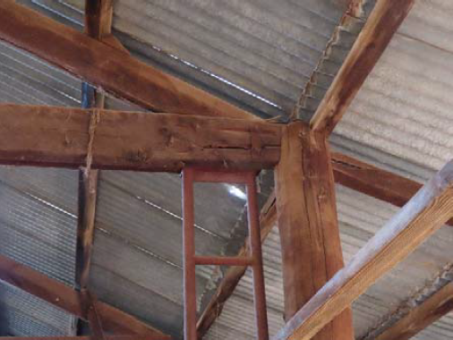  As per the floor framing note, moisture absorbed into roof framing elements can lead to fungal rot and pest attack.
 | Figure 2: Termite infestation resulting in significance reduction in structural capacity of this roof truss bottom chord leading to subsequent steel strengthening.

STRUCTURAL STEEL | Moisture which remains in contact with steel elements or parts of the steel elements such as at cap and base plates / bearing plates / cleat plates / fixings etc, which are unprotected or have failed coatings will result in corrosion of the steel. Significant advanced corrosion of these steel elements can reduce their structural capacity.

CAST IRON / WROUGHT IRON ELEMENTS | 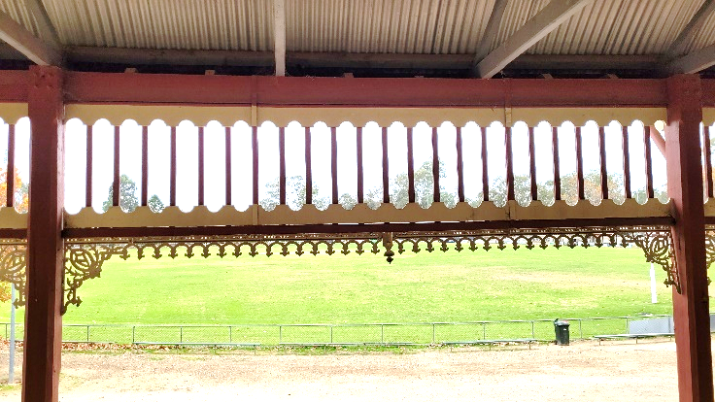  As per structural steel note moisture remaining in contact with unprotected cast iron and wrought iron elements will result in rusting of these elements. Cast iron elements can have cracks which may allow moisture inside the elements where rusting will advance without display until it is well advanced.
 | Figure 3: Cast Iron lacework.
MASONRY WALLS | 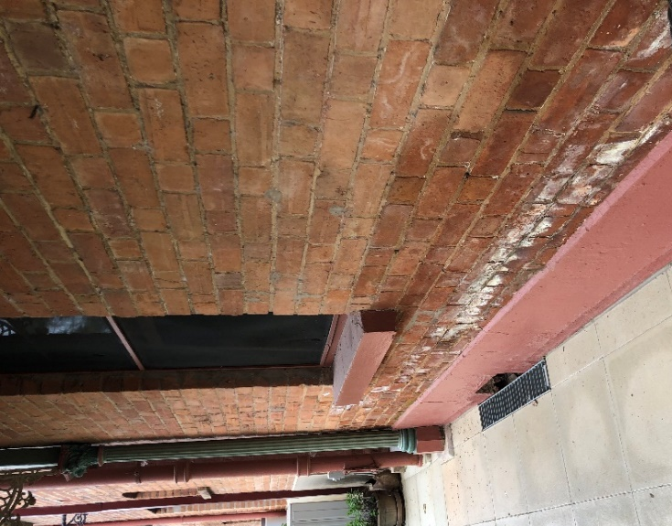  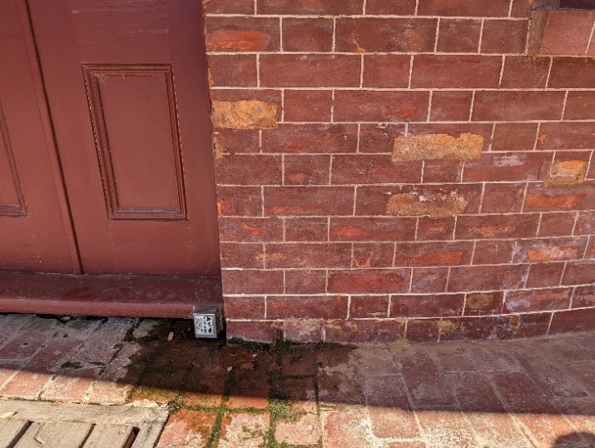  Moisture absorbed into the base of the masonry walls will rise up the walls via capillary action. Subsequent drying out of this moisture that contains salts will result in the crystallisation of the salts either on the surface of the mortar and masonry units or below the surface of these elements. The latter will result in fretting of the mortar and / or the face of the masonry units as the greater volume of the crystallised salts creates expansive forces on the mortar or masonry material. Severe cases of this rising damp and salt attack can result in local structural issues of the wall elements. Refer Heritage and Floods: Looking after flood-affected masonry for detailed remedial works advice  Figure 4: Brick face deterioration due to rising damp with salt crystallisation behind the surface of the bricks.
 | Figure 5: Extensive rising damp resulting in salt crystallisation above the rendered plinth.
For buildings with external and internal masonry walls, often there is inadequate sub floor ventilation to the base of internal walls. This can mean the sub floor ventilation to some rooms will be ineffective or inadequate, or to localised areas where no ventilation is possible.
In‐ground walls, particularly basement walls and sub floor walls, where the internal sub ground level is significantly lower than the external ground level, will be subject to hydrostatic pressures from flood water inundation that has permeated into the ground. These in‐ground walls may not have been designed to cater for this additional hydrostatic pressure and therefore will be at risk of bulging and or failure depending on their construction and restraints.
In the event that buildings and structures are located in the flow path of flood waters, hydrodynamic pressures associated with the high-speed moving flood water which are greater than hydrostatic pressures, can result in overall building failure with the building shifting off its footings, or localised wall failures. In addition, debris in the flowing waters can result is significant impact forces on the buildings and structures.
Inundation of the ground soils can result in buoyancy forces that lift buildings or structures off its footings, particularly lightweight buildings such as timber framed single and double storey buildings.
Flood waters that have permeated into the ground will change the moisture content in soils the building’s footings are founded on and can lead to footing movement ‐ refer to Heritage and Floods: building superstructure. Both of these types of footing movements will subsequently result in wall movements. Excessive wall movements will induce stress in masonry walls which can exceed the tensile capacity of the walls and result in cracking.

To enhance a superstructure's flood resilience, it's essential to assess its structural components and regularly inspect for signs of excess dampness or moisture. The following tasks are recommended to manage risks during future flood events, in reference to the Disaster Risk Management Cycle.

Risk Management Cycle

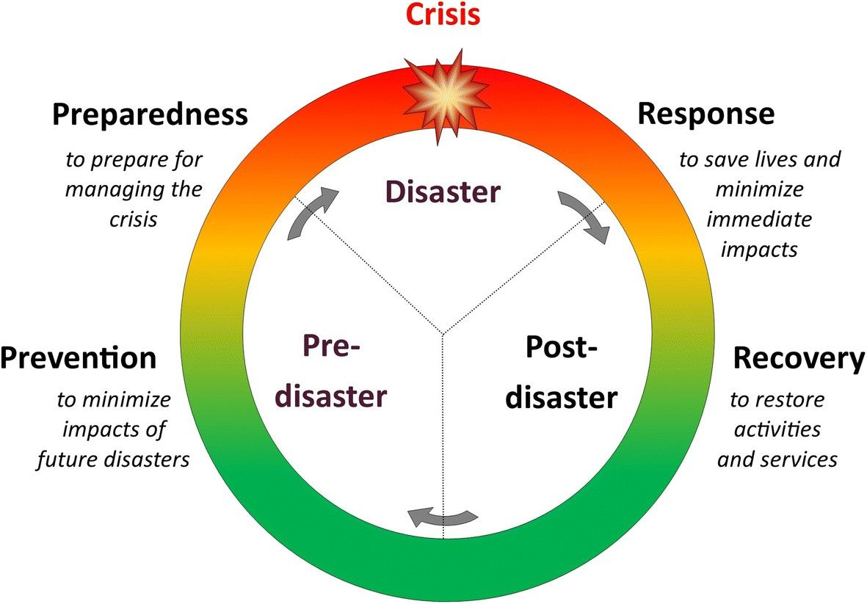
Figure 6: Risk Management Cycle – providing clarity to disaster process.

Note:
- Engage a heritage consultant to determine a scope of works.
- If your place is included in the Victorian Heritage Register or is an archaeological site, under the Heritage Act 2017 you are obligated to contact Heritage Victoria for a pre-application meeting before starting any works to apply for a permit or permit exemption.

Risk management approach

Stage | Approach | Strategies
Prevention | Investigate | - Investigate sub floor spaces to ensure they have adequate sub floor ventilation. This requires a total review of sub floor ventilation to the building and not just to the building’s external walls.  - Carry out an assessment of the roof drainage components including gutters, downpipes and underground drains servicing these above ground components.  - Refer to Heritage and Floods 3: building footings for prevention recommendations to ensure footing performance is satisfactory as this is necessary to ensure satisfactory performance of the walls.  - Arrange for periodic pest inspections which may possibly require installation of bait traps or barriers around the building.
 | Monitor | - Monitor walls for cracking and any evidence of bulging / leaning post flood.  - Ensure damp proof courses to the base of the building walls are not bridged by built up garden levels or installation of paths / ramps and steps up against the building walls.  - Ensure the soil to sub floor spaces are dried out if wet.  - Ensure timber to ground floor is separated from masonry support structures with an appropriate membrane to prevent moisture ingress into the timber.  Engage a suitably experienced structural engineer to review the capacity of any retaining walls to cater for pressures associated with flood waters.
Preparedness | Awareness | - Be aware of potential flooding and severe weather warnings.  - Block sub floor vents in external walls to prevent direct flood water ingress into the sub floor space.  - Carry out cleaning of roof drainage components including gutters, downpipes and drains servicing these components.  - Where possible ensure site outlet drainage is clear of debris.  - Brace any in‐ground walls which have been determined to be vulnerable to additional lateral pressures associated with flood waters.
Response | Inspect | - Remove debris against the building.  Open the building at first opportunity to allow natural drying of internal structure to begin. Opening of the building includes opening hatches to the sub floor space or creating hatches if none exist.
Recovery | Engage | - Consult with Heritage Victoria and a heritage professional in determining the next steps.  - Engage a structural engineer to review the extent of damage to the structure and surrounds.  - Unblock sub floor vents to external walls.  A Heritage Permit or Permit Exemption may be required to undertake these works.
 | Resilience | Attend to Preparedness Items not having previously been addressed.  Development or review of the Disaster Management Cycle and efficacy of the emergency response will improve future flood response measures.

