Outdoor heritage

Cannon, tanks and other large military objects

What is outdoor heritage?
Many RSLs and other heritage organisations are the custodians of cannon, tanks and other large military objects. These items have usually been rendered innocuous and cannot shoot or move. Often they are stored outside due to a lack of appropriate indoor storage space.
We often assume that these larger objects can withstand all sorts of conditions. But, like all materials, they constantly deteriorate over time. If this decay occurs over a long period of time, it may not be obvious. It is important to take steps to minimise the risk to larger objects so they can be appreciated by future generations.

What are outdoor heritage items made from?
- Cannon are generally made from cast iron or bronze.
- Cannon carriages may be made from cast iron or timber.
- Other guns may be made from iron or steel.
- Anchors are made from wrought iron.
- Tanks and other vehicles or machinery are made from steel and other metals such as brass or aluminium as well as rubber and plastic.
- Planes are made from aluminium and alloys of other metals.
- Oil paint has been used on many items either during use or after installation outdoors.
- Some outdoor heritage is made from (or contains traces of) asbestos, radioactive paint or insecticides.

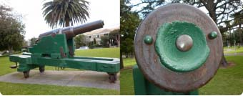
This cannon is one of a pair originally from Fort Gellibrand now located in Hopetoun Gardens, Elsternwick in the City of Glen Eira. An original slightly damaged tompion protects the interior from water and rubbish. It is very rare for original tompions to survive and most cannons will not have one. Once the interior of a cannon has been cleaned and any corrosion treated, a well fitting, painted, well seasoned timber plug can be used instead. The plug should be sealed in place with low acid silicone caulk and marked with its date of manufacture.
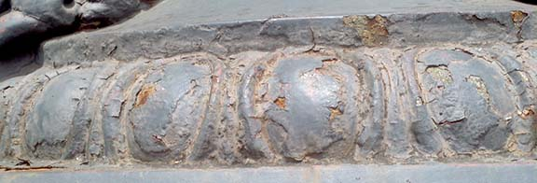
Corrosion (rust)
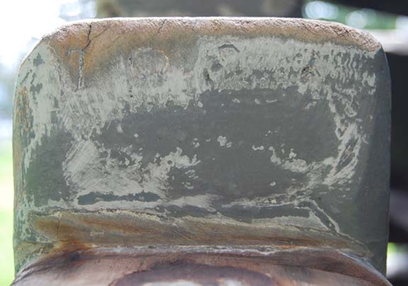The orange rust visible under the paint is caused by breakdown of the paint film allowing water and oxygen to corrode the metal. The paint will have to be removed and replaced but this must be done carefully to avoid damaging the fine detail of the casting. The paint may contain valuable historic information such as original colours and should be tested before removal.

Beware of poor quality ‘repairs’
Careless sanding has partially obliterated the original lettering on this cannon carriage. These letters contain important information about the origins of the cannon.

How do these threats damage outdoor heritage items?
Environmental threats
- Damage can vary significantly from location to location according to the environment and exposure of the item.
- Corrosion will be faster in wetter areas and near the sea.
- Water, dampness, pollution and salts can cause serious corrosion (rust) of metals.
- Corrosion caused by chlorides is self-perpetuating and can only be stabilised by professionals.
- Paint will fade and break down very quickly in exposed areas.
- Insects and fungi will attack wood, causing holes, weakness and invisible voids.
- Weeds and plant roots can grow through objects, causing serious disruption.
- The weight or structure of an item can cause it to collapse or render it dangerous.
- Incompatible materials exposed to water can self-destruct.
- Dirt and dust will hold water onto objects and accelerate corrosion, and provide soil for plants to grow.
Human threats
- Outdoor heritage items need regular maintenance – without this they will deteriorate faster.
- Graffiti looks very unsightly but does not cause major damage.
- Scratches in paint can cause small aggressive areas of corrosion of iron and steel.
- Water and rubbish can collect inside cannons and cause them to rust from the inside out.
- Ill-advised attempts to remove graffiti, corrosion or dirt can and have caused HUGE damage to outdoor heritage items.
Keep your outdoor heritage objects clean and dry. Dirt, dust, water and dampness
will accelerate corrosion.
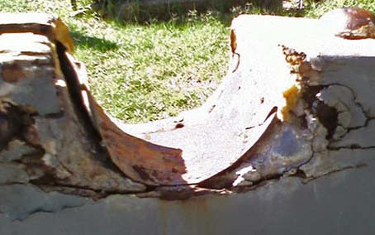Damage caused by incorrect ‘repairs’
The timber of this cannon carriage has been damaged by the use of car body filler by an amateur tradesperson attempting to ‘fix’ it. The hard filler is pushing the cracks in the wood further apart. Water is now entering the wood through the cracks and is exacerbating the corrosion of iron components, as well as continuing to cause cracks in the wood.

Hazards of large outdoor heritage items
Cannons and other artillery often rest on carriages with iron or wooden wheels or other wooden supports. The wood can decay due to fungal or pest attack. Corrosion may weaken them to the point of collapse. This damage may be invisible.
These supports can be weakened and can become a significant risk of collapse and can be a danger to the public, for example if children play on the object. Tanks and other large items may contain small crevices where hands or limbs can become trapped.
It is important that an engineer with experience in historic materials examines outdoor military items regularly to check their safety and give advice on structural support techniques.
Materials such as asbestos or radioactive paints are very hazardous to human health. If asbestos is found, you must contact a licensed asbestos remover. Worksafe Victoria can provide more information.

REMEMBER
- Before you do ANYTHING, consult your local council’s heritage advisor and a metals conservator or other qualified heritage specialist.
- Before you start, ALWAYS look at the list of resources at the end of this fact sheet. There will be detailed information already available.
- Never give up – something that looks ‘hopeless’ can often be recovered.
- All outdoor heritage items will age – it is the speed at which this happens that you can influence.
- It is not a disgrace for an item to look its age and reflect its history.
- Removing graffiti, algae, moss or lichen without expert guidance may do more harm than good.
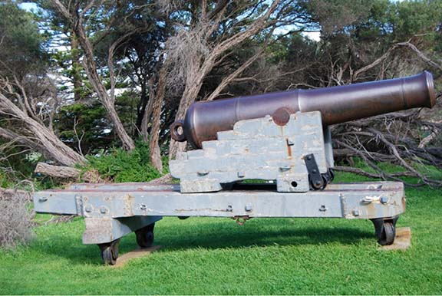
Is this cannon safely supported?
The wooden carriages supporting cannons are often weakened by rot and can make the structure unsafe. In this instance, x-ray analysis by the owners of this cannon showed that the carriage was still strong enough to support the cannon.
Photo courtesy Moyne Shire

General Principles

Location and siting
DO
- Build a cover or roof over larger outdoor items to protect them if possible.
- Drain areas where rain pools.
- Raise metal objects off the grass onto a plinth
DON’T
- Assume that these larger objects are immune from deterioration.
- Allow metal objects to sit in water.
- Maintenance and repair
DO
- Establish a regular maintenance plan, including safety checks, for all large outdoor items.
- Research the original colours of an item before considering any painting. Many items were never painted in use and should not be painted now.
- Engage a metals conservator to analyse the original paint and determine original colours.
- Think carefully about whether painting is appropriate. Paint can conceal rust in the short term but the corrosion process will continue under the paint. You may be causing more damage by painting.
- Engage a metals specialist or conservator to first stabilise underlying rust and advise on the correct type of new paint, if you choose to paint.
- Use fish oil to inhibit corrosion on unpainted cast and wrought iron. Apply fish oil diluted 50:50 with Shellite every six months during warm, dry weather.
- Use fish oil, followed by the primers and paints recommended by the fish oil manufacturer, if no conservation advice is available.
DON’T
- Remove original components.
- Use orbital sanders or grinders or other aggressive tools to remove metal corrosion or decayed wood.
- Sand, grit or soda blast anything.
- Use hard materials to fill holes in wood. Hard materials include car body filler, plaster, epoxy, putty, polyurethane or commercial wood fillers.
- Paint outdoor heritage items without ensuring you are using the correct paint. It is not appropriate to use paint simply because it is cheap or handy.
- Assume that all military items were black or grey – research the correct colours.

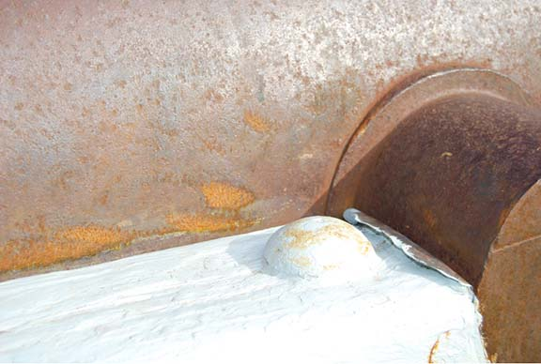Careless workmanship causes damage
This cannon has been scratched by a angle grinder which was incorrectly used to remove a layer of decayed wood from the carriage.
Except for safety reasons, decayed wood should not be removed as it can contain important information such as text and original craftsmen’s tool marks.

RESOURCES
Engineers with experience in historic materials can be found in Heritage Victoria’s directory of Consultants and Contractors
See: www.dpcd.vic.gov.au/heritage/heritage-places-and-objects/Consultants-and-contractors
There are publications available which can easily be adapted to outdoor military items.
- ‘Outdoor Storage and Display: Basic Principles’, Canadian Conservation Institute:
www.cci-icc.gc.ca/publications/notes/15-8-eng.aspx
- ‘Outdoor Storage and Display: Remedial Measures’, Canadian Conservation Institute:
www.cci-icc.gc.ca/publications/notes/15-9-eng.aspx
- ‘Lubrication for Industrial Collections’, Canadian Conservation Institute:
www.cci-icc.gc.ca/publications/notes/15-5-eng.aspx
- ‘Wood Preservation’, Heritage Victoria:
www.dpcd.vic.gov.au/__data/assets/pdf_file/0009/36828/Timber.pdf
- ‘Metalwork’, Heritage Victoria:
www.dpcd.vic.gov.au/__data/assets/pdf_file/0006/36825/Metalwork.pdf
- ‘Graffiti’, Historic Scotland:
www.historic-scotland.gov.uk/index/learning/publications/publicationsresultsdetail.htm?id=4fde7dfd7
- ‘Bronze Sculpture’, Historic Scotland:
www.historic-scotland.gov.uk/index/learning/publications/publicationsresultsdetail.htm?id=4fde7df620
- ‘Bird Control’, Historic Scotland:
www.historic-scotland.gov.uk/index/learning/publications/publicationsresultsdetail.htm?id=4fde7df124
- ‘Dangers of Abrasive Cleaning’, National Park Service, USA:
www.nps.gov/history/hps/tps/briefs/brief06.htm
- ‘Asbestos’, National Park Service, USA:
www.nps.gov/history/museum/publications/conserveogram/02-11.pdf
- ‘Standards in the Museum Care of Larger
& Working Objects’, UK Collections Link:
www.collectionslink.org.uk/discover/site-information/487-standards-in-the-museum-care-of-larger-a-working-objects

Where can I get this and other fact sheets? The DPC Preserving war heritage and memorabilia fact sheets provide information about the care and conservation of a range of heritage material. They can be downloaded at www.dpc.vic.gov.au/veterans/factsheets
Disclaimer The material contained in this guide is for general reference only and should not be relied upon as the sole basis for heritage conservation or restoration. A professional conservator or conservation architect should be consulted before any conservation or restoration is undertaken. The Victorian State Government does not warrant the accuracy or completeness of the information and disclaims all liability for any loss or damage that may be caused by reliance upon it. Provision of names of suppliers or websites does not imply that a supplier is endorsed or approved by Heritage Victoria or the Department of Premier and Cabinet.

