Impact to Building Footings

About this technical note
This technical note was prepared by Joe Spano (Ingegnaria Consultants) in collaboration with Heritage Victoria in response to the 2022 Victorian floods.

Building footing performance
A building’s footings performance can have a severe impact on the performance of the building’s superstructure – walls in particular. Small-scale heritage buildings generally have low stiffness bluestone or rubble footings. Wall damage resulting from footing movements typically includes visual symptoms such as:
cracking to brickwork,
out of level board claddings,
wall leans and bulges,
windows and doors sticking,
and glazing fractures.

Other superstructure damage because of poor footing performance typically includes floor and roof planes being distorted out of level, and resultant inappropriate falls to roof drainage gutters which in turn can lead to water ingress and more building fabric issues.

Flood events result in large volumes of water around the building, which depending on the time taken for these waters to recede, will impact on the moisture content in the ground. The slower the receding of the waters, the higher the in‐ground moisture content is likely to be because of the flood. A rise in moisture content in the soils the building footings are founded on, or the development of a perched water table high in the ground, can lead to the following issues:
Immediate – Decrease in structural properties of the founding soils due to saturation of soils – such as weakening of fine cohesive soils like silts and clays, settlement of fill or sand soils, liquefaction of soils. Buildings with footings seated on weakening soils can develop gross settlements locally or throughout the building.

Long term – Volume change in reactive clay soils which predominantly long term in a post flood scenario would include shrinkage of the soils due to the soils drying out and returning to their equilibrium moisture content. Footings seated in drying clay soils settle at various locations depending on the stiffness of the footings and other factors, or combination of factors, that are also impacting on the moisture content of the clay soils.

Buildings with evidence of historical footing movement are likely to incur more damage post flood because of the ground saturation than buildings that have had little historic footing movement

Victorian climatic regions
Regions in the northwest of Victoria (north and west of Stawell / Avoca / Castlemaine / Seymour / Euroa/ Wangaratta), are defined to be in arid Climatic Zones 4 and 5 in AS2870 Residential Slabs and Footings Code. Deeper-seated movements of reactive soils are expected in these areas than within the same type of reactive clay soils in regions south of these areas with ‘normal’ Climatic Zones 1 to 3. The deeper-seated movements in the northwest are likely to result in more building movement particularly with buildings that have shallow and / or bluestone or rubble low stiffness footings.

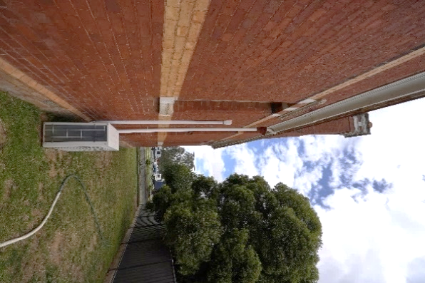
Figure 1: These trees are too close to the building for a site geology that was assessed to contain moderately reactive clays with deep seated movements (Rochester Court House, VHR H1482).

Risk Management Cycle
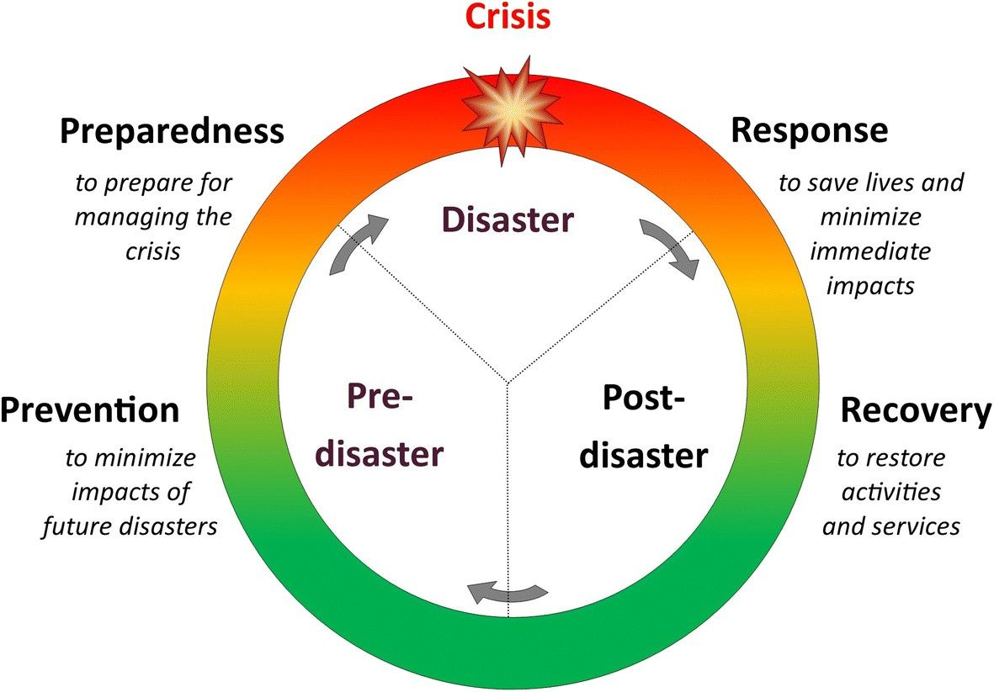
Figure 2: Risk Management Cycle – providing clarity to disaster process.

Note:
- Engage a heritage consultant to determine a scope of works.
- If your place is included in the Victorian Heritage Register or is an archaeological site, under the Heritage Act 2017 you are obligated to contact Heritage Victoria for a pre-application meeting before starting any works to apply for a permit or permit exemption.

Risk management approach
Stage | Approach | Strategies
Prevention | Investigate | Carry out a geotechnical investigation to establish existing building footing information – type of footings, depth of footings, type of founding soil, reactivity of founding soil, moisture content in founding soils at time of investigation, presence of non-soil material such as tree roots etc. Note buildings determined to be founded on or in fill soils will require structural intervention as soon as possible. Arrange for structural engineer to assess geotechnical investigation findings
 | Monitor | Monitor building movement and cracking for a period to see if the movement is continuing or stable. Note this monitoring can be done via surveying where the walls have significant lean movements or with proprietary wall markers such as Tell‐Tails where the wall cracking is to be monitored. The latter can be more crudely done with pencil lines drawn on the wall across the crack. These lines are to have a marked start and finish stroke and be measured at time of first marking. The length and the date the length was measured to be marked adjacent the line. Repeat measurements at intervals to similarly marked next to the original reference and the relative movement can then be identified.  Ensure all underground water carrying services are watertight. This is typically done by camera (CCTV) investigations and pressure tests.
 | Checks and considerations | Ensure tree proximity to buildings complies with guidelines in AS2870 Residential and Slabs and Footings Code for the various types of reactive soils. Note this refers to all trees near the building and can include property and adjacent property trees. Trees that contravene the above guidelines to be removed OR isolated from the building with the installation of appropriate depth and plan extent root barriers.  Ensure site surface levels fall from the building and therefore will direct water positively away from the external walls.  Consider apron paving around the perimeter of the building for masonry buildings with footings seated on highly to extremely reactive clay soils. Note the aim of apron paving is to essentially create an umbrella over the soil mass that is supporting the building footings and therefore minimise moisture content changes due to seasonal moisture changes.
Preparedness | Awareness | Be aware of potential flooding and severe weather warnings.  Ensure site underground drainage and surface drainage inlets and outlets are in good working condition and that any debris is removed.  - Note: This is not likely to impact on the extent of flooding but will improve the time it takes for the flood waters to recede and allow subsequent rainfalls to be handled efficiently and effectively.
Response | Inspect | Check site drainage outlets are free from flood debris.
Recovery | Engage | Engage a heritage professional to provide advice.  Engage a structural engineer to review the extent of damage to the structure and surrounds.  In the unlikely event of gross settlements having occurred to the building, structural intervention maybe required such as localized underpinning. Arrange for structural engineer to assess the issue.  Ensure underground site drainage and surface drainage inlets and outlets are free from flood debris.  Consult with Heritage Victoria to determine if a Heritage Permit or Permit Exemption is required to undertake these works.
 | Resilience | Attend to Preparedness Items not having previously been addressed.  Review of the Disaster Management Cycle and efficacy of the emergency response will improve future flood response measures.

