Name of Heritage property: _________________________________________________________________

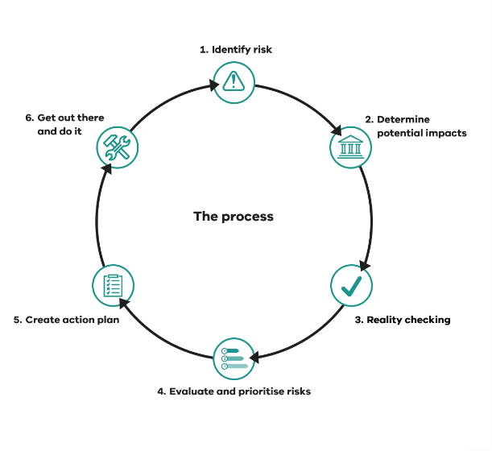
Address: ________________________________________________________________________________

Type of Heritage: _________________________________________________________________________

Date: ______________ Completed by: _______________________Review date: _____________________

Using this worksheet
This Disaster Preparedness Worksheet is generic and can be adapted to your situation.
If a section does not apply to your situation you can delete or cross them out.
While working through the process, try to complement your existing systems rather than replicate them.
Having a site plan or a floor plan of your heritage property (or the place where your heritage object(s) or collection is located) will also help you with your planning. If you don’t have one to hand, a quick, rough sketch will work too.

Table 1. Threats and Data Sources
Threat | Evidence | Data source | How to access
Storm | Storms can happen anywhere, at any time of year and are often accompanied by strong winds, large hailstones and lightning. | VicSES | https://www.ses.vic.gov.au/know-your-hazards/storm
Bushfire
Grassfire
Flood (riverine / flash)

Table 2. Potential Impacts
Threat | What is at risk (eg. Timber building) | Possible impacts | What do we already do to reduce this risk? | What more could be done?
Bushfire | Timber buildings | Embers may lodge or enter cracks in weatherboards causing total destruction

Table 3. Reality Checking – Risks identified on site and potential actions to remediate
Issues observed | Location | Potential actions that need to be taken
Evidence of falling damp | Main building, master bedroom, north-west corner. | Investigate roof and gutters, make repairs

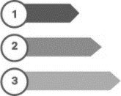Table 4. Risk Evaluation
Risk number | The risk | What are the chances this will happen? (likelihood) (Almost certain, likely/unlikely/rare/very rare/ extremely rare) | If it happens, what might the level of damage or loss be?  (consequence)  (Catastrophic/Major/Moderate/Minor/Insignificant) | Risk Rating  (Extreme, High, Medium, Low, Very Low)
1 | Bushfire | Unlikely- is a chance as in an undulating area with high fuel loads (leaf and bark litter) and close to forest but high rainfall. | Major- if totally destroyed, property will be irreplaceable
2
3
4

Use this risk matrix to plot your risks (circle with your risk number (or name) from Table 4). See Risk 101 [hyperlinked] for further instructions.
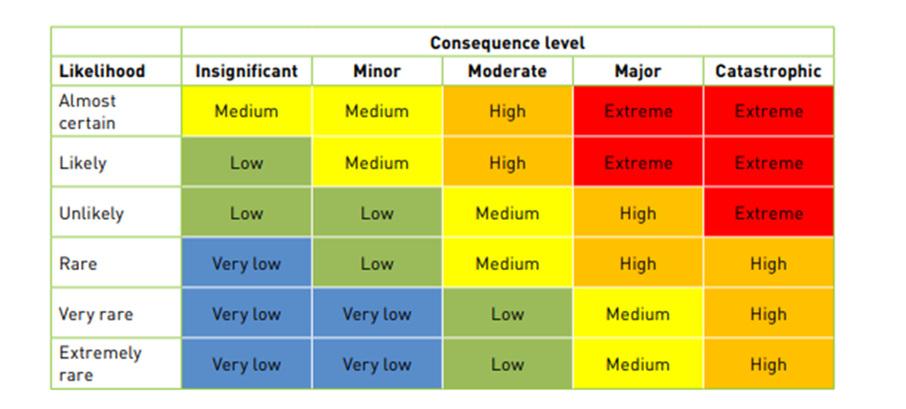

Questions to consider when completing this process
Any issues with completing the process? ___________________________________________________________________________________________________________
____________________________________________________________________________________________________________________________________________
What could be done differently next time? ___________________________________________________________________________________________________________
_____________________________________________________________________________________________________________________________________________
Was it a worthwhile process? _____________________________________________________________________________________________________________________

PRINT this table separately and DISPLAY where people can see

ACTION PLAN

Table 5. Action plan
Number (in priority order) | Action | Permit Required? Where From? | Resources | Budget | Potential Barriers & Possible Solutions | Actions Owner | Due Date | Done (Initial & Date) | Notes For Next Time
1 | Rake bark and leaf litter and remove from property (green waste bin or take to tip if too big) | No (allowed under Heritage Victoria’s general exemptions (p.27)) | Rakes, wheelbarrow, shovels, trailer. | N/A - free green waste disposal at council tip | None | Jane (gardener) | 1/09/2023 |  | First line is an example only

