Timber in Buildings

About this technical note
This technical note was prepared by Greg Owen (Period Building and Conservation) in collaboration with Heritage Victoria in response to the 2022 Victorian floods.

This note discusses managing the timber in heritage buildings, that is so often present in these buildings, and so often affected by flooding and high intensity rain events. Experts advise that rising water flooding and high intensity rain events are increasing in intensity and frequency, so we need to learn how to live with them and improve the resilience of our heritage buildings to be able to cope with this more frequent trauma. Of course, any changes to the building fabric need to be done sensitively, and not unnecessarily, to protect the significance of the heritage place, for which it is important.

When timber is wet it is more susceptible to damage from some pests and fungal attack, both with potentially devastating effects. For fungal attack, or rot, to occur we need four things:
- fungus which may lay dormant in timbers for decades and,
- food, in this case cellulose, which the timber provides,
- moisture and
- oxygen.

Fungus is freely available and probably already in the timber, lying dormant. Timber is made up of cellulose which is food for fungus. Oxygen is readily available in the air; all it needs is the damp to get it going. Timber as a porous material allows water to enter, particularly from the end grain. Rot can travel inside the timber digesting sound damp timber. With well-ventilated timber in buildings, the outer surface might get wet from rain, but this typically evaporates during the next dry spell, stopping the fungus attack before it takes hold. Where it is kept moist for long periods, is when fungus flourishes.

However, this is not a problem on its own, as timber boat hulls and wharf timbers live their lives wet. Where it is a problem is where timber is damp and in contact with air mostly at the wet/drying point. In these conditions timber can be:
- attacked by fungus causing digestion of the timber, leading to structurally weakened and soft ‘pulpy’ timber.
- a great host for mould, which while not causing damage to the timber, is a hazard for the human occupants of the buildings if it builds to high levels.
- more readily attacked by wood eating pests. Whilst not necessarily needing the contact with the air, moist timber is much more attractive to pests such as termites.
Timber will be present in heritage buildings in various places depending on the construction. The buildings can be all timber or just use timber floors, joinery, and roof framing. One of the greatest problems for timbers being flooded are those which cannot be well ventilated to dry out after the event, such as floors and their subfloor framing, lined timber framed walls and roof framing with ceilings. Floors and subfloor framing are generally the most at risk, due to the high evaporation load of moisture into the subfloor space from the saturated soil beneath, which may occur for some considerable time after the event.

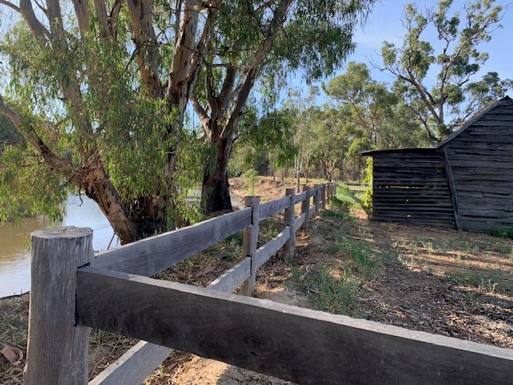
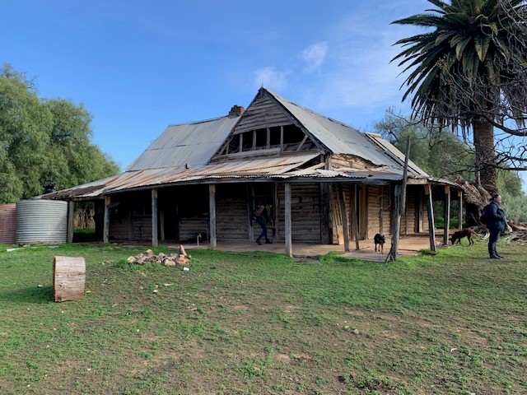

Figure1: Masters Hut Source: Jo Lyngcoln 2022 Figure 2: Bael Bael Homestead Source: Jo Lyngcoln

For vulnerable timber in buildings potential damage stemming from flooding can be reduced by implementing protocols as part of a Disaster Management Cycle to avoid or mitigate risks at various stages of any future flood event:

Risk Management Cycle
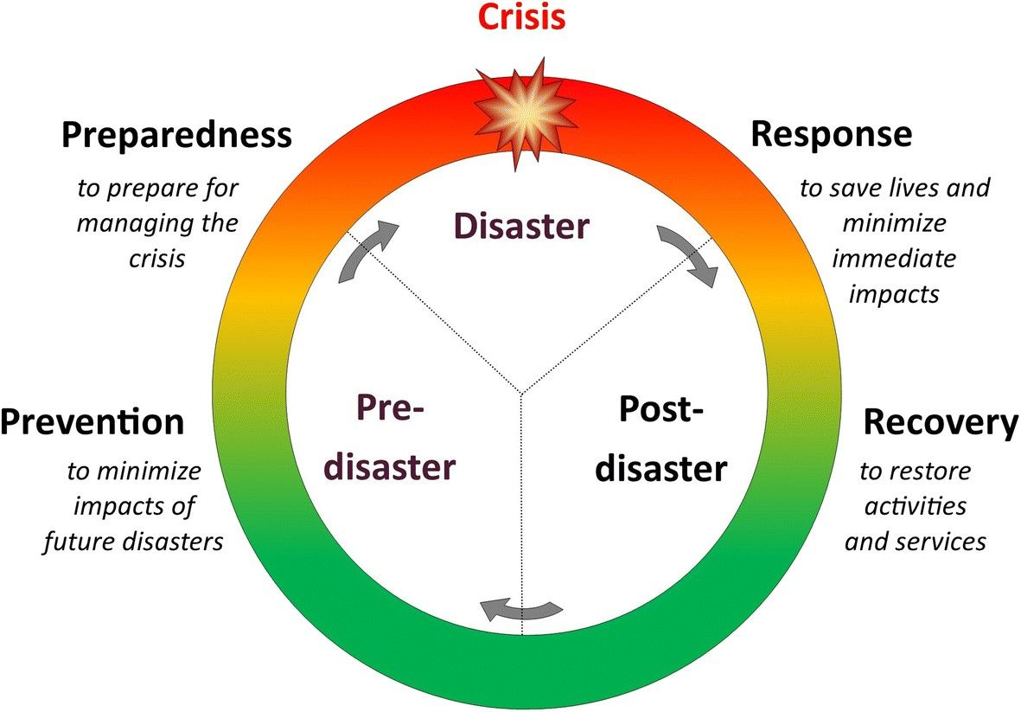
Figure 3: Risk Management Cycle – providing clarity to disaster process.

Note:
- Engage a heritage consultant to determine a scope of works.
- If your place is included in the Victorian Heritage Register or is an archaeological site, under the Heritage Act 2017 you are obligated to contact Heritage Victoria for a pre-application meeting before starting any works to apply for a permit or permit exemption.

Risk management approach

Stage | Approach | Strategies
Prevention | Plan | - If inundation is a relatively frequent occurrence and/or the consequences of inundation are considerable, consider flood mitigation measures to the whole site or parts thereof. Some methods include:  - A levy encircling the site,  - Installation of permanent barriers, open at the top, to prevent water entering subfloor vents (but remember these can hold the water in if they are overtopped by the flood level, so build a plug & socket into the barrier to be able to drain flood water after the event)  - Construction of temporary barriers which block off subfloor vents, doorways etc. These barriers may require some permanent tracks or hardware mounted on the building, with the barriers themselves kept stored somewhere on site, readily available.  - Consult with a heritage professional to assist with planning, implementation and completion of any preparedness works, documentation and to guide through Heritage Victoria’s approvals processes.
 | Ventilation | - Heritage buildings often have fewer and smaller subfloor vents than we now know, by research, is needed to prevent damp subfloor spaces. Traditional sub floor vents were often also very decorative and made using cast metals both of which mean that the free ventilation area of the vent can be very low. This may mean the ventilation of the subfloor space is too low during normal weather conditions and may be advisable to be upgraded. This upgrading could help speed the recovery of inundation effects.  - For some buildings, it is very difficult to provide suitable sub floor air conditions by natural ventilation, even in ‘normal’ weather. This is frequently the case in buildings with common walls on boundaries, such as High St shops built to both boundaries. These buildings will need special consideration and efforts to be able to successfully dry out all areas of the subfloor space relatively evenly.  If there are timber floors and they are clear finished, consider using breathable finishes rather than common lacquers most floor polishers recommend. Many oils and hard waxes offer much better breathability and allow some evaporation from the top surface of the flooring in the recovery phase, reducing floor cupping and speeding drying. Common polyurethane and other lacquers seal the top surface of the flooring allowing minimal drying from that surface post inundation. Most oils and hard waxes also offer the benefit of not requiring sanding before recoating which means your flooring lasts a lot longer, before replacement.
Preparedness | Awareness | - If warning of the impending flood is available:  - use polythene sheet and sandbags to prevent entry of rising water into the building as a whole and/or the subfloor space. If the likely inundation level is above floor level, sandbagging of the subfloor vents in a masonry building would be ineffective.  - Ensure the equipment required to respond to an inundation is available, e.g., sandbags & polythene sheet, air recording data recorders, pumps, etc.  - If many buildings are likely to be inundated if your site is inundated, e.g., a whole low-lying town or suburb, consider that there may be difficulty accessing flood restoration contractors and suitable equipment quickly, to respond to the event. You may choose to have some equipment permanently onsite and have some people trained in their use for your site. This equipment would need to regularly serviced/check to ensure it is operational when you need it.
 | Access | - Ensure there is good access to all subfloor spaces for the response and recovery phases. Masonry buildings have brick walls going all the way to the ground, and with older heritage buildings masonry was built even under doorways, so there is often no access or ventilation between ‘rooms’ subfloor. Sometimes there are dwarf masonry walls across large rooms to support the floor, which also block access. `Access is best achieved by floor hatches, but some rooms don’t lend themselves to having floor hatches and floor hatches can be unsightly and unsympathetic if the floors are exposed. Traditionally floor hatches are never placed where they will be normally walked on, so as not to place them under load and so they don’t squeak, so floor hatches are not cut into hallways, toilets and other small or narrow rooms. Access to these rooms are best accessed from another room through a hole constructed in the masonry subfloor wall. If a floor hatch is placed behind the door in the neighbouring room close to the wall and a hole in the masonry wall is constructed under the door where the wall is not supporting load, access can be much easier.
Response | Rising Flood Waters | - If warning of the impending rising flood is available:  - Consider using polythene sheet and sandbags to prevent entry of rising water into the building as a whole and/or the subfloor space by blocking vents and access doors. If the likely inundation level is above floor level, sandbagging of the subfloor space, alone, in a masonry building would be ineffective.  - Remove floor coverings, furniture, built in cupboard contents etc, where possible and safe to do so, and store high on site or in another suitable location. Consider removal and storage of built-in furniture/cabinetry. Significant heritage contents and collections should be moved and recorded by trained staff, wherever possible.  - If sandbagging has been put in place, but some water is still entering the subfloor space, consider using a pump to extract water ponding under the building. Access could be made through internal floor hatches. Digging a small hole (sump) into the earth can help drain the last of the ponding water, allowing the pump to drain it out. Always run petrol- and diesel-powered pumps outside to prevent build-up of dangerous exhaust gases inside.  - If water is not above floor level, position temperature and humidity data recorders in various representative places under the floor, and with one externally, to start monitoring air conditions.  - As soon as flood levels have dropped to below floor level and it is safe to enter, open all doors and windows to promote ventilation whenever security needs permit.  As soon as flood levels have dropped to below the lower edge of subfloor vents, pump out the remaining subfloor water, as described above and unblock any sealed vents to start air circulation. If easily undertaken, remove subfloor vents, and any metal mesh covers, installed to prevent bushfire embers entering, to promote ventilation. Be sure to replace them before the next fire season.
 | Flooding from roof or floors above | - Check inside and out, during the event to see where water is overflowing from the rainwater goods system and or might cause damage. Don’t worry if it is safely overflowing directly onto the ground, this is often an intentional safe overflow point in the system and shouldn’t cause damage. If there are any obvious blockages causing overflowing, e.g. leaves washed down to outlets, remove these if it is safe to do so. Yes, you may get very wet!  - Take note of where water is entering the building during the event, as it may not be readily visible later.  - If not already done so and your building has timber floors or wall framing:  - Consider sandbagging and polythene sheet, or other means, to build an internal levee on the floor below known problem spots, to encourage the water to flow directly out of the building rather to other areas inside or underneath. Buckets and even wheelie bins will soon overflow in such events if trying to catch the inflow.  - If there is warning of an approaching storm or high intensity rainfall event, consider the response and preparedness recommendations in Technical Note 5. Floods and Heritage: Flood management of roof and rainwater goods.
Recovery | Rising Flood Water: Actions | - Access all subfloor spaces and check for ponding water on the ground. If found, pump out the water. Digging a small hole (sump) into the earth can help drain the last of the ponding water, allowing the pump to drain it out. Always run petrol & diesel powered pumps outside to prevent build-up of dangerous exhaust gases inside.  - If not already undertaken in the Response phase, place air temperature and humidity data recorders in the subfloor space in the rooms above and outside.  - If the subfloor space was affected:  - If not already started, clear subfloor vents and open up building to ventilate as per the response phase above.  - Check if the ground in any subfloor spaces has been covered by plastic or other waterproof membrane (which is done in some buildings to reduce the normal humidity level in the space) and remove it out of the building before starting ventilation efforts  - If the external ambient air has a humidity of at least 10% lower than the subfloor space, start ventilating the subfloor space with fans. Fans can blow into the subfloor vents from outside or down the floor hatches from above floor level. Ducted fans are best with the duct sealed to the vents or hatch. If this sort of equipment is not available, remember, any ventilation is better than none. If the outside air has a similar humidity to the subfloor space, don’t bother ventilating, but try to expedite dehumidified air drying as per below.  - Engage flood restoration professionals to drop the humidity of the subfloor space air, to start drying out the earth below (which is evaporating lots of moisture into the air), subfloor timbers & masonry. This may be done using professional industrial dehumidifiers circulating air in & out of the spaces. Dehumidifiers are most effective if they recycle the air in a relatively sealed space, such as the subfloor space or a subfloor space and the room above it. The moisture load is too high for domestic dehumidifiers to be effective. The lower humidity air from the dehumidifier needs to circulate roughly evenly to all parts of the space. This may require more ducting to release it at the far corners of a space to allow it to pass over the whole space before exhausting or recycling. Monitor the drying efforts using the data loggers installed above and by measuring timber moisture content. Do not try to dry the spaces out too quickly. The compromise you have is that the timbers and any porous masonry present in the sub floor space is best dried slowly, but the earth below the space now holds enormous amounts of moisture which needs to be removed to return the building to normal conditions. So long slow drying is the answer for traditional buildings.  - Don’t panic if floorboards have cupped or otherwise deformed, this is common and can usually be remedied by controlled drying. Avoid taking advice to remove any significant floorboards, until the drying phase is completed and then not without consulting suitable heritage experts who have inspected the situation.  - Consult with Heritage Victoria and a heritage professional in determining the next steps.  A Heritage Permit or Permit Exemption may be required to undertake these works.
 | Resilience | Attend to Preparedness Items not having previously been addressed.  Review of the Disaster Management Cycle and efficacy of the emergency response will improve future flood response measures.

