Masonry

About this technical note
This technical note explains how to look after masonry walls that have been inundated by floodwaters and what can be done to reduce the impact of future floods.

Damage to masonry walls may include movement and cracking due to structural forces as well as damage to the masonry materials due to the action of soluble salts. Traditional masonry materials like bricks, mortar, sandstones and limestones, are relatively porous and will soak up floodwaters and whatever they are carrying in solution. Flooding, or intense rain and storms, commonly make rising damp problems worse, mobilising salts which later crystallise within the masonry causing decay. Salts must be removed to limit further damage. The information in this note is particularly relevant to older buildings, but the principles can be applied to porous masonry of all ages.

One of the important observations following the 2022–2023 floods in northern Victoria is that lack of maintenance and poor maintenance practices have resulted in much more damage to masonry walls than would have occurred had they been better looked after.

It’s important to be clear about the distinction between solid walls and those made with a cavity, which are often described as double brick. Solid walls are likely to be found in buildings of the nineteenth and very early twentieth centuries, while cavity walls were introduced from the late nineteenth century.

The key points listed below are explained in subsequent sections. Separate technical notes cover other aspects of caring for flood-affected buildings and structures.
Risk Management Cycle
Figure 1: Risk Management Cycle – providing clarity to disaster process.

Note:
- Engage a heritage consultant to determine a scope of works.
- If your place is included in the Victorian Heritage Register or is an archaeological site, under the Heritage Act 2017 you are obligated to contact Heritage Victoria for a pre-application meeting before starting any works to apply for a permit or permit exemption.

Risk management approach

Stage | Approach | Strategies
Prevention | Mitigate | 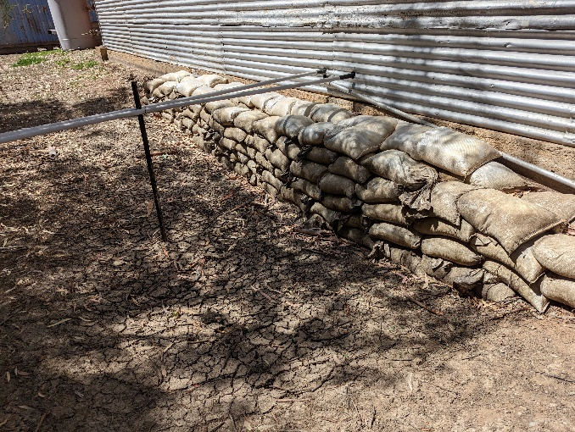  - Seal off potential water entry points such as old drains and sewer lines.  - Consider installation of removable flood gates and other barriers, such as sandbags Figure 2: Sandbagging. Source David Young
Preparedness | Consider and Plan | - Old walls need to ‘breathe’ - don’t coat them with sealers or paint them with acrylic paints.  - Think twice before installing a new damp-proof course.  - Improve integrity of solid walls by filling joints and voids in masonry but don’t use sealers.  - Cavity walls should be checked for salt damp and for corrosion of wall ties.  - Be aware of potential flooding and severe weather warnings.
Response | Look | Documenting the impact of the flood immediately after the event is crucial. Images and notes will provide valuable information for heritage consultants involved in the decontamination and clean-up process. This should include looking for structural damage as an engineering assessment may be needed. Refer to Technical Note 2 Heritage and Floods: Impact to building footings.
 | Clean up and Salvage | - After the flood open doors and windows to let air through and allow the building to dry naturally.  - Flush out wall cavities to remove flood-deposited silt.
Recovery | Key Issues | - Soluble salts are the principal cause of damage to porous masonry in older buildings. Damage occurs due to the growth of salt crystals within the pores of the bricks, stones, and mortar.  - Rising damp commonly carries salts up into walls from the soils beneath.  - Floods may mobilise salts, dissolving and carrying them further up the walls than before.  - Intense or prolonged high rainfall can also mobilise salts in the masonry.
 | Removing Salts | - Salts must be removed to prevent damage; the process is known as desalination.  - Begin salt extraction as soon as possible after floodwaters have receded.  - Techniques for removing salts from masonry include captive-head washing and poulticing, as well as the use of sacrificial treatments.  - Captive-head washing uses a low-pressure water spray to dissolve salts within an enclosed head; the salty wash water is captured in a wet vacuum cleaner.  - Poulticing uses highly absorbent materials to draw saline (salty) moisture from the masonry so that the salts crystallise within the poultice rather than the wall.  - Sacrificial mortars, plasters and renders can be used to protect masonry over longer periods.  - These techniques can be used separately or in combination, depending on the circumstances.  - Monitor progress of salt extraction using simple analytical techniques.  - Anticipate the need for follow up treatments as deeper salts come to the surface.  - Do not use techniques such as high-pressure washing or blasting of any form.  - Eroded mortar joints may require repair (repointing).  - Previous repointing of mortar joints with cement mortar will slow drying and limit desalination of walls and may need to be replaced with a deliberately weak (sacrificial) lime mortar.  - Interior walls may also require desalination.  - Do not attempt to ‘lock in’ the salts with hard renders or chemical treatments.  - Do not remove original lime plasters that are still in sound condition.  - Do not replaster with gypsum plasters; instead use lime-based materials.  - Monitor for long term structural movement and engage a structural engineer if required.
 | Engage | Engage a heritage consultant to determine a scope of works and then contact Heritage Victoria for a pre-application meeting.  Before starting any works apply to Heritage Victoria for a permit or permit exemption.
 | Resilience | - Attend to Preparedness items not having previously been addressed.  - Development or review of the Disaster Management Cycle and efficacy of the emergency response will improve future flood response measures

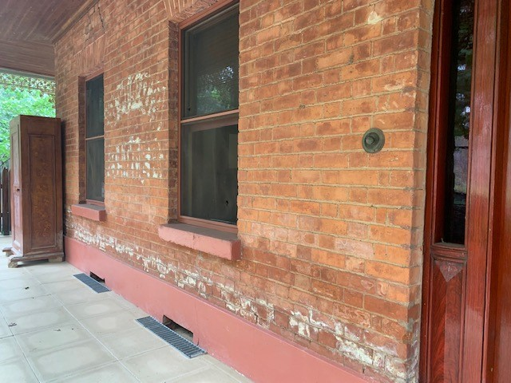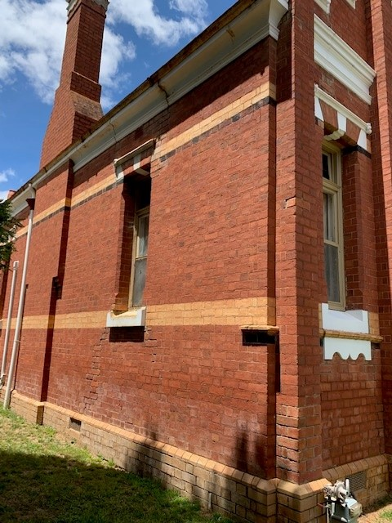
Figure 4: Rising damp with salt attack beginning. Source: Jo Lyngcoln 2022
Figure 3: Rising damp and salt attack above cement rendered plinth. Source: Jo Lyngcoln 2022

The following sections expand on the key points using the same numbering:
Prevention

Seal off potential water entry points.
Abandoned sewer lines and old pipes and drains beneath a building can allow floodwaters easy entry into cellars, basements, and sub-floor spaces. If practicable, these should be sealed off on the outside of the building. Such work may disturb archaeological materials and so will require permit approvals for places listed on the Victorian Heritage Register.

Consider removable flood gates and other barriers.
For buildings at particular risk of flooding, consideration should be given to the installation of flood barriers. These could include covers that seal over sub-floor vent grilles. To be effective they would need to seal well against the wall surface yet be easily removed once the flood has receded.
The next level of flood defence might be temporary barriers that seal off the lower parts of doorways and other openings. They could be hinged gates that close against a frame, or drop-in boards that sit in channel sections. Most would require permanent fixings set into door reveals and their detailing would need careful consideration of options to minimise the visual impact. Any such changes would require permit approvals for places on the Victorian Heritage Register.
The use of temporary barriers will add to the hydrostatic forces on the walls during a flood and an engineering assessment will be needed to ensure that the building can withstand the additional loads.
Preparedness

Old walls need to ‘breathe’.
Old masonry walls are made of bricks, stones and mortars that are quite porous, they contain a lot of air in their pore spaces. Some of this air moves out of the walls when they warm up during the day and moves back in when the walls cool down at night. Hence the walls ‘breathe’, out and in, with daily temperature changes and with changes in air pressure. Looking after old walls means allowing them to continue breathing. Avoid water-repellent coatings, sealers, and any other coating, such as acrylic paint, that will block pores and trap moisture and salt inside the walls where they will cause damage. Masonry walls that have never been painted should not be painted with anything other than traditional limewash that is free of polymer additives that are often promoted as improving the product.
Some authorities recommend the application of cementitious renders over existing porous brickwork in order to minimise floodwater entry through the walls. As well as radically changing the appearance of the building, contemporary cementitious (and acrylic) renders are incompatible with old brickwork because they will be too rigid and because they restrict the all-important breathing of the porous materials.

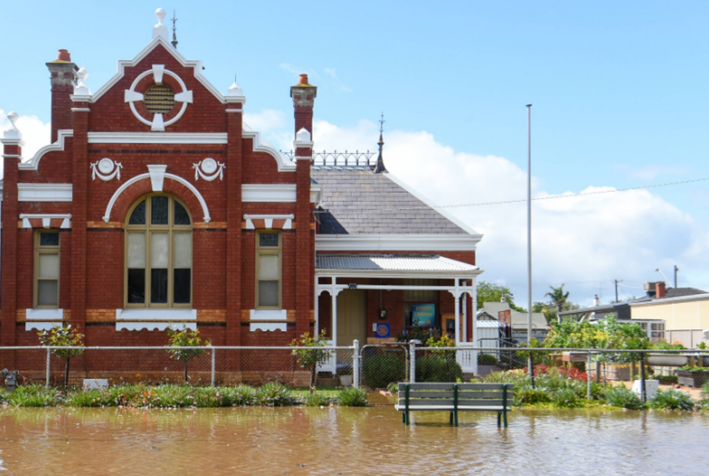
Figure 5: Rochester Court House: receding waters. Source: Darren Howe, Bendigo Advertiser, 14 October 2022.

Think twice before installing a damp-proof course.
A new damp-proof course (DPC) may be warranted if there is none, or if the existing one is not performing adequately. If so, the new DPC should be set at a level below any floor timbers, as they need protection from dampness as well. However, before deciding to install a new DPC, basic housekeeping measures should be undertaken to reduce the damp ‘stress’ on the walls by lowering ground levels and ensuring that they are graded so that water is carried well away from the base of walls. Ensure that roof drainage systems work as intended and that drains are not blocked. Remove concrete access ramps from against the walls and replace them with structures that don’t block sub-floor vents. Give an old DPC the chance to work properly before deciding to install a new one.
It should be recognised that a future flood may carry salts higher in the walls than the new DPC and may mobilise any salts that are left in the wall, which is why it’s so important to remove them now, and to be prepared to do it again after the next flood.

Improve integrity of solid walls.
Thick old walls, particularly those of rubble stone, often have substantial voids in the centre or core of the wall. With time, floods as well as rising and falling dampness can leach out some of the lime binder from the centre of the wall leading to progressively larger voids. Walls with extensive voids may leak through the joints during floods resulting in inundation of cellars and basements.
The risk of leaks can be reduced, and the structural integrity of the walls improved by ensuring that all voids in the wall are properly filled. This may require investigation by a specialist to establish the scale of the problem and to specify the necessary repairs. As well as deep repointing (deep packing) of the mortar joints, the work may involve grouting with lime-based mixes that include plasticising agents. Filling the joints and the core will slow water penetration through a wall, but not totally prevent it, particularly in a prolonged flood.

Cavity walls also need attention.
The above advice applies to solid walls and not to cavity walls where the void (cavity) is intentional. Weep holes in the outer leaf of cavity walls (and in brick veneer construction) are there to allow any water that gets into the cavity to safely drain away. They should never be filled and should be kept cleaned out as part of routine maintenance. It may be necessary to introduce new weep holes or to widen the existing to ensure adequate drainage.
Cavity walls should be checked for rising damp and salt attack that may be eroding the brickwork inside the cavity. This is particularly important for early cavity walls with relatively weak mortars. Rendering, painting or sand-blasting the exterior may have transferred the natural point of evaporation to the inside of the outer leaf where, unseen, there may be considerable loss of mortar. In such cases, the outer leaf may need to be rebuilt in sections (the process known as undersetting).
The condition of the metal wall ties should also be checked. Any sign of corrosion (rusting) of the ties should be further investigated by trial removal of a sample number of ties. Most corrosion of ties occurs just inside the mortar where it is impossible to see, even with good lighting and inspection equipment. Remedial insertion of ties may be needed to regain the structural integrity of the walls.
Response

Look for structural damage.
Flooding may have caused cracking and other structural damage which should be assessed by an engineer with demonstrated experience in heritage buildings. Movement and cracking of walls can result from footing movements in the short term, due to saturation of the ground resulting in softening of the founding soils and uneven settlements, AND/OR in the long term, with reactive founding soils slowly drying out to their pre-existing moisture content. Cellar and basement walls may bulge due to hydrostatic pressure (the sideways pressure from the water-saturated soils) and may need bracing to restrain them. The hydrodynamic forces associated with fast-moving floods may distort walls (particularly from the impact of flood-borne debris) and may even move lighter building off their footings. Refer to Heritage and Floods: Impact to building footings.

Open the building and allow it to dry out.
After the floodwaters have receded open windows and doors to let air through the building and begin cleaning out silt and mud from interiors as soon as possible. It’s much easier to remove mud while it is still damp. Remove covers from sub-floor vent grilles and clean away any debris that prevents good airflow. Open floor traps to improve air circulation through sub-floor spaces. While the upper parts of buildings should be allowed to dry naturally, additional ventilation may be required for sub-floor spaces, cellars, and basements. Very rapid drying using dehumidifiers should be avoided as this may damage floor timbers and worsen the effects of salt attack. Drying out of sub-floor spaces may take a long time. It is strongly recommended that a heritage professional is engaged before undertaking any mechanical drying.

Flush out wall cavities.
Floodwaters may have deposited silt in wall cavities, which will slow drying of the masonry. Though the amount of silt is likely to be relatively small, cleaning out the wall cavities will have the additional benefit of removing accumulated mortar debris which may be bridging the cavity, leading to dampness on the inner leaf of the wall. Flushing the cavities will mean removing vent grilles and possibly bricks to allow hosing out of silt and debris. Fans may assist in subsequent drying. It is strongly recommended that a heritage professional is engaged before undertaking any mechanical drying.
Recovery

Salt attack
Most traditional masonry materials such as bricks, mortar, sandstone, and limestone are relatively porous and allow moisture to enter their pores. When that moisture contains soluble salts, such as sodium chloride (common table salt), the salt can be carried deep into the pores of the material. On drying, the moisture evaporates but the salt is left behind forming tiny crystals. With repeated cycles of wetting and drying, enough salt can accumulate to exert a bursting pressure from within, forcing apart the constituent grains and leading to crumbling and decay. This is salt attack (sometimes described as salt weathering) and it is the principal mechanism of masonry decay in older buildings.

Rising damp
The tiny pores in masonry materials can create a strong capillary suction which will draw moisture up into a wall from the soils beneath. This capillary suction is commonly known as rising damp and is an issue that needs to be managed in all masonry walls. In modern buildings an impermeable barrier, known as a damp-proof course (DPC), is inserted at the base of the wall during construction. Older buildings may have no DPC, or the DPC may be ineffective, allowing dampness to rise in the walls, often up to a metre or so above ground level. By itself, rising damp is not particularly damaging to masonry; it is the salts that the dampness carries up into walls that do the damage.

Floods may mobilise salts.
Old walls may have accumulated substantial amounts of salt over the years. These salts may not be obvious, or they may be hidden by previous repairs, such as the re-rendering and painting of plinths and the lower parts of walls. During floods the salts in the walls can be dissolved by the floodwaters which carry them further up the walls, initially to the peak flood level. The capillary suction that is rising damp then takes over and draws the floodwater and salt further up the walls. As the masonry dries out the salts are left much higher in the walls than before, often at levels where the rate of natural evaporation is greater than it is closer to the ground. The result can be rapid decay of the surface of the brick or stonework, particularly in warm and windy conditions.

Intense rainfall can also cause problems.
While not actually creating a flood, intense rainfall can also cause problems when roof and eaves gutters overflow and the ground around and underneath buildings becomes saturated with moisture. The water table beneath the building is temporarily raised, which in turn promotes more rising dampness in the walls. The result is like a flood: salts are carried further up the walls and cause damage as the moisture evaporates.

We must get the salt out.
The only way to prevent damage from salt attack is to get the salt out, or at least to reduce the concentration of salt to a point where it no longer fills pores and causes decay. Traditional treatments for rising damp have focused on inserting new DPCs in the base of walls. However, in situations of high salt loads it is essential to also remove the salt, otherwise decay will continue as the salt will go on dissolving and recrystallising with changes in humidity, long after the floodwaters have gone.

Start salt extraction as soon as possible.
Desalination of flooded masonry should begin as soon as practicable after floodwaters have receded. This is to limit damage caused by salt attack and because less-soluble salts will be more readily extracted while the walls are still damp. However, the practicalities of cleaning up after floods, including removal of debris and dealing with insurance issues, and even becoming aware that there is a salt problem, mean that it will commonly be some time before salt extraction can be started. Nevertheless, the sooner the better.

Salt extraction (desalination) techniques
Techniques for removing salts from masonry include two that have been developed in recent decades: captive-head washing and poulticing with absorbent materials. There’s also the use of sacrificial treatments based on deliberately weak mortars, plasters, and renders.

Captive-head washing
Captive-head washing (CHW) utilises an enclosed head within which water at normal tap pressures is sprayed onto the wall surface. The unit is connected to a wet vacuum cleaner, which sucks back most of the water and which holds the head against the wall. A rubber skirt around the head protects the wall from abrasion and provides the vacuum seal. As the unit is slowly drawn over the wall surface, the water dissolves some of the salt on and in the masonry before it is sucked back into the tank of the wet vacuum cleaner. Though only near-surface salt will be extracted, the small amount of water that remains in the masonry will dissolve salt that’s deeper in the wall. Subsequent passes will progressively draw out more salt. Depending on the amount of salt in the wall many passes may be required to reduce the salt concentrations to acceptable levels. Experience suggests that each area should have three passes in one day, with the surface not allowed to dry between passes in order to promote dissolution of less-soluble salts (particularly sulphate salts).
The captive-head washing system is marketed as “BlueVac” by Let’s Clean Pty Ltd:
http://www.letsclean.com.au/bluevac-captive-head-washing-system

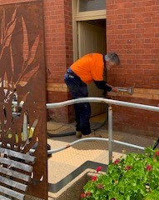
Figure 7: Demonstration of poultice application by Greg Owen. Source: Jo Lyngcoln 2022

Figure 6: Demonstration of captive head washing by Greg Owen. Source: Jo Lyngcoln 2022

Poulticing with absorbent materials
Combining a highly absorbent material with paper pulp produces a poulticing medium with high suction which actively draws moisture and salt from porous masonry. The poultice is applied as a wet slurry, either by trowel or by spraying it onto the wall surface. Water in the poultice soaks into the masonry and dissolves the salts. Depending on the location and climate the poultice is left on the wall for two to six weeks until the moisture in the wall dries back out through the poultice which captures the salt. Once it has dried the poultice is peeled off and a new application made. The number of cycles of poulticing will depend on the amount of salt in the wall; at least two applications will be needed.
The poultice is marketed as “Cocoon” by Westox Building Products (Westlegate Pty Ltd): https://westox.com/product/cocoon-20-litre/

Sacrificial mortars, plasters, and renders
Sacrificial mortars, plasters and renders are made deliberately weak so that they will fail first and so protect the surrounding masonry. Their action is similar to poultices except that they lack the active suction of the poultice and so work much more slowly. Sacrificial mortars and plasters are made more porous by adding air-entraining admixtures to lime and sand mortars. By repointing mortar joints with these materials dampness and salts can be drawn from the surrounding bricks or stones. Sacrificial plasters transfer the zone of evaporation (and hence salt crystallisation and decay) out into the new plaster, away from the masonry behind. Being porous they will store some salt until they eventually fail; the debris should be collected to prevent recycling salts through the base of the walls. They may need to be replaced with a further coat of porous plaster or the joints repointed in another weak mix.

Which technique should be used?
The decision about which treatment to use will partly depend on the amount of salt present: for small amounts captive-head washing will be efficient, whereas larger amounts warrant poulticing. Combining the two techniques can have benefits: for example, using several initial passes of CHW to reduce very high salt loads will make the first cycle of poulticing more effective. Further, poulticing leaves some residue of paper fibres which can be effectively removed using a clean-up pass of CHW.
The breakeven point where the costs for each technique will be similar will vary from job to job, but around three or four non-consecutive days of three passes of captive-head washing per day may have similar costs to two cycles of poulticing with a pass of CHW for cleaning up. This is a guide only and many factors will affect the cost of a particular job including travel and accommodation costs for remote sites, as well as exposure and seasonal conditions that might suggest a particular technique.
Though less effective at salt extraction, sacrificial techniques can be a useful way of capturing the smaller amounts of salts that are deeper in the masonry and which will take time to come to the surface. This suggests using CHW or poulticing for most salt, with follow-up sacrificial treatments.

How much salt?
Understanding the scale of the salt problem and monitoring the progress of desalination requires analysis of salt concentrations. A variety of techniques can be used, ranging from detailed chemical analysis of samples through to simpler measurements of electrical conductivity from which estimates of salt content can be made. A conductivity meter can be used to measure the wash water in the vacuum tank of the captive-head system so that the progressive reduction in salt loads can be monitored with each pass across the surface of the masonry. Similarly, by weighing out a known sample of dried poultice, dissolving that in a fixed volume of distilled water and then measuring the conductivity, the amount of salt extracted with each cycle of poulticing can be recorded.
These techniques enable the progress of desalination to be monitored, but they do not measure how much salt is left in the wall. For some projects it will be appropriate to take samples by drilling into mortar joints at a series of depths (intervals of 0–10, 10–20 and 20–40 mm is commonly measured) and analysing the samples for salt content. This can be by electrical conductivity, or by more expensive chemical analyses. Only the latter can identify which salts are involved, conductivity only estimates the total amount of salt.

Follow-up treatments may be needed.
Although most salt may be removed in a relatively short campaign, the need for follow-up treatments should be anticipated. Flooding will drive some salts deep into thick walls and these may take time to slowly migrate back to the surface. Inspect walls after six, 12 and 24 months looking closely for signs of fine white powdery crystals on the surface. These are most likely to become apparent after periods of dry, warm to hot and windy weather, i.e. summer in southern parts of Australia. Follow-up treatments might include several passes of captive-head washing, which might need repeating after a further 12 months. Review the condition of any sacrificial treatments, particularly renders on plinths, which should be removed and replaced before they fail, to maximise their effectiveness and to reduce the risk of recycling the salt through the base of walls.

Do not use blasting and high-pressure techniques.
Treatments like blasting with very high-pressure water (with or without abrasives) should not be used under any circumstances; they will damage the surface of the masonry and simply drive salts deeper into the walls. Light pressure washing with the nozzle held well back from the surface may have a role in rinsing salt from strong surfaces (such as cement renders) but it should be recognised that this risks recycling salts into the soils below and back through the walls.

Repairing eroded mortar joints
Lime mortar joints at the base of older walls are often eroded by the combined effects of rising damp and salt attack. Floods can worsen the damage to the point where the outer part of the mortar joint needs replacing. This is the process known as repointing and it’s important that it is done with mortar that is weaker and more porous than the bricks or stones, so that they are protected from further salt attack. This means using a mortar like the original, made of lime and not cement. Lime mortars are best made using dense lime putty and washed concrete sand (not bricklayer’s sand).

Dealing with hard cement mortar repairs
Mortar loss from masonry joints has often been poorly repaired in hard cement mortars. Because cement mortars are relatively impermeable, they prevent walls drying out through the joints and as a result salt attack is focused on the masonry units. It’s much easier to replace mortar than it is to replace bricks or stones. To remove hard cement-mortar a narrow cut is made along the centre of the joint with a small diamond disc cutter. Then, working from either side towards the free space, a sharp chisel is used to remove the mortar from the bricks or stones. With care this method can minimise damage to the edges (arrises) of the masonry units.

Desalinating interior walls
Internal wall surfaces can also be desalinated using either captive-head washing, poulticing or a combination of both. However, previous repairs to internal plasters may have been done with cement which will slow drying and may drive dampness and salts higher in the wall. It may be necessary to remove the cement plaster to enable salt extraction from the brickwork behind.

Don’t try to ‘lock in’ the salts.
Waterproofing and salt-retarding additives for plasters are often promoted as a way of ‘locking in’ any salts remaining after desalination treatments. This is not good practice for older buildings, it is much better to remove all the salt. The additives require the use of strong cement plasters which are not compatible with older walls of porous masonry.

Retain original lime plasters.
Where original lime plasters survive in reasonable condition they should be kept and repaired. Because they are more porous it will be possible to extract salt through them using the techniques described above. Some early plasters consisted mostly of earth and sand with very little lime binder except in the top coat. Plasters like this may not survive a severe flood and will likely need replacing.

Do not replaster with gypsum plasters.
Modern gypsum plasters (based on plaster of Paris) should not be used wherever there’s a risk of further dampness. This is because gypsum behaves as a salt when wet and will cause damage similar to other salts as it crystallises on drying. Instead, use traditional lime plasters, based on lime putty, coarse, sharp sand and hair for reinforcing. Topcoats of lime and very fine sand can have a proportion of finely ground limestone added to improve workability and hardening of the lime.

Monitor for long term structural movement.
As noted earlier, there may be long term structural movements in the walls as founding soils slowly return to their pre-flood moisture content. As this may take months walls should be routinely monitored for any signs of movement. Refer to Heritage and Floods: Impact to building footings.

Reference should be made to the resources listed below. These have more details about aspects and advice for appropriate treatments.

Resources | Hawkesbury-Nepean Floodplain Management Steering Committee. 2006. Reducing vulnerability of buildings to flood damage: guidance on building in flood prone areas.  Heritage Council of Victoria. 2020. Lime mortars for the repair of masonry. Heritage Technical Code, HTC1, Heritage Council of Victoria.  Heritage Council of Victoria. 2020. Repointing with lime mortars. Heritage Technical Code, HTC2.  https://www.heritage.vic.gov.au/protecting-our-heritage/maintaining-and-modifying-a-heritage-property  Historic England. 2015. Flooding and historic buildings. Rev 2nd edn. Historic England.  https://historicengland.org.uk/images-books/publications/flooding-and-historic-buildings-2ednrev/  Young, D. 2008. Salt attack and rising damp: a guide to salt damp in historic and older buildings. Heritage Council of NSW, South Australian Department for Environment and Heritage, Adelaide City Council, Heritage Victoria, Melbourne.  Young, D. 2021. Mortars: materials, mixes and methods; a guide to repointing mortar joints in older buildings. Heritage Councils of Victoria, New South Wales, South Australia, Western Australia, Tasmania and Queensland, Melbourne

