Timber Bridges

About this technical note
This technical note was prepared by RBA Architects + Conservation Consultants in collaboration with Heritage Victoria in response to the 2022 Victorian floods.
Bridges, mainly built over water courses and flood plains, are intrinsically susceptible to damage by flooding and intense storm events. Increasing moisture levels in soils may lead to loss of structural foundation integrity. Timber bridges, which in Victoria are generally over sixty years old, are particularly vulnerable, especially those which are no longer in service or actively maintained.
The more frequent occurrence of extreme weather events and ensuing wind, bushfire and flood damage can reduce the service life of timber bridges incrementally over time and substantially increase the risk of catastrophic failure of the structure consequently.

Timber as a structural material can be prone to degradation caused by a number of factors including:
- Fungal attack.
- Termite attack.
- Marine Organism attack.
- Corrosion of metal fasteners or components.
- Interface between metal, concrete and timber elements causing water traps.
- Shrinkage and splitting.
- Fire damage.
- Weathering.
Most of these factors are exacerbated by extreme, recurring precipitation and flood events, which may also have an adverse impact on the integrity of timber bridges, including:
- Buoyancy - uplift forces exerted on submerged bridge components.
- Drag forces of the water on submerged components (hydrodynamic force).
- Impact forces of large floating objects and debris causing bending failure of piles.
- Scouring around the base of the bridge structure (hydraulic action).
- Sediment build-up around piles.
- Increased moisture levels in soil causing failure of abutment piles due to increased earth pressure loads and creating a more desirable habitat for termites.

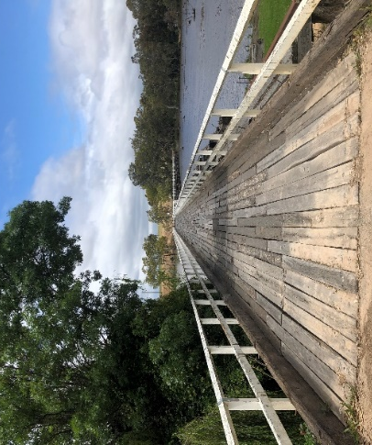
Examples of state-listed timber bridges.
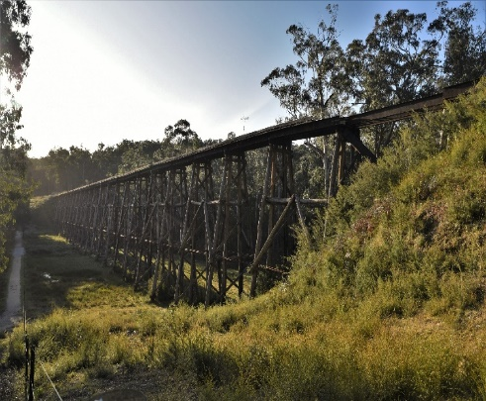
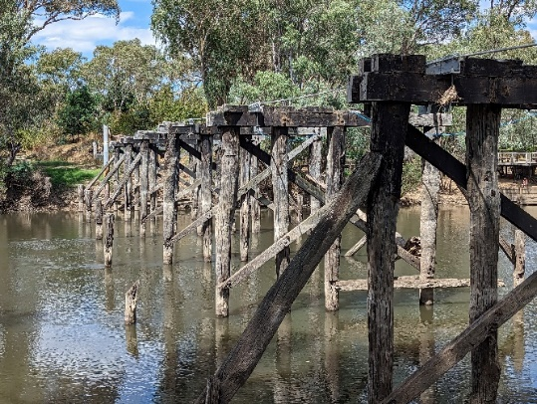

Figure 1: Old Goulburn Bridge Figure 2: Kirwans Bridge Figure 3: Stony Creek Bridge

Risk Management Cycle

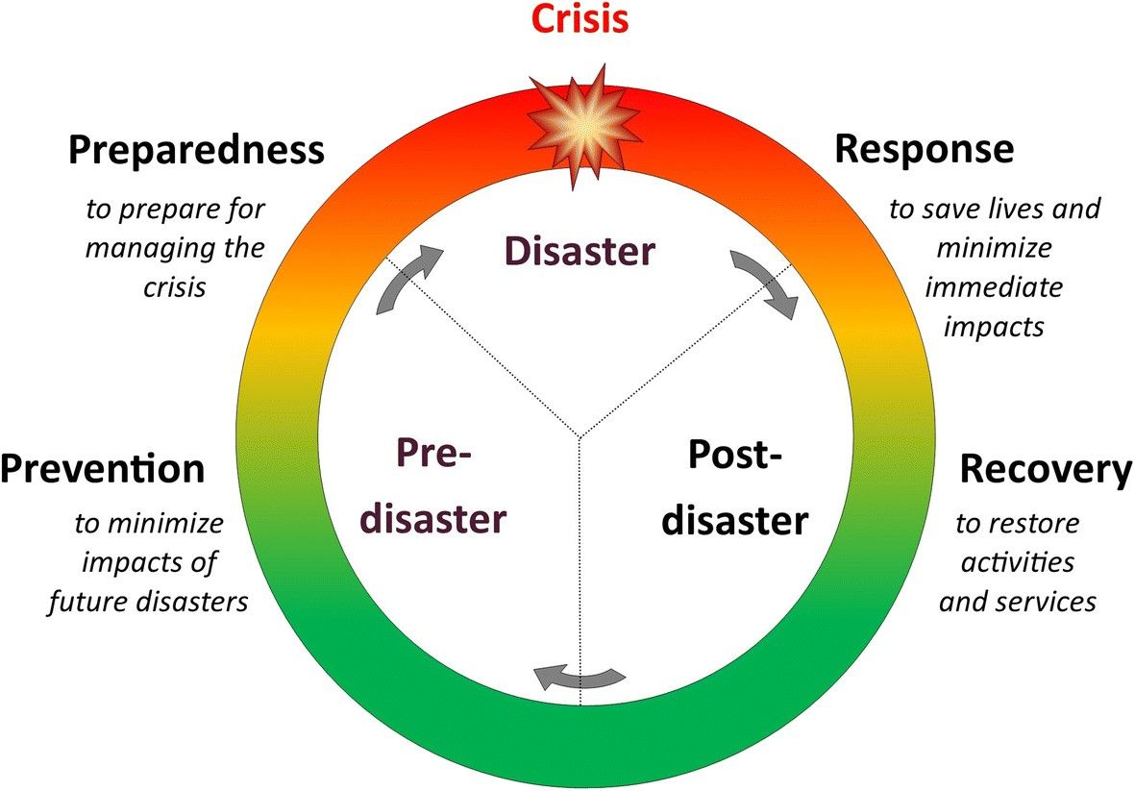

Figure 1: Risk Management Cycle – providing clarity to disaster process.

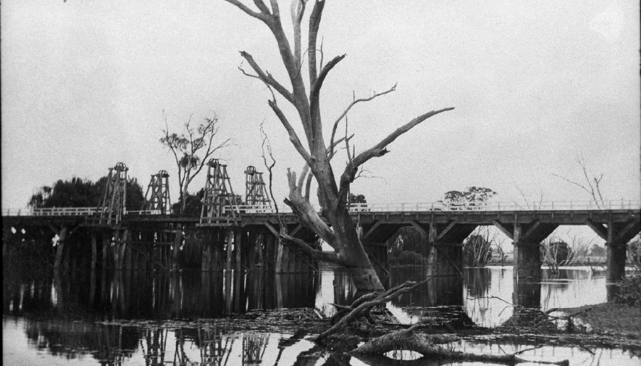
For these vulnerable timber bridges potential damage stemming from flooding can be reduced by implementing protocols as part of a Disaster Management Cycle to avoid or mitigate risks at various stages of any future flood event:
Note:
- Engage a heritage consultant to determine a scope of works.
- If your place is included in the Victorian Heritage Register or is an archaeological site, under the Heritage Act 2017 you are obligated to contact Heritage Victoria for a pre-application meeting before starting any works to apply for a permit or permit exemption.

Risk management approach
Stage | Approach | Strategies
Prevention | Strategies | - Consult with a heritage professional to assist with planning, implementation and completion of any bridge works, documentation and to guide through Heritage Victoria’s approvals processes.  - Prepare a Conservation Management Plan (CMP) to guide future management and use of the place.  - Prepare and implement a Bridge Maintenance Strategy which sets out a plan of regular inspections, routine maintenance, programmed maintenance and rehabilitation as required.  - Document the existing bridge (to be included in the Bridge Maintenance Strategy and/or CMP), including 3D digital recording, with a record of member sizes and connection details to assist in the ongoing monitoring and maintenance of its condition and in its repair or reconstruction in the event of damage.  - Strategies such as structural upgrades, raising of the bridge or its relocation may need to be considered when severe risks posed by flooding cannot be contained by regular maintenance alone. This would need to be discussed further with all relevant Authorities.  - Prepare an Options Assessment to guide the best approach for future use and conservation. An adaptive reuse of a non-serviceable timber bridge such as becoming a walking or bike path, may ensure longevity.
 | Inspect | - Arrange regular inspections by a Structural Engineer of the superstructure and substructure of the bridge and drainage. All major members should be inspected to determine their structural integrity, using methods such as hammer sounding, micro resistance drilling, visual assessment.  - Visually inspect all members to determine likely age including, surface marks to determine processing method, stamps and labelling, hardware type compared to historic catalogues, etc.  - Inspect stream beds and riverbanks for signs of scouring and the general condition of the surrounding area, such as overgrown vegetation or a build-up of debris around the bridge structure.  Issues noted in an inspection which fall outside the scope of routine maintenance should be addressed by rehabilitation works as advised by the engineer. Written approval from Heritage Victoria will be required before the commencement of any works to the bridge.
Preparedness | Awareness | - Be aware of potential flooding and severe weather warnings.  If an extreme weather event is predicted, and it is safe to do so, secure loose fabric without damaging any component (no drilling), ensure that drainage is clear, and the bridge and surrounds are free of debris and excess vegetation. If maintenance is being undertaken routinely as per the Bridge Maintenance Strategy, the work at this point should be minimal.
Response | Safety | - Follow VICSES guidelines in regard to safety around trees, drains, low-lying areas, creeks, canals, culverts and floodwater.  - Do not access the area until flood waters have receded, and it is safe to do so.  - Do not access the bridge until declared safe following a structural assessment by a structural engineer.  - Avoid contact with flood waters as they may contain sewage and other contaminants which may pose a health risk. Use appropriate protective equipment such as waterproof gloves and gum boots.
 | Record | - Document the impact of the flood.  - Take photographs and make notes.  - Video recordings may also be useful
 | Inspect | - A preliminary structural inspection should be undertaken by a structural engineer to identify any immediate make-safe works required. Make-safe works should be carried out as soon as is practicable in consultation with Heritage Victoria.  - The bridge should be thoroughly inspected to ascertain the full extent of damage to the structure, when safe to do so.  - The riverbed and bridge abutments should be checked for scouring.
 | Cleanup | - Collect and dispose of flood debris in accordance with EPA and Local Government guidelines. Note that treated timber must go to a landfill licenced for this type of waste.  - A Heritage Permit or Permit Exemption may be required before disposing of any component of the bridge, even if it appears to be damaged beyond repair.
 | Salvage | - Search the area including where relevant, the watercourse and banks surrounding and downstream of the bridge, for detached bridge components.  - Salvage detached bridge components for potential re-use in the repair or reconstruction of the bridge. Identify (relative to any available documentation), label and record these items prior to storage
Recovery | Engage | - Consult with Heritage Victoria and a heritage professional in determining the next steps.  - Engage a structural engineer to review the extent of damage to the structure, assess the salvaged material’s potential for reuse, and to plan a program of work to repair, or reconstruct the bridge.  - A Heritage Permit or Permit Exemption may be required to undertake these works.
 | Resilience | - Ideally from a heritage perspective, the bridge would be reinstated to the condition it was in prior to the flood event, using like-for-like materials and detailing. This may not be possible for reasons of cost feasibility, building code compliance and safety. If maintenance has not been undertaken regularly, the condition of the bridge prior to flooding may have been deleterious and would now require further conservation works.  - Undertake an options assessment to guide the best approach for future use and conservation.  - Review of the Disaster Management Cycle and efficacy of the emergency response will improve future flood response measures
 | Resilience | - Review the Maintenance Plan and Emergency Management Plan and update with new information to improve the future resilience of external finishes to withstand disasters, including flooding, fire and earthquakes.  - Review of the Disaster Management Cycle and efficacy of the emergency response will improve future flood response measures.
Below includes further information to help you understand common terms and resources:
Terminology
The following terminology identifies various timber components, or collection of components, used in the construction of timber bridges in Victoria. These have been listed alphabetically and includes multiple alternative names and a brief description of each element. Rail and road bridges sometimes have alternative terminology. Drawings have been included for greater clarity in identifying these elements:

Element | Alternative name | Description
Balustrade |  | Handrails and posts constructed to the outer edge of the deck
Bay |  | Area between two Trestles
Buoyancy |  | Uplift forces exerted on submerged bridge components
Brace | Bracket | Single diagonal member attached across Piles and located between the Crosshead and the Wale. On high bridges, there may be several levels of Braces and Wale beams
Corbel |  | Supporting the ends of timber Girders to transfer vertical and horizontal Girder loads to the Crosshead.
Cross Brace |  | Two crossing Braces
Crosshead | Headstock, Cap | Round or square edged member connecting the tops of the Piles, parallel to the bank, which transfer vertical and horizontal loads from Girders and Corbels down to the Trestles.
Deck | Floor | The upper trafficable surface of a bridge.
Girder | Beam | Generally, refers to steel Girders or Beams, horizontal members, on top of and perpendicular to the Crossbeams
Hydraulic action | Scouring | Force of water causing material to be dislodged and carried away. Compression.
Hydrodynamic force | Drag | Force enacted on a structure by water. This includes positive frontal pressure against the structure, drag effect along the sides, and negative pressure in the downstream side.
Pile | Post | These are round Posts set in the riverbed or in the ground below the bridge. Outer Piles are generally set at an angle (Pile Batter).
Pile Batter | 1:6 | The angle at which a Pile is installed at an angle (raked)
Raker Pile |  | Outer Pile which is installed at an angle (raked), refer to Pile Batter.
Scour | Erosion | Scouring is the erosion of soil or sediment of riverbanks including surrounding structural supports of bridges. This is often caused by fast-moving water, such as during flood or heavy storm events.
Stringer | Notch stringer, Beam, Girder | Round or square edged horizontal timber member located perpendicular to the bank, connecting each Trestle.
Superstructure |  | Above the deck
Substructure |  | Below the deck
Trestle | Pier, Bent | Two (double) or four (quad) Piles connected by a Crosshead at the top of the Piles and with Braces and Wales below the Crosshead. Each Trestle is connected at the outer edge by timber Stringers or steel Girders.
Wale | Wailer | Horizontal beam fastened across all the Piles in a Trestle below each level of Braces, working with Crossheads and Braces to distribute horizontal load.

Terminology Drawings
The following drawings are based on Victorian Railways – Way and Work Branch, 1936.

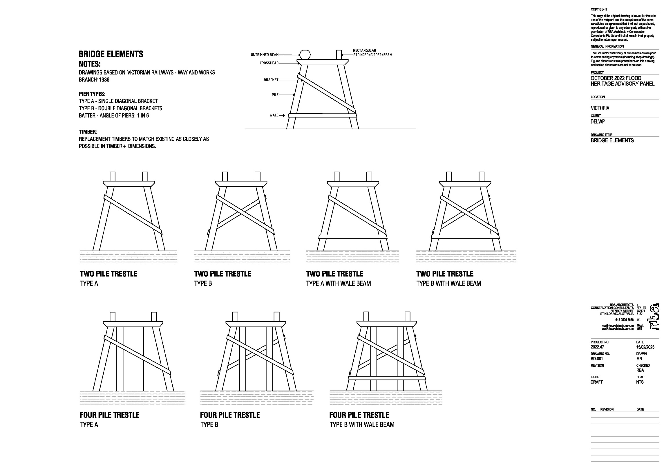

Generic repair drawings
The following repairs to timbers are generic for timber bridges.

Resources | VicRoads Bridge Maintenance and Repair Manual July 2018:  https://www.vicroads.vic.gov.au/business-and-industry/technical-publications/bridges-and-structures  https://www.ses.vic.gov.au/plan-and-stay-safe/emergencies/flood  Environmental Protection Authority Victoria – How to clean up after a flood  https://www.epa.vic.gov.au/for-community/how-to/clean-up-after-a-flood

