Maritime Heritage at Risk Program

Annual Report: 2022/23

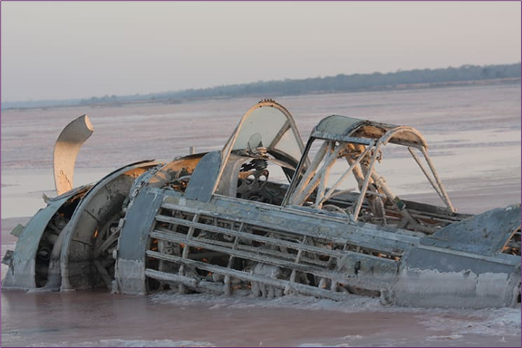

The Maritime Heritage at Risk Program delivers site management initiatives to protect Victoria’s most significant at-risk shipwrecks and other maritime heritage such as submerged aircraft wrecks.

The most significant at-risk shipwrecks are actively managed through a Risk Register with the aim of minimising their further deterioration. In 2022/23 there were 25 shipwrecks on the Register including three wrecks (*Clarence,* P.S *Clonmel* and *Thistle)* thatare currently buried.

The 2022/23 Annual Report includes information on conservation, monitoring, compliance and inspections conducted at wreck sites. In addition, data is collected on the current condition and potential future risk to wrecks.

The program was expanded in 2022/23 to include On Watch* shipwrecks and submerged aircraft wrecks.

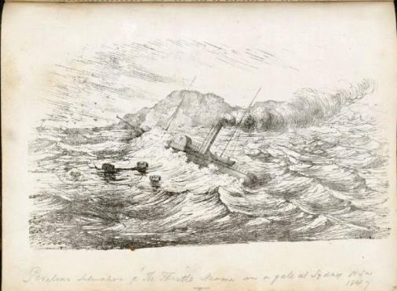

Baker. W “Perilous situation of “The Thistle” steamer in a gale at Sydney, N.S.W 1847”.

Source: Public Domain

Note (*): On Watch wrecks are high significance wrecks assessed as being at medium risk and medium significance wrecks assessed as high risk.

ON WATCH WRECKS

The Maritime Heritage at Risk Program uses a quantifiable methodology to assess a wreck’s significance and the level of risk associated with environmental and human factors. Based on the outcomes of these assessments, one of three site management actions is assigned to the wreck based on a significance-risk matrix. No Action (green), for sites where risk and significance are low to medium or are offsetting; On Watch (yellow), for sites that require periodic monitoring; or Maritime Heritage Risk Register (red), for sites of high significance and risk.

High significance wrecks assessed as medium risk and medium significance wrecks assessed as high risk are included on the On Watch list (see page 10 for details). Periodic monitoring is then conducted at these sites given that pre-emptive action is likely to be less resource intensive than when a wreck has been included on the Maritime Heritage Risk Register.

Currently there are 16 shipwrecks on the On Watch list and two aircraft wrecks included on a provisional basis (see Submerged Aircraft Wrecks section below).

SUBMERGED AIRCRAFT WRECKS

When the Maritime Heritage at Risk (MHR) Program was envisaged in 2016 the intention was to commence with shipwrecks and subsequently include submerged aircraft wrecks.

In March 2023 Heritage Victoria initiated a study aimed at developing a comprehensive database of all submerged aircraft wrecks in Victoria from 1909 to the present.

The aircraft wrecks in the database would then be assessed with a modified MHR methodology with the most significant at-risk aircraft wrecks included in the MHR program. This will enable Heritage Victoria to initiate active site management of those aircraft wreck sites including the safeguarding of human remains.

To 30 June 2023 initial data has been obtained on 110 submerged aircraft wrecks across all aviation categories including general aviation, commercial and military aircraft.

While the database will not be completed until the end of 2023 and the aircraft wrecks have not been comprehensively assessed as a full collection, it has been decided that two aircraft wrecks, Fairey Firefly (serial no: PP589) and Fairey Firefly (serial no: TW677), will provisionally be included in the 2022/23 MHR program because of the previously reported presence of human remains.

SITE MANAGEMENT ACTIVITIES: 2022/23

The key site management activities conducted in 2022/23 were:

|  |  |
| --- | --- |
| **ACTIVITY** | **LOCATION** |

|  |  |  |
| --- | --- | --- |
| Conservation | Amazon | S.S City of Launceston |

|  |  |  |
| --- | --- | --- |
|  |  |  |

|  |  |  |
| --- | --- | --- |
| Shipwreck Monitoring | Clarence | S.S City of Launceston |
| William Salthouse | P.S Thistle |
| Alert | S.S Glenelg |
| Joanna | Cheviot |
| Mountain Maid | S.S Cambridge |
| S.S Conside | S.S Queensland |
| Coogee | Amazon |

|  |  |  |
| --- | --- | --- |
|  |  |  |

|  |  |  |
| --- | --- | --- |
| Port Monitoring | Port Albert | Port Welshpool |
|  |  | |
| Compliance | Ongoing activities. |  |

|  |  |  |
| --- | --- | --- |
|  |  |  |

|  |  |  |
| --- | --- | --- |
| Inspections | *City of Launceston* | Mountain Maid |
| Monarch | Fairey Firefly (PP589) |

|  |  |  |
| --- | --- | --- |
|  |  |  |

CONSERVATION

Amazon

*Amazon* was a 402 ton, wooden barque​ built in Jersey (Channel Islands), England in 1855. The vessel was an international trader​ and left Melbourne on 12 December 1863 for Mauritius with a cargo of salted meats. The *Amazon* was struck by a gale in Bass Strait and subsequently wrecked at Inverloch on 16 December 1863.​

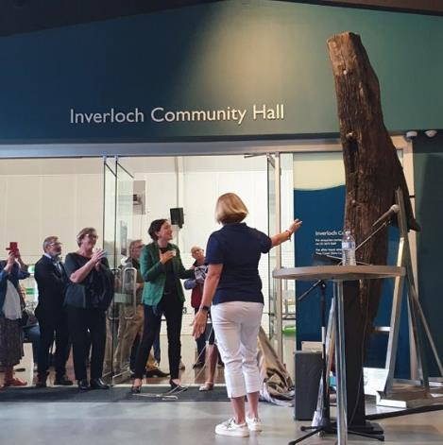The wreck continued to undergo significant changes in sand cover in 2022/23. From July to November 2022 there was a gradual loss of sand cover over the bow material on the beach culminating in January 2023 when part of the hull, frames and other wooden fragments were exposed. From February 2023 onwards the bow remains were progressively covered by sand until they became close to completely buried by May 2023. The majority of the wreck material underwater has remained consistently buried through 2022/23.

During the year regular meetings were held with The Amazon 1863 Project Inc community group to discuss conservation and community activities.

A community day with the group was held in August 2022 including a presentation and artefacts display. 

Photo: *Amazon* deadwood artefact display Source: Heritage Victoria

In April 2023 Heritage Victoria visited The Amazon 1863 Project Inc and Parks Victoria to provide a presentation and catalogue artefacts in their possession.

S.S City of Launceston

Continuation of conservation activities (provided by Professional Diving Services) including the installation and maintenance of zinc anodes to stabilise the condition of the wreck.

WRECK MONITORING

The Community Shipwreck Monitoring Program commenced in November 2018 and is now in its sixth year of operation. Queenscliff, Werribee, Port Albert and Port Welshpool Volunteer Coast Guards and Inverloch Surf Life Saving Club monitor and report on human interference at fourteen important high risk wreck sites, including six Protection Zones.

This program enables Heritage Victoria to receive timely information and provide a more rapid response to human interference at wreck sites. It also provides ongoing monitoring of wrecks which cannot be regularly monitored by Heritage Victoria maritime archaeologists.

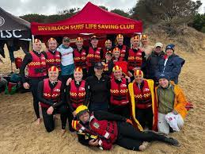

Photo: Inverloch Surf Life Saving Club members

Source: Inverloch Surf Life Saving Club

The participants conducted 96 site visits to shipwrecks during 2022/23. Most alerts were for the *City of Launceston* wreck site.

The program is supported with funding from the Commonwealth Department of Climate Change, Energy, the Environment and Water.

PORT MONITORING

There were 22 port monitoring visits conducted by Port Albert and Port Welshpool Volunteer Coast Guards during 2022/23. This includes the monitoring of diving vessel activity at jetties and boat ramps.

Professional fishers were active at both locations but there was no indication of diver activity.

COMPLIANCE

Compliance visits were undertaken by Heritage Victoria during boating and diving operations. A handful of vessels were educated about Protection Zones, particularly at the *City of Launceston* wreck site.

In 2022/23 a report was made to the Commonwealth Government on an advertisement in a popular website offering to purchase artefacts from a Dutch shipwreck in Western Australia.

A dive website was contacted to request the removal of information encouraging diving at a Protected

Zone shipwreck. The website is no longer available.

INSPECTIONS

Four inspections and risk assessments were conducted during 2022/23.

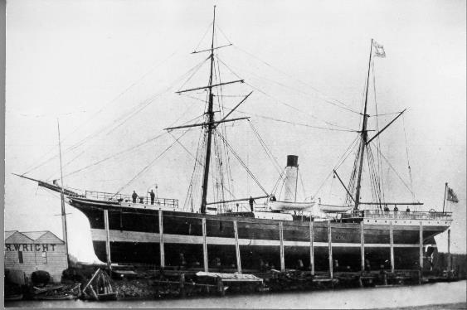

**S.S *City of Launceston***was an iron screw intercolonial steamer built in Glasgow, Scotland in 1862.On its final voyage it collided with SS *Penola* on 19 November 1865 and sank without loss of life. In March 1982 *City of Launceston* became the first shipwreck to be declared an Historic Shipwreck under Victorian legislation.

The *City of Launceston*was visited by Heritage Victoria on 30 December 2022. The purpose of the visit was to survey and photograph the wreck to assess any damage. The wreck was last visited in January 2021.

S.S *City of Launceston* on Wright’s Slip, Williamstown.

Source: State Library of Victoria

The survey indicated that there has been some degradation since the last visit in an area just before the bow. However, features on the deck including the hatch, funnel and engine cylinder were visible with no noticeable damage.

During the visit, five vessels were detected fishing within or near the Protection Zone. Information on those vessels was collected and those on board reminded of their responsibilities not to fish in the area.

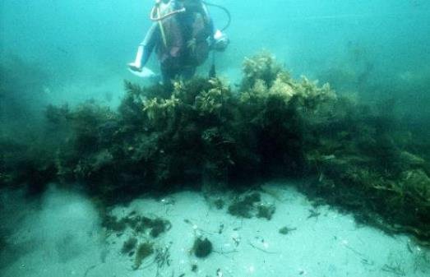

In July 1867, the ***Monarch*** - on a voyage from Melbourne to Newcastle - grounded on a bank in Port Phillip Bay in heavy seas. Attempts to re-float the ship failed and it eventually sank. Monarch was a wooden barque built in Southampton, England in 1836.

The wreck of Monarch was visited by Heritage Victoria in December 2022. The site was completely buried and no significant disturbance detected.

Photo: *Monarch* site. Source: Heritage Victoria.

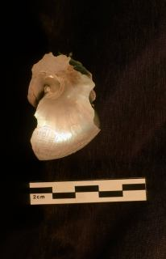

***Mountain Maid*** was a small two-masted wooden brig built as a trading vessel in Dundee, Scotland in 1841. Returning from Manila in 1856 with a cargo of rice, sugar and rope the vessel *was* wrecked after colliding with SS *Queen* in the West Channel of Port Phillip Bay on 24 September 1856.

*Mountain Maid*was visited in December 2022 following reports of increased fishing activity and anchoring in the area.

The portside of the hull lies flat in five metres of water and is covered by sand and shell debris. The starboard side of the hull is missing with wreckage spread over an area of about 600 square metres. There are intact areas of the wreck including exposed planking and framing timbers.

Overall, the condition of the wreck is stable with no visible damage from human interference.

Photo: *Mountain Maid* artefact.

Source: Heritage Victoria.

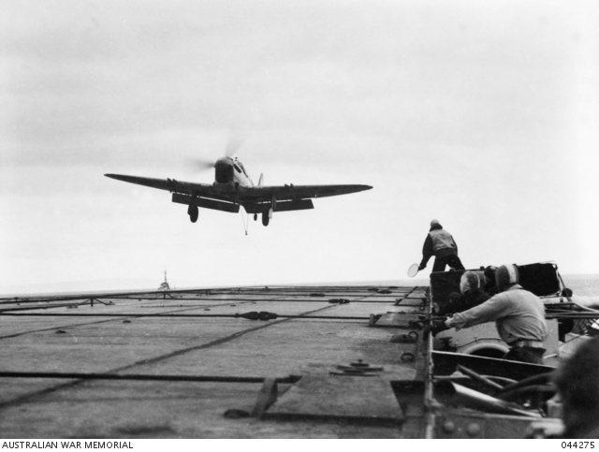In July 1947 two British Navy **Fairey Firefly** aircraft operating off the aircraft carriers HMS *Theseus* and HMS *Glory* collided mid-air and crashed into Port Phillip Bay off Frankston.

The site of one of the aircraft, Fairey Firefly(PP589) was visited on 23 March 2023.

The location is a silty, flat site about 24 metres deep limiting dive time to about 20 minutes. Visibility at the location was very poor (0-2 metres) on the day and the wreck could not be located.

Heritage Victoria is planning to return to both Fairey Firefly sites in the winter of 2024 when visibility is likely to be better.

Photo:Fairey Firefly landing on HMS *Glory* c.1951. Source: Australian War Memorial.

RISK REGISTER: 2022/23

The following were identified to be the most significant Victorian shipwrecks at the highest risk in 2022/23.

| **Priority** | **Shipwreck** |
| --- | --- |
| 1 | Amazon |
| 2 | P.S Clonmel* **(currently buried)** |
| 3 | S.S Conside |
| 4 | Loch Ard |
| 5 | Monumental City |
| 6 | Thistle **(currently buried)** |
| 7 | Barbara |
| 8 | Cerberus (H.M.V.S)* |
| 9 | Cheviot |
| 10 | S.S City of Launceston* |
| 11 | Clarence* **(currently buried)** |
| 12 | Nautilus |
| 13 | Countess of Hopetoun (H.M.V.S) |
| 14 | P.S Thistle |
| 15 | William Salthouse* |
| 16 | Alert* |
| 17 | S.S Cambridge |
| 18 | Carlisle |
| 19 | Lady Mary Pelham |
| 20 | M.V City of Rayville |
| 21 | T.S.S Coramba |
| 22 | S.S Glenelg* |
| 23 | S.S Gulf of Carpentaria |
| 24 | S.S Kanowna |
| 25 | S.S Queensland |

* Protected Zone wrecks

ON WATCH LIST: 2022/23

Following are the Victorian shipwrecks and aircraft wrecks on the On Watch list in 2022/23.

| **Shipwreck** | **Location** | **Date Lost** |
| --- | --- | --- |
| S.S *Casino* | Apollo Bay. | July 1932 |
| HMAS *Goorangai* | South Channel, Port Phillip Bay. | November 1940 |
| *Monarch* | Between Coles and West Channels, Port Phillip Bay. | July 1867 |
| *Mountain Maid* | Between Coles and West Channels  Port Phillip Bay. | September 1856 |
| *Ozone* | Indented Head, Port Phillip Bay. | March 1925 |
| *Schomberg* | Curdies Inlet, Peterborough. | December 1855 |
| S.S *Ant* | Thirteenth Beach, Barwon Heads. | June 1866 |
| S.S *Auckland* | Beware Reef, near Cape Conran. | May 1871 |
| *Columbine* | Between Barwon Heads and Point Lonsdale. | April 1854 |
| *Coogee* | Ships Graveyard, outside Port Phillip Heads. | February 1928 |
| *Eleutheria* | Port Phillip Bay. | July 1866 |
| *J-7 Submarine* | Picnic Point, Hampton  (Sandringham Yacht Club). | August 1930 |
| *Schah* | Shipwreck Creek, 6 miles SE of Mallacoota. | December 1837 |
| *Victoria Tower* | Point Impossible, west of Thompsons Creek, Breamlea. | October 1869 |
| *W.B Godfrey* | Godfrey Creek, west of Lorne. | March 1891 |
| *Leven Lass* | Little Rookery Beach, Phillip Island. | December 1854 |
| Aircraft Wreck | Location | Date Lost |
| Fairey Firefly PP589 and TW677 | Frankston, Port Phillip Bay. | July 1947 |

OUR PARTNERS

Heritage Victoria would like to thank its partners for their contribution to the program in 2022/23.

| **Activity** | **Partner** |
| --- | --- |
| Conservation | Parks Victoria.  The Amazon 1863 Project Inc.  Professional Diving Services. |
|  |  |
| Wreck Monitoring | Queenscliff Volunteer Coast Guard (VF 9).  Werribee Volunteer Coast Guard (VF 10).  Port Albert Volunteer Coast Guard (VF 19).  Port Welshpool Volunteer Coast Guard (VF 20).  Inverloch Surf Life Saving Club. |
|  |  |
| Port Monitoring | Port Albert Volunteer Coast Guard (VF 19).  Port Welshpool Volunteer Coast Guard (VF 20). |
|  |  |
| Funding | Commonwealth Department of Climate Change, Energy, the Environment and Water. |

## Heritage general enquiries: 03 7022 6390 Email: [heritage.victoria@delwp.vic.gov.au](tel:heritage.victoria@delwp.vic.gov.au)

## 

## Deaf, hearing or speech impaired? Please contact the National Relay Service on

## 133 677 or [www.relayservice.gov.au](http://www.relayservice.gov.au)

**Front Page Photo Credit:**

Wreck of CAC Wirraway (A20-714) in Lake Corangamite, Victoria. Source: Camperdown Chronicle, 23 September 2019.

# 