Useful resources and contacts

Information about preservation
The Australian War Memorial has online conservation guides.
See: www.awm.gov.au/collection/conservation/
The State Library of Victoria has online conservation guides.
See: www.slv.vic.gov.au/explore/conservation-guides
Heritage Victoria has a number of brochures about preserving heritage.
See: www.dpc.vic.gov.au/heritage/publications-and-research/technical-information
The Australian Institute for the Conservation of Cultural Material provides information about conservation.
See: www.aiccm.org.au
reCollections is website with detailed information about caring for heritage materials.
See: www.collectionsaustralia.net/sector_info_item/3
Museums Australia (Victoria) has a series of online information sheets as well as the Small Museums Cataloguing Manual.
See: www.mavic.asn.au/resources
The Department of Veterans’ Affairs (DVA) produces a useful online guide called Caring for Your Wartime Memorabilia.
See: www.dva.gov.au/aboutDVA/publications/commemorative/memorabilia
The National Library of Australia produces a useful resource for small heritage organisations called Preserving Australia’s Documentary Heritage: A Starter Kit for Community Groups.
See: www.nla.gov.au/services/starterkitcommunity.pdf

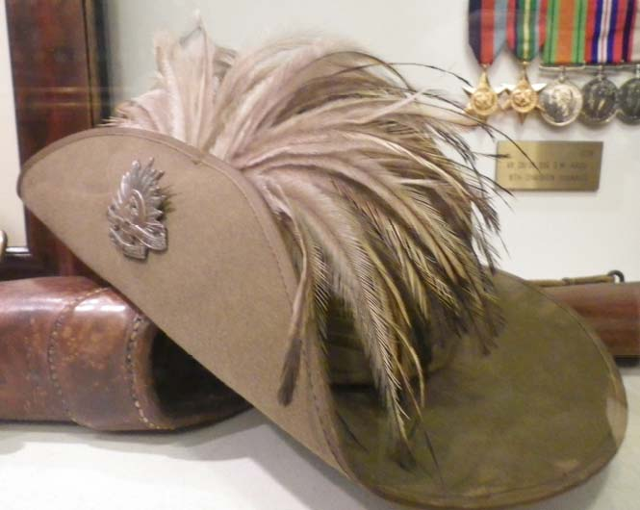
The following Australian organizations have lists of suppliers of conservation materials on their conservation resources pages:
- ‘Products and Suppliers List’, Powerhouse Museum:
www.powerhousemuseum.com/pdf/preservation/products_and_suppliers.pdf
- ‘Specialist Services and Suppliers’, Australian War Memorial:
www.awm.gov.au/collection/conservation/suppliers/
- ‘Preserving Physical Records’, National Archives of Australia:
www.naa.gov.au/records-management/agency/preserve/physical-preservation/index.aspx
There are a number of very useful resources offered by organizations overseas which are easily accessible on the internet:
- The US National Parks Service Museum Management Program publishes Conserv-o-grams and the Museum Management Manual.
See: www.nps.gov/history/museum/publications/
- The American Institute for Conservation publishes Caring for your treasures.
See: www.conservation-us.org
- The Canadian Conservation Institute publishes a ‘Caring For’ series
See: www.cci-icc.gc.ca
- The UK Institute of Conservation’s Conservation Register publishes conservation fact sheets.
See: www.conservationregister.com/

Training in heritage skills
The following organisations provide training for Victorian RSLs and other community organisations which care for veterans heritage collections.
Museums Australia (Victoria)
Museums Australia provides Community Collections Training which is offered on a regional basis and includes workshops in significance assessment, collection management, preventive conservation and interpretation. Contact Museums Australia (Victoria) or see:
www.mavic.asn.au/events-training
Museums Australia (Victoria) also coordinates Victorian Collections. This is a free, online cataloguing system that will enable community museums and galleries, historical societies, sporting, church, armed forces and other service groups to record their local heritage and culture to ensure collections are well-documented for the future. If you would like to be involved contact Museums Australia (Victoria) on (03) 8341 7344 or info@victoriancollections.net
The Royal Historical Society of Victoria (RHSV) supports its members in the preservation, organisation and publication of historical records. It is the peak body in Victoria for local historical societies. RSLs are eligible to become affiliates of the RHSV and then may receive assistance about collections management, cataloguing and records preservation. Each year the RSHV holds four seminar days in different parts of Victoria, on topics of interest for local historical societies and other heritage organisations such as RSLs.
Public Record Office Victoria (PROV)
PROV’s Archival Support program provides a range of training in the preservation and conservation of records, records management and digitisation to community based organisations and individuals who care for cultural collections. Contact the Community Archives team at PROV or find out about upcoming workshops and training at:
www.prov.vic.gov.au/communitycollections/training&seminars.asp

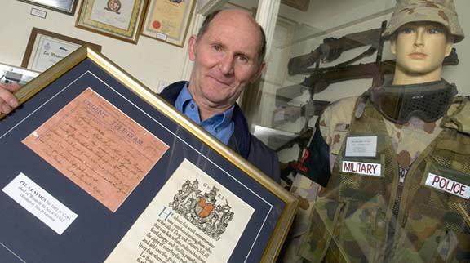

Caring for Heritage Collections Online Course
This online course offered by The Centre for Cultural Materials Conservation (CCMC) at the University of Melbourne is aimed at people who are caring and responsible for heritage collections, and will be useful and relevant to those working in community museums, historical societies, and with public and private collections. There are four key topics covered in the course, intended to provide information about the main causes of damage to heritage collections, and practical measures that can be employed to reduce the impact of these on the collections. www.cultural-conservation.unimelb.edu.au/students/courses/online.html
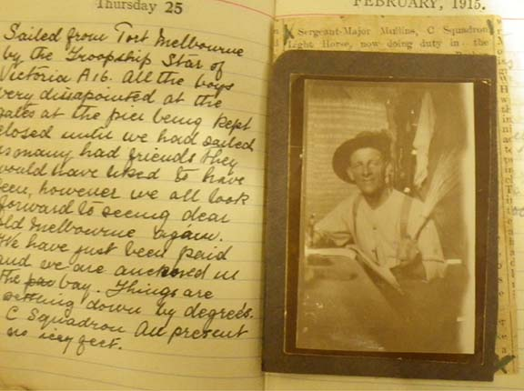

Where can we apply for funding?
RSLs and other community organisations may apply for a variety of grants to develop, conserve and display their veterans heritage collections. In most instances RSLs will meet the definition of ‘community museum’, ‘historical society’ or ‘community collecting organisation’. Check your eligibility with funding bodies before applying.
The following list provides details of potential funding sources. It is not exhaustive and it can pay to be creative when thinking about fundraising.
Local History Grants Program
Public Record Office of Victoria (PROV)
PO Box 2100
North Melbourne Vic 3051
Telephone: (03) 9348 5688
Fax: (03) 9348 5656
Email: grants@prov.vic.gov.au
Web: www.prov.vic.gov.au
The Local History Grants Program (LHGP) supports projects that preserve, record or publish Victorian local history. The program is administered by the Public Record Office of Victoria (PROV).
Community Heritage Grants Program
National Library of Australia (NLA)
National Library of Australia
Canberra ACT 2600
Telephone: (02) 6262 1147
Fax: (02) 6273 2545
Email: chg@nla.gov.au
Web: www.nla.gov.au/chg/
The Community Heritage Grants Program is run by the National Library of Australia and aims to preserve and provide access to nationally significant Australian cultural heritage material held by community groups.
Veterans Council Grants Program
Veterans Branch, Victorian State Government
Department of Premier and Cabinet
1 Spring Street
Melbourne Vic 3001
Telephone: (03) 9208 3228
Email: veterans@dpc.vic.gov.au
Web: www.dpc.vic.gov.au/
The Victorian Veterans Fund supports commemoration projects and events of regional and local significance. This includes community education programs, exhibitions or displays, initiatives or activities that honour or commemorate veterans’ service.

Funding to Restore War Memorials an Avenues of Honour
Restoring Community War Memorials and Avenues of Honour Grants Program
Veterans Branch, Victorian State Government
Department of Premier and Cabinet
1 Spring Street
Melbourne Vic 3001
Telephone: (03) 9208 3228
Email: veterans@dpc.vic.gov.au
Web: www.dpc.vic.gov.au/
The Victorian Government’s Restoring Community War Memorials and Avenues of Honour Grants program supports communities in Victoria to ensure local war memorials and honour rolls are restored to their original condition or enhanced to reflect local communities’ service history. Under the program, any Victorian ex-service organisation, local government, school or community organisation can apply for funds to help repair, protect, restore and enhance war memorials and honour rolls.

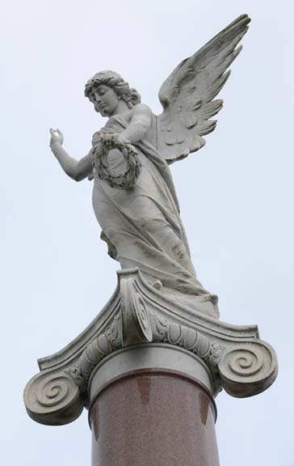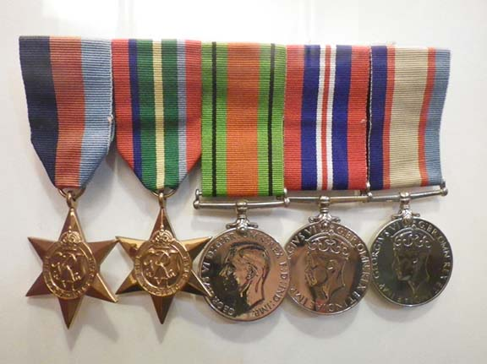

Other funding sources
Arts Victoria
www.arts.vic.gov.au/content/Public/Funding_Programs/Funding_at_a_Glance.aspx

Philanthropy Australia
www.philanthropy.org.au/index.html

Museums Australia (Victoria)
www.mavic.asn.au/services/museum-grants/

Regional Arts Victoria
www.rav.net.au/funding-and-resources/fund

Australia Council for the Arts
www.australiacouncil.gov.au/grants

Department of Families, Housing, Community Services and Indigenous Affairs
Volunteer Grants – Equipment
www.fahcsia.gov.au

Regional Development Victoria
Regional Infrastructure Development Fund (RIDF)
www.business.vic.gov.au/BUSVIC/STANDARD/PC_60276.html

Where can I get this and other fact sheets? The DPC Preserving war heritage and memorabilia fact sheets provide information about the care and conservation of a range of heritage material. They can be downloaded at www.dpc.vic.gov.au/veterans/factsheets
Disclaimer The material contained in this guide is for general reference only and should not be relied upon as the sole basis for heritage conservation or restoration. A professional conservator or conservation architect should be consulted before any conservation or restoration is undertaken. The Victorian State Government does not warrant the accuracy or completeness of the information and disclaims all liability for any loss or damage that may be caused by reliance upon it. Provision of names of suppliers or websites does not imply that a supplier is endorsed or approved by Heritage Victoria or the Department of Premier and Cabinet.

