Medals and medallions

What are medals?
Military medals, decorations and campaign and service awards are generally made from metal which has been cast, struck, moulded, stamped or chased to produce a specific shape or image. They are usually worn on formal occasions and are suspended from a ribbon. The colours and appearances of medals and medallions are very important and should not be altered. Medal ribbons use specific colours which also relate to the particular military campaign.
Military medallions are generally issued for commemorative purposes and are made in a similar way to medals. The presentation cases are an important part of a medal or medallion and should be retained.
What are medals and medallions made from?
- Medals and medallions may be made from copper, brass, bronze, pewter, iron or steel and, more rarely, aluminium, silver or gold.
- Metals and medallions often have a fine layer of a chemical coating called a patina, which creates a specific colour.
- Some medals and medallions may be plated with silver, gold, platinum or rhodium over a base metal such as pewter.
- Lacquers, varnishes or waxes may have been applied to medals and medallions and are often invisible
- Some medals have bars or other items attached to the ribbons.

What are medal ribbons made from?
- Medal ribbons may be made of silk or synthetic fabrics with natural or synthetic dyes.
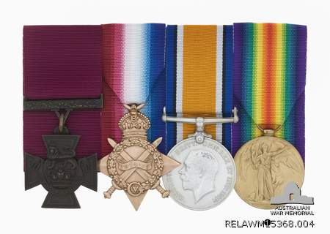

What does ‘patina’ mean?
‘Patina’ refers to a green or brown film on the surface of bronze or similar metals, produced by oxidation over a long period. This photo shows a group of medals, each with a different coloured patina. Note the rich bronze patina on the Victoria Cross (left hand side with the burgundy coloured ribbon). Such a patina is an important part of the medal and should not be rubbed away.
Photo courtesy Australian War Memorial

What are the main threats to medals?
- high humidity
- dust
- salts and pollution
- skin oils and sweat
- neglect
- incorrect attempts at repair or cleaning
- excessive or aggressive polishing
- commercial metal polishes
- theft and loss (as they are small and portable).
- light (affects ribbons, not metal)
- insects and mould (affects ribbons not the metal)

How do these threats damage medals?
- Water, dampness, pollution and salts can cause serious corrosion of metals.
- Corrosion will be faster in wetter areas and near the sea.
- Acid vapours from timber, particle board and industry will tarnish metals.
- Abrasive cleaners can scratch medals and leave disfiguring residues.
- Chemical cleaners strip layers of metal from medals and reduce sharpness.
- Cleaning varnished or waxed medals with chemical or abrasive cleaners will lead to patches of damage.
- Medals stored together or loose in a drawer can dent or scratch each other.
- Dust promotes corrosion by holding moisture onto the metal.
- Dissimilar metals in contact can cause accelerated corrosion of one of the metals (galvanic corrosion).
- Careless handling can lead to accidents, scratching and dents.
- Humidity can promote mould growth on medal ribbons.
- Light will fade the colours and weaken the fibres of medal ribbons.
- Insects can attack silk ribbons, especially in conditions of high humidity.
- Medals have considerable financial value and can be stolen or loose value due to incorrect restoration attempts.

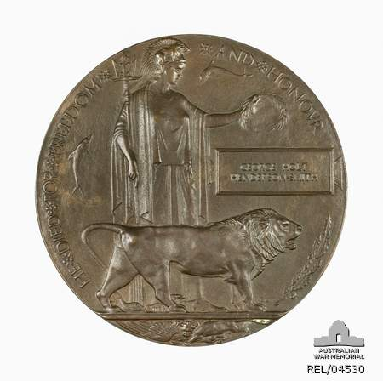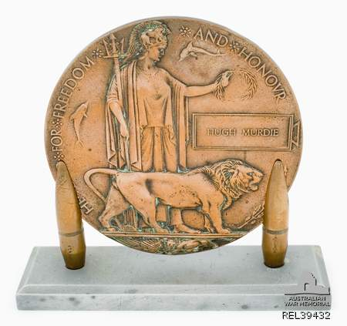

The dangers of polishing – less is more
These ‘Dead Men’s Pennies’ from World War One illustrate the dangers of polishing. The medallion on the left is in excellent condition with its original rich bronze patina that was created by the makers of this sombre commemorative medallion. It has been not been polished and has been stored carefully. By contrast, the medallion on the right has been aggressively polished and has lost its original patina. It is now an unfortunate bright copper colour, which would have been seen as disrespectful at the time of its creation.
When it comes to medals and medallions, less intervention leads to better preservation.
Photos courtesy Australian War Memorial

REMEMBER
- Patina is an essential component of medals and can be very easily removed by over-enthusiastic polishing.
- An important, rare or significant medal deserves professional care from a conservator – never try to clean one of these medals yourself.
- Never put medals with original ribbons on permanent display as the light will fade the ribbons.
- Before you do ANYTHING, consult a metals conservator.
- Before you start, ALWAYS look at the following list of resources. There will be detailed information already available.
- Never give up – something that looks ‘hopeless’ can often be recovered.
- All medals and original ribbons will age – it is the speed at which this happens that you can influence.
- It is not a disgrace for a medal or medallion to look its age and reflect its history.

How to preserve your medals
The key to looking after medals is correct storage and handling.

Cleaning and handling
DO
- Wear cotton or nitrile (not latex) gloves to handle medals, as acid from your fingers will cause tarnish.
- Research before cleaning metals to find out the original colour and patina, and only clean less important medals which are meant to be shiny, and only if you have corrosion prevention storage materials to put them in afterwards.
- Use silver or jewellery cloths to clean medals ONLY if absolutely necessary for display or ceremonial purposes.

DON’T
- Attempt to clean important, rare or significant medals yourself.
- Handle medals with bare hands. Acid from your fingers can mark them.
- Use chemical cleaners or dips on medals and medallions.
- Use any commercial polishes or dips to clean medals or medallions.
- Use commercial polishes or waxes as they often contain silicone which cannot be removed and will complicate future conservation work.
- Wash original medal ribbons. The dyes can run and bleed into each other.
- Iron original medal ribbons – the heat and pressure weaken the fibres.

Storage
DO
- Keep medals in a clean and dry place away from extremes of temperature, light and humidity.
- Store medals in boxes made from acid-free cardboard. Hoop pine plywood may also be used but must be coated (see below).
- Ensure that display boxes are lined with acid free cardboard and frames have acid free cardboard mounts.
- Coat the interiors of timber or plywood storage and display boxes and frames with several coats of shellac, clear acrylic or low Volatile Organic Compound (VOC) acrylic paint which must be allowed to dry for three months before the medals are installed.
- Use corrosion prevention storage materials: they will protect your medals. You will find a list of corrosion prevention storage materials at the end of this flyer.
- Wrap medals if it is not possible to buy corrosion prevention storage materials. Materials such as polyethylene or polypropylene (not PVC) plastic bags; acid-free, alkaline buffered tissue paper or well washed cotton and linen fabrics such as sheets, handkerchiefs or tea towels may be used, but it is likely that tarnish will still occur.
DON’T
- Store medals in PVC sleeves – PVC corrodes metal.
- Store medals in standard cardboard particle board or plywood boxes, or wooden boxes designed to hold coins. These materials produce acids which can harm metals and ribbons.
- Wrap medals in new, brightly coloured fabrics. Some contain finishes or dyes which can cause metals to corrode.
- Wrap medals in woollen felt because the sulphur in wool can cause metals to tarnish.
- Expose medals to dampness. The metal will corrode and the fabric will can become mouldy.

Display
DO
- Display medals which have lost their original ribbons. You can attach replica ribbons and it does not matter if these fade. Make sure you sew a small label onto the back of the new ribbon to record that it is a modern replacement.

DON’T
- Put medals with original ribbons on permanent display – the ribbons will fade and weaken.

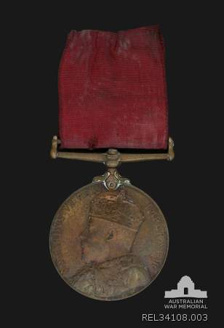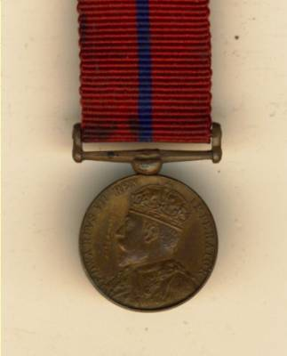
Medal with correct ribbon
https://www.dixonsmedals.co.uk/product_info.php?products_id=1015806&osCsid=jm634s8jd2cfa9bttfs7jj64s4https://www.dixonsmedals.co.uk/product_info.php?products_id=1015806&osCsid=jm634s8jd2cfa9bttfs7jj64s4https://www.dixonsmedals.co.uk/product_info.php?products_id=1015806&osCsid=jm634s8jd2cfa9bttfs7jj64s4
Front of medal

What’s wrong with this medal?
This medal is a Metropolitan Police Bronze Coronation Medal (1902). For an unknown reason the ribbon has been replaced with the wrong one. The correct ribbon for this medal is a lighter red with a blue stripe down the middle. The colour and pattern of ribbons is just as important as the medal. If your medal is missing its ribbon, you may like to contact the Australian War Memorial for advice and referral to a medals specialist. Always keep original ribbons for reference purposes.
Photo courtesy of Australian War Memorial

Is a ‘shiny’ medal always good?
In the military, some medals are supposed to look shiny. Once they have become part of a heritage collection, their use is different. Regular polishing will slowly remove layers of metal. Medals should be kept for future generations to learn from. It is best to keep most medals unpolished, and instead polish duplicate and less important medals. Once medals are polished they should be stored in corrosion prevention bags (see list below).

Should I polish my medals?
Do not polish medals unless it is absolutely necessary for display or ceremonial purposes. Repeated polishing is abrasive and will dull the design of the medal over time. Every time a medal is polished some of the metal is lost. Some medals have patina or a gilded (gold-plated) layer which is easily polished away.
If you must polish your medal, this should be done without the ribbon attached using a silver or jewellery cloth.
Instructions for safely polishing medals
The Australian War Memorial website (see below) has detailed instructions on how to remove ribbons and polish medals safely.

Where can I buy acid-free boxes and other museum quality products?
Museums Australia (Victoria) has compiled a Museum Suppliers list. This contains the contact details of speciality suppliers which sell materials for the proper storage and display of heritage items. www.mavic.asn.au

RESOURCES
There are many publications available with more detailed information. Much of the information on medals is also relevant to medallions.
- ‘Conservation: Medals’, Australian War Memorial www.awm.gov.au/collection/conservation/medals/
- ‘Medals’, Department of Veterans Affairs www.dva.gov.au/aboutDVA/publications/commemorative/memorabilia/Pages/page%2011.aspx
- ‘How to Clean Medals’, Department of Veterans Affairs www.dva.gov.au/aboutDVA/publications/commemorative/memorabilia/Pages/page%2022.aspx
- ‘Cleaning Medal Ribbons’, Department of Veterans Affairs www.dva.gov.au/aboutDVA/publications/commemorative/memorabilia/Pages/page%2012.aspx
- ‘Basic Care of Coins, Medals and Metallic Art’, Canadian Conservation Institute

www.cci-icc.gc.ca/publications/notes/9-4-eng.aspx
- ‘Looking after Silver’, Powerhouse Museum www.powerhousemuseum.com/pdf/preservation/looking_after_silver.pdf
- reCollections: Caring for Collections Across Australia www.collectionsaustralia.net/sector_info_item/3

Corrosion prevention storage products
- Products and Suppliers List, Powerhouse Museum www.powerhousemuseum.com/pdf/preservation/products_and_suppliers.pdf
- Impregnated Silver and Brass Storage Bags – Purchase at department stores. Brands include Hagertys, Silverguard and Inca.
- Corrosion Intercept Bags: www.underraps.com.au/intercept_pages/corrosion_intercept.html
- Storage bags and showcase linings can be made from activated charcoal or silver impregnated fabric (see Powerhouse Museum list for suppliers).
- Oxygen free storage, KeepSafe Anoxic storage

keepsafe.ca/new-main-menu/products/oxygen-free-display-storage/anoxic-storage/

Where can I get this and other fact sheets? The DPC Preserving war heritage and memorabilia fact sheets provide information about the care and conservation of a range of heritage material. They can be downloaded at www.dpc.vic.gov.au/veterans/factsheets
Disclaimer The material contained in this guide is for general reference only and should not be relied upon as the sole basis for heritage conservation or restoration. A professional conservator or conservation architect should be consulted before any conservation or restoration is undertaken. The Victorian State Government does not warrant the accuracy or completeness of the information and disclaims all liability for any loss or damage that may be caused by reliance upon it. Provision of names of suppliers or websites does not imply that a supplier is endorsed or approved by Heritage Victoria or the Department of Premier and Cabinet.

