Roof and Rainwater Goods

About this technical note
This technical note was prepared by Greg Owen (Period Building and Conservation) in collaboration with Heritage Victoria in response to the 2022 Victorian floods.
Flooding can result from rising water levels, like rivers and drains, as well as rainwater overflowing from roofs and drainage systems during heavy rainfall. This note focuses on how to manage the risk of rainwater flooding in heritage buildings. Climate change is causing more frequent and intense heavy rain events, so we need to make our heritage structures more resilient to handle this added pressure while preserving their historical value.

There are several ways to protect buildings from rainwater flooding:

- Cladding typically guides rainwater away from the building, usually toward its edges.
- Gutters and rainwater systems, such as eave gutters or roof gutters (like box gutters and valleys), divert rainwater to a suitable discharge point and prevent it from falling on people entering or exiting buildings. Although eave gutters aren't mandatory, buildings with wide eaves and ground surface drainage beneath the drip line can also effectively keep water away from the structure. These systems must now be designed to handle high-intensity rainfall events that have occurred regularly in most parts of the state for many years. The design for eave gutters is based on a 1 in 20 year 5-minute rainfall intensity, while box gutters, which could cause damage when overflowing, use a 1 in 100 year 5-minute intensity. In the 19th and early 20th centuries, buildings did not use such precise calculations and instead relied on past practices, often from other countries.
- Safe overflow points are integrated into the gutter and rainwater system to allow water to escape to a safe area when the system cannot manage the water load, such as when there are blockages. Ideally, the system should have multiple safe overflow points to protect against blocked eave gutters, eave gutter outlets, rain heads, downpipes, and stormwater drains. These points should direct overflow water away from the building onto the ground, which should slope away from the structure toward surface drainage

Protection from rainwater flooding can be reduced by implementing protocols as part of a Disaster Management Cycle to avoid or mitigate risks at various stages of any future flood event:

The following tasks are recommended to manage risks during future flood events, in reference to the Disaster Risk Management Cycle.

Risk Management Cycle

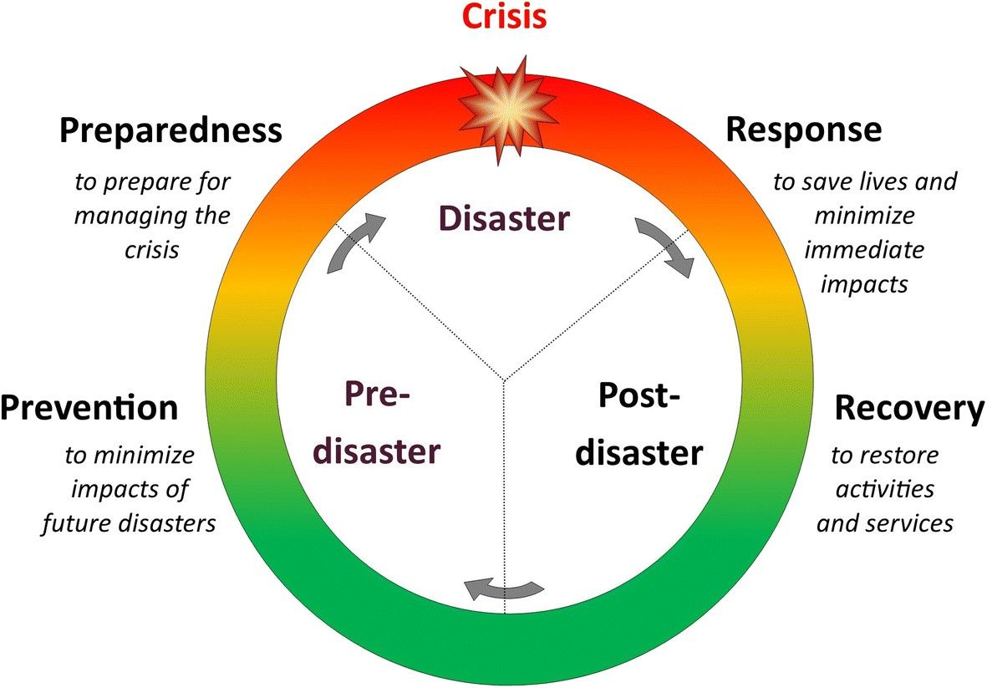
Figure 6: Risk Management Cycle – providing clarity to disaster process.

Note:
- Engage a heritage consultant to determine a scope of works.
- If your place is included in the Victorian Heritage Register or is an archaeological site, under the Heritage Act 2017 you are obligated to contact Heritage Victoria for a pre-application meeting before starting any works to apply for a permit or permit exemption.

Risk management approach
Stage | Approach | Strategies
Prevention | Plan | - Have the condition of roof and rainwater goods inspected by someone skilled in heritage roofs. This can often be done easily, even in difficult to access roofs, by the use of drones, but the inspector will prefer to go to site and take their own photos, as they need them in high resolution and of key points on the roof.  - Keep your roof and rainwater goods in good order, particularly your gutters, both the ones up on the roof (roof gutters) and on the eaves (eave gutters). If you have trees around have them checked regularly for leaves and blockages and clear them as necessary. Checks can be made by drone if it is difficult or unsafe to access the roof or gutters. Take high resolution still photos, not videos, close to the areas you need to look at and blow them up on your computer.  - Have your rainwater goods checked for flow adequacy. Many heritage buildings have both inadequate flow capacity for high intensity rain events, poor safe overflow provisions and vulnerable building fabric and contents, meaning they overflow more often, and the consequences are significant. We are also seeing higher intensity rain events more frequently with climate change and buildings need to adapt to be resilient. Consider increasing the flow capacity of the system if heritage significance is not adversely affected.  - Have your rainwater goods checked for safe overflow provisions. Whilst we plan for the system to be able to handle at least 1 in 100-year rainfall intensities, things happen. A tennis ball can block a downpipe, birds die in the gutters, pigeons love to nest in rain heads! When these things happen, we need a plan B, and that is provisions built into the system that allow overload flows to safely discharge to the ground without damaging building fabric.
Preparedness | Awareness | - If there is warning of an impending storm or prolonged rain event:  - Double check the gutters and other rainwater goods are clean and fully operational.  - Cover and/or move floor coverings, furniture, built in cupboard contents etc, where possible, from places where there are known problems with flash flooding from above, such as under inadequately sized box gutters.  - Consider sandbagging and polythene sheet, or other means, to build an internal levee on the floor below known problem spots, to encourage the water to flow directly out of the building rather to other areas inside or underneath. Buckets and even wheelie bins will soon overflow in such events if trying to catch the inflow.  - Ensure the equipment required to respond to an inundation is available, e.g. sandbags & polythene sheet, air recording data recorders, pumps, etc.
 | Consider | - If many buildings are likely to be inundated, e.g. a whole low-lying town or suburb, consider that there may be difficulty accessing flood restoration contractors, and suitable equipment quickly to respond to the event. You may choose to have some equipment/materials permanently onsite and have some people trained in their use for your site. These equipment/materials would need to be regularly serviced/checked to ensure it is operational when you need it.  - If flooding of the building is a regular occurrence, consider raising susceptible equipment and materials to above high flood level. Consider using free standing furniture instead of built-in furniture so it can be removed before flooding. Consider wall hung cupboards in bathrooms/toilets and stainless-steel framed benches with stainless shelves in kitchens etc.  - If there are timber floors and they are clear finished, consider using breathable finishes rather than the common lacquers most floor polishers recommend. Many oils and hard waxes offer much better breathability and allow some evaporation from the top surface of the flooring in the recovery phase, reducing floor cupping and speeding drying. Common polyurethane and other lacquers seal the top surface of the flooring allowing minimal drying from that surface, post inundation. Most oils and hard waxes also offer the benefit of not requiring sanding before recoating which means your flooring lasts a lot longer, before replacement.  - Consider, in conjunction with the impacts on significance, creating sensible access provisions to hidden spaces in the building, e.g., in roof spaces not normally accessible and with slate roofs that cannot be easily opened up. This will allow a much quicker response to problems in the response and recovery stages.
Response | Check | Check inside and out, during the event to see where water is overflowing from the rainwater goods system and might cause damage. Don’t worry if it is safely overflowing directly onto the ground, this is often an intentional safe overflow point in the system and shouldn’t cause damage. If there are any obvious blockages causing overflowing, e.g., leaves washed down to outlets, remove these if it is safe to do so. Yes, you may get very wet!
 | Action | - If not already done so:  - Cover and/or move floor coverings, furniture, built in cupboard contents etc, where possible, from places where there are known problems with flash flooding from above, such as under inadequately sized box gutters.  - Consider sandbagging and polythene sheet, or other means, to build an internal levee on the floor below known problem spots, to encourage the water to flow directly out of the building rather to other areas inside or underneath. Buckets and even wheelie bins will soon overflow in such events if trying to catch the inflow.
Recovery | Clean up | - If substantial amounts of water enter the building and flow down under the floor, consider recovery recommendations in Heritage and floods: impact on building footings and Heritage and floods: looking after flood affected masonry.  - Sweep out, wet vacuum and wipe out as much water as possible as soon as possible after the event, from floors, walls, roof spaces, furniture etc.  - Visually investigate normally hidden spaces such as subfloor spaces and roof spaces to check for moisture levels and any damage and to determine if they need drying.  - If the external ambient air has a humidity of at least 10% lower than the affected interior space, start ventilating the space with fans. Fans can blow into the building from outside or from inside the building to outside. Ducted fans are best with the duct sealed to windows etc. Arrange fans so that the air moved by fans has to travel right across the building to exit, e.g. fans one side, windows open the other side. If this sort of equipment is not available, remember, any ventilation is better than none. If the outside air has a similar humidity to the subfloor space, don’t bother ventilating, but try to expedite dehumidified air drying as per below.  Engage flood restoration professionals to drop the humidity of the building air to start the drying out of any masonry walls, plaster and timberwork. This may be done using professional industrial dehumidifiers blowing air into the space or drawing air out and blowing it back into spaces. The moisture load is too high for domestic dehumidifiers to be effective. The lower humidity air must circulate roughly evenly to all parts of all rooms. This may require more ducting to release it at the far corners of a space to allow it to pass over the whole space before exhausting or recycling.
 | Salvage | - If substantial amounts of water enter the building and flow down under the floor, consider recovery recommendations in Heritage and floods: impact on building footings
 | Resilience | Review of the Disaster Management Cycle and efficacy of the emergency response will improve future flood response measures.

Consider:
CHANGING CLIMATE | Our climate is changing, and intense rainfall events are becoming more frequent and intense. What used to be 1 in 200 or 1 in 100-year heavy rain events might now happen more often, like every 50 or 150 years. This means the old way of designing for these events using historical data might not protect our buildings as well in the future. It's advisable to design for more intense rainfall events than before.
HERITAGE BUILDING ROOF DESIGN | Traditional roofs were designed for claddings, but they often became complex for aesthetic reasons. They weren't always well-planned for the function of gutters and rainwater systems. Traditional roofs often had many hips, valleys, and complex designs, which made the hydraulic design more complicated. If you have such a roof, it's best to seek professional advice.
CONTEMPORARY LEGISLATIVE REQUIREMENTS & HYDRAULIC DESIGN | In Victoria, licensed roof plumbers must handle metal roofing, gutters, and rainwater systems, regardless of the cladding. All installations must meet current design requirements, including hydraulic design, based on the Plumbing Code of Australia. You can meet these requirements through standard methods or a specially prepared solution. However, some heritage buildings may not fit the standard methods, like narrow box gutters or those that change direction. Upgrading the original design may be needed.
HERITAGE RESPONSE TO LEGISLATIVE AND CLIMATE REQUIREMENTS | While altering the original design of a heritage building to meet current legislative requirements may not be ideal, it can help the building withstand future weather conditions. If you're making changes, consider future-proofing the design to handle expected future challenges. For example, design eaves gutters for a 1 in 100 or 150-year event instead of the standard 1 in 20 years. If the building has vulnerable elements, like plastering or wall decorations, design the box gutter for a 1 in 150 or 200-year event, or at least investigate the implications of such an upgrade.

