Wooden objects

What are wooden objects?
Many war-related objects are wooden, including furniture, carvings, ship models, functional items and boxes.

What materials are wooden objects made of?
- Timber. The timbers used to make objects were chosen for their appearance, availability, ease of working and cost.
- Paint, varnish or wax. These materials were used to change, darken or enrich the colours of the wood, and to protect it. A wide variety of natural paints and varnishes were used. Paints included oil, casein and water based paints. Varnishes included amber, shellac, dammar, copal or pine resins. From the 1920s cellulose nitrate, PVA, acrylic, epoxy and other synthetic paints and lacquers are also found. Waxes included beeswax and carnauba.
- Other materials such as inlays, metal hardware, leather or upholstery. See the flyers on these topics for information on the care of these materials

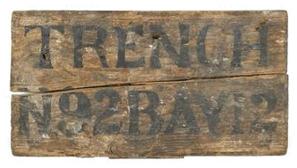Would you fix and polish this wooden sign?
This is an improvised trench sign used at Fromelles during World War One. It was found in the British trenches from which both the Australians and British advanced in their attack on Fromelles on 19 July 1916. The wear and damage demonstrate the difficult conditions it has gone through and tells us something of the challenging conditions during the Fromelles campaign.
This historical evidence would be lost if it was cleaned or restored to brand new appearance.
Photo courtesy Australian War Memorial.

What are the main threats to wooden objects?
Moisture in all its forms is the main enemy of timber and can cause many types of deterioration. Human intervention is also a major cause of damage. Some threats include:

Moisture related threats
- mould
- insect attack
- high and fluctuating humidity and temperature.

Human created threats
- war damage
- light exposure
- accidents
- neglect
- dust
- poorly planned moving or display
- incorrect attempts at repair or cleaning
- excessive or aggressive polishing
- paint stripper
- commercial metal polishes and wood stains.

How do these threats damage wooden objects?
- Water and humidity (high or fluctuating) can cause:
- Warping, joints pulling apart, splitting or cracking.
- Veneer, inlays, varnish or paint to peel, powder or flake.
- Varnish to become dull or blanched (developing a whitish appearance).
- Mould to grow in the wood or on dust, wax or varnish.
- An increased threat of insect attack.

Light and heat can cause:
- Varnish to darken or become more yellow.
- Flaking or ‘alligatoring’ of varnish.
- Paint to fade or discolour.
- People can cause:
- Fading and/or a change in the colour of the wood by exposing objects to direct or excessive light.
- Physical damage and abrasion caused by knocks and falls or battle damage.
- Damage from well intentioned but ill-advised restoration treatments.
- Lack of cleaning causes dust to collect on flat surfaces and become embedded in the wax or varnish causing a whitish appearance.

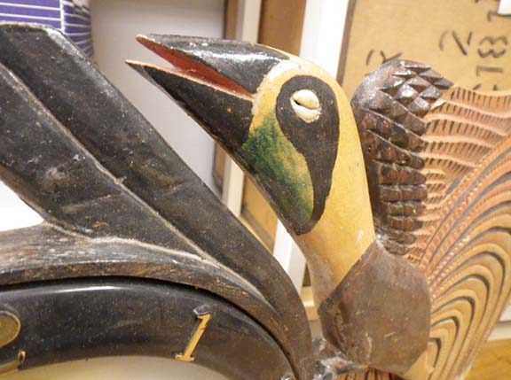The dangers of dust cloths and dusting
This object from Papua New Guinea has delicate carving with many sharp edges. It should be stored fully enclosed in a lidded box to protect the delicate tips.
For storage purposes this item may be covered with a dust cloth, but cloths should be removed carefully to avoid catching and breaking the sharp points. When dusting, care should also be taken to prevent breaking the tips of the fine woodwork. Use soft, dry microfibre or dust attracting cloths to gently remove dust. Don’t use feather dusters or fluffy clothes/fabric to remove dust, as feather fragments or fluff can get caught in splinters or cracks and pull pieces of wood off.
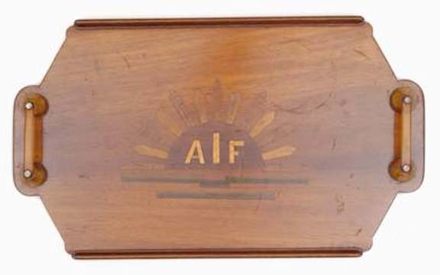Photo courtesy of Australian War Memorial

Marks on wooden objects
This is a wooden drinks tray owned by Major WH Marshall of the Australian Army Medical Corps during World War Two. It was made from wood and service issue toothbrushes and is now characterised by numerous marks (rings and scratches) resulting from its use. These marks are an important part of the tray’s history as a functional item. They enable us to reflect on the role of recreation and social time in the lives of army medical service personnel. These marks should not be removed by repolishing.
Photo courtesy of Australian War Memorial

Varnish and paint can be cleaned and retouched and do not have to be stripped and replaced.

REMEMBER
- The original timber, upholstery, paint and varnish are an important part of the history of any wooden object.
- Varnish and paint can be cleaned and retouched and do not have to be stripped and replaced.
- Many wooden items that appear to be irretrievably damaged can be greatly improved by a conservator.
- The timber of historic items is not living and does not require ‘feeding’. Don’t ‘feed’ them with oils.
- Before you do ANYTHING, consult a conservator.
- Before you start, ALWAYS look at the list of resources at the end of this fact sheet. There will be detailed information already available.
- Never give up – something that looks ‘hopeless’ can often be recovered.
- All wooden items will age – it is the speed at which this happens that you can influence.
- It is not a disgrace for a wooden object to look its age and reflect its history.
- Wooden objects are important and deserve professional care.
- Modern varnishes, stains and new upholstery will make historic wooden objects look brand new and obliterate their history.

Cleaning
DO
- Regularly and carefully dust wooden objects in storage and on display
- Use brush vacuuming or soft, dry microfibre or dust attracting cloths to gently remove dust as outlined below.
DON’T
- Use oil impregnated cloths or brushes, as they will leave residues.
- Use metal polishes on hardware as polish residues will stain wood.
- Use feather dusters or fluffy clothes to remove dust, as feather fragments or fluff can get caught in splinters or cracks and pull pieces of wood off.
- Dust objects if surfaces are flaking or unstable.

Waxes and other coatings
DO
- Consider waxing with clear, microcrystalline wax such as Beckett’s Clear Furniture Wax or Renaissance Wax following the instructions for its use. This will improve the appearance of varnished furniture without making it look brand new.
DON’T
- Ever apply waxes or coatings containing silicone, as this can never be removed.
- Apply new paint, stains or other colourants (such as those in some furniture cleaners or waxes).
- Apply oils, including linseed oil, as these will darken the finish.
- Apply lacquers, varnishes or other clear finishes.

Storage
DO
- Do store wooden objects in dark rooms. Put timers onto lights.
- Cover objects in storage with dust covers, e.g. washed clean cotton sheets.
- Store wooden objects indoors, not in external structures such as sheds.
DON’T
- Don’t pull dust sheets off objects quickly. Delicate edges may become snagged and break off.
- Store in areas of high and fluctuating temperatures or humidity.
- Store near an exterior wall or window.

Display
DO
- Use darker storage and display environments. Short term displays are preferable.
DON’T
- Display under bright lights and turn off lights when the room is not in use.
- Expose to direct or indirect sunlight where possible.
Check other fact sheets in this series for guidance on the care of metal components on/in wooden objects.
Does wood require ‘feeding’?
The wood of heritage objects is not living and does not require ‘feeding’. Don’t ‘feed’ it with oils.

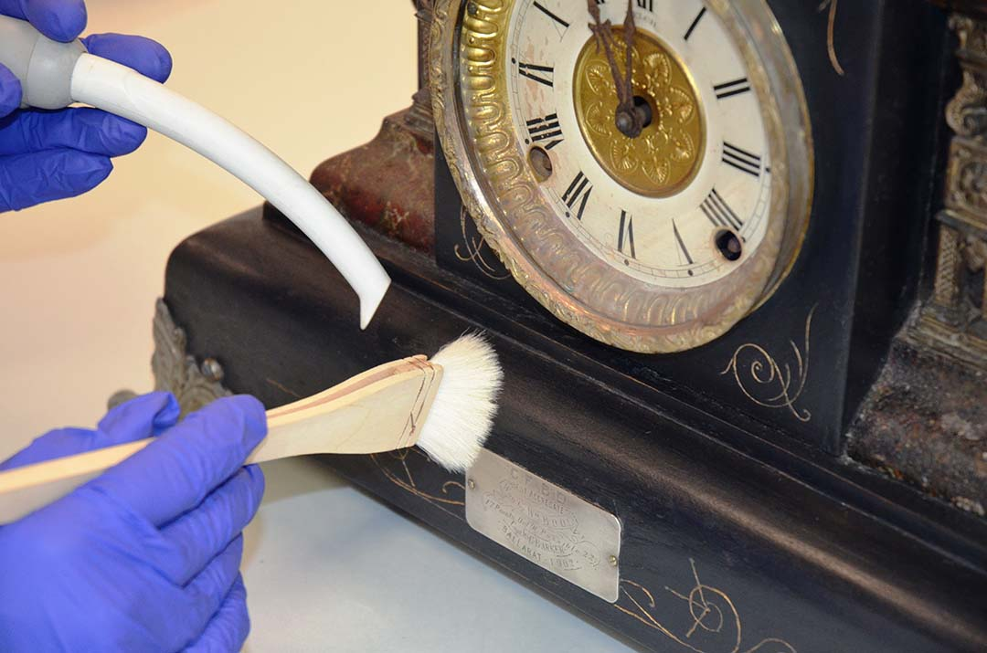
Brush vacuuming
This conservator is using a brush to move dust off an object directly into a vacuum cleaner. A thin hose has been fitted to the vacuum cleaner to avoid sucking up detached pieces. The vacuum cleaner is fitted with a HEPA filter to prevent dust from spreading into the storage area. This is the best technique for removing dust from objects.
Never apply a standard vacuum cleaner nozzle to an object, as it can scratch or remove fragile components.
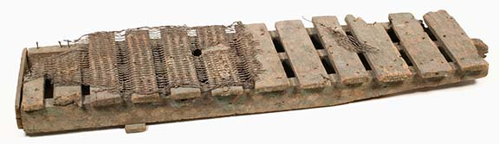
Wood and additional materials
Some wooden items have components made from other materials such as metal or leather. The rough hand-made nature of this First World War duckboard from Fromelles demonstrates the ingenuity of the diggers, while the mesh demonstrates how slippery the trenches were. All these materials are important parts of the object and help tell its story. Even if you don’t know the reasons why a material is present, it is important to retain and care for it as part of the object; later research on the object may reveal more information. Storage conditions should be suitable for wood as well as the other materials from which an item is made.
Photo courtesy of Australian War Memorial

RESOURCES
There are many publications already available on the care of wooden objects:
- ‘Caring for Your Treasures – Furniture’, American Institute for Conservation:
www.conservation-us.org/index.cfm?fuseaction=Page.viewPage&pageId=629&parentID=497
- ‘Care and Conservation of Furniture’, ICON UK Institute of Conservation:
www.conservationregister.com/PIcon-carefurniture.asp
- US National Parks Service Conserv-o-grams
  - Dusting Wood Objects:
www.cr.nps.gov/museum/publications/conserveogram/07-05.pdf
  - Cleaning Wood Furniture:
www.cr.nps.gov/museum/publications/conserveogram/07-01.pdf
  - Waxing Furniture And Wooden Objects: www.cr.nps.gov/museum/publications/conserveogram/07-02.pdf
  - Silicone In Furniture Waxes And Polishes: www.cr.nps.gov/museum/publications/conserveogram/07-06.pdf
  - Emergency Treatment For Water-Soaked Furniture and Wooden Objects:
www.cr.nps.gov/museum/publications/conserveogram/07-07.pdf
- Smithsonian Museum Conservation Institute – Moving, Packing, and Shipping Furniture:
www.si.edu/mci/english/learn_more/taking_care/movefurn.html

Disclaimer The material contained in this guide is for general reference only and should not be relied upon as the sole basis for heritage conservation or restoration. A professional conservator or conservation architect should be consulted before any conservation or restoration is undertaken. The Victorian State Government does not warrant the accuracy or completeness of the information and disclaims all liability for any loss or damage that may be caused by reliance upon it. Provision of names of suppliers or websites does not imply that a supplier is endorsed or approved by Heritage Victoria or the Department of Premier and Cabinet.

