

Honour rolls (wooden)

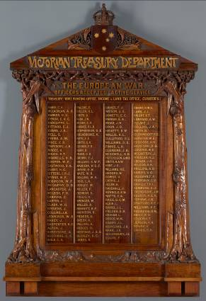

**Victorian Treasury Department honour board 1916**

Made by Robert Prenzel, born Germany 1866, arrived Australia 1888, died 1941, Blackwood (*Acacia melanoxylon*) metallic paint and other materials, 191.5 x 128.0 x 13.2 cm, National Gallery of Victoria, Melbourne, Gift of the Director of Finance, Public Works Department, Victoria, 1976. The original varnish and lettering have not been replaced, adding to the authenticity and beauty of the board.

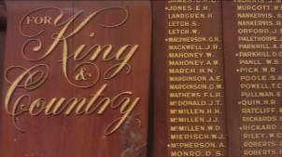

**What are honour rolls?**

Honour rolls were created by communities to list the names of service people who fought and/or died in war. Most date from the First World War and were intended to commemorate the service and sacrifice of people in local towns and districts. Honour rolls can be made from wood, stone, metal, paper, and photographs. Wooden honour rolls are the most common type and are generally found mounted on internal walls. (See other flyers in this series for care of non-wooden honour rolls, such as metal rolls.)

**What materials are wooden honour rolls made from?**

* Timber. The timbers used for honour boards were chosen for their appearance, availability, ease of working and cost. Australian mountain ash or Blackwood may have been chosen for their fine grain and beautiful colours, although their hardness made them more difficult to carve. Groups with less money tended to use pine or veneers.
* Varnish or wax. These materials were used to darken and enrich the colours of the wood and to protect it. A wide variety of natural varnishes such as amber, shellac, dammar, copal or pine resins were used. From the 1920s, cellulose nitrate and other synthetic lacquers are also found. Waxes include beeswax and carnauba. Some varnishes, such as shellac, are naturally coloured, while in other cases pigments were mixed with the wax or varnish to darken the wood.
* Lettering. Most lettering is gilded using real gold leaf or artificial gold leaf (which was usually made from brass). Older gilding is attached with natural adhesives, such as gelatine or egg white. Later, synthetic adhesives were used.

**The loss and displacement of honour rolls**

Honour rolls are one of the most vulnerable types of war heritage. They are relatively easy to move and, over the years, a number have been displaced and lost to their communities. As schools, churches, RSLs and other community buildings close down, particularly in regional Victoria, honour rolls continue to be at risk. It is important that the ownership of honour rolls is clear and that a trusted organisation is responsible for their care.

Honour rolls should be photographed, documented and placed on an asset register.

Honour Rolls can also be listed on the Victorian War Heritage Inventory. See www.veterans.vic.gov.au

**What are the main threats to honour rolls?**

Moisture in all its forms is the main enemy of timber and can cause many types of deterioration. Human intervention is also a major cause of damage. Some threats include:

**Moisture related threats**

* mould
* insect attack
* high and fluctuating humidity and temperature.

**Human threats**

* light exposure
* accidents
* neglect
* dust
* poorly planned re-hanging or de-mounting
* incorrect attempts at repair or cleaning
* excessive or aggressive polishing
* paint stripper
* commercial metal polishes and wood stains

**How do these threats damage honour rolls?**

Water and high/fluctuating temperature and humidity can cause:

* Warping, joints pulling apart, splitting or cracking.
* Brass (artificial gold) lettering to become dull, brown or corroded.
* Veneer, varnish or lettering to peel.
* Varnish to become dull or blanched (developing a whitish appearance).
* Mould to grow in the wood or on dust, wax or varnish.
* An increased threat of insect attack.

Light and heat can cause:

* Varnish to darken or become more yellow.
* The varnish on top of the lettering to discolour (the lettering underneath will still be bright).
* Flaking or ‘alligatoring’ of varnish and/or gilding.

People can cause:

* + Fading and/or a change in the colour of the wood by exposing honour rolls to direct or excessive light.
  + Physical damage caused by knocks and falls.
  + Damage from well intentioned but ill advised restoration treatments.
* Lack of cleaning causes dust to collect on flat surfaces and become embedded in the wax or varnish causing a whitish appearance.

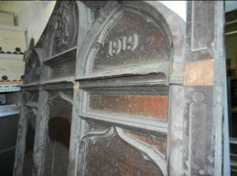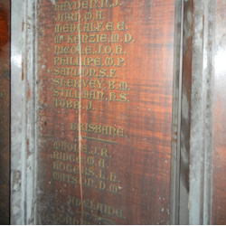

**Neglected honour rolls**

The varnish on this honour roll is blanched and dust has sunk into it. This damage has been caused by exposure to warm and humid conditions, perhaps in a shed. Fluctuating temperature and humidity have caused the large vertical crack. However, a conservator will be able to recover the beautiful original varnish without the need to strip and stain the timber.

**REMEMBER**

* Theoriginal timber, varnish and gilding are important parts of the history of any honour roll. As is the case with many types of memorials, all these materials were very carefully chosen by the community to express their feelings and to fit within their budget. Stripping, re-varnishing, staining and re-gilding lettering will destroy this history and should not be done.
* Varnish can be cleaned.
* The wood of honour rolls is not living and does not require “feeding”. Don’t “feed” them with oils.
* If an honour roll is very badly damaged it may be preferable to make a new one and keep the original in your organisation’s archives. But many honour rolls that appear to be badly damaged can be greatly improved by a conservator. Before you do ANYTHING, consult a conservator.
* Before you start, ALWAYS look at the list of resources at the end of this fact sheet. There will be detailed information already available
* Never give up – something that looks ‘hopeless’ can often be recovered.
* All honour rolls will age – it is the speed at which this happens that you can influence.
* It is no disgrace for an honour roll to look its age and reflect its history.
* Honour rolls are important and deserve professional care.
* Modern varnishes, stains and lettering will make historic honour rolls look brand new but this will obliterate their history.

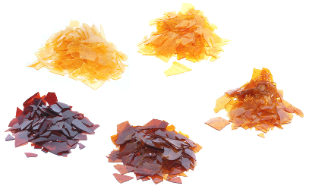

**Honouring the original intention of the community**

This image shows different varieties of shellac, illustrating part of the range of varnish colours which were used on honour boards. The people who originally commissioned honour boards often choose a particular varnish colour. This is an important component of an honour board and **should never be removed during restoration**.

*Source:* *commons.wikimedia.org/wiki/File:Shellac_varities.png*

**Honour rolls should look their age**

Honour rolls are historical objects which tell a story. They should look their age.

The old and worn finishes and lettering of honour rolls are an important part of their history. This is the patina of age.

**General principles**

**DO**

* Regularly and carefully dust honour rolls on open display using specialised brush vacuuming (see Wooden Objects flyer) or soft, dry microfibre or dust attracting cloths to gently remove dust. This does not mean applying a standard vacuum cleaner nozzle to the wood. See the instructions on the Wooden Objects flyer.
* Cover honour rolls in storage with dust covers, e.g. washed clean cotton sheets, but remove carefully to avoid snagging.
* Store in a stable area of the building where possible, e.g. an interior wall, not in areas of high and fluctuating temperatures or humidity.

Store wooden honour rolls indoors, not in external structures such as sheds.

**DON’T**

* Use oil impregnated cloths or brushes, as they will leave residues.
* Use feather dusters or fluffy clothes to remove dust, as feather fragments or fluff can snag in splinters, carving or cracks and pull pieces of wood off.
* Dust honour rolls if surfaces are flaking or unstable.
* Attempt to re-paint any lettering yourself – always get professional advice.
* Display under bright lights and don’t forget to turn off lights when the room is not in use.
* Expose to direct or indirect daylight. While most honour rolls are displayed publicly, a darker environment is better.
* Ever apply waxes or coatings containing silicone, as this can never be removed.
* Apply wood stains or other colourants (such as those in some furniture cleaners).
* Apply oils (including linseed oil) as these will darken the finish and make lettering difficult to see.
* Apply lacquers, varnishes or other clear finishes

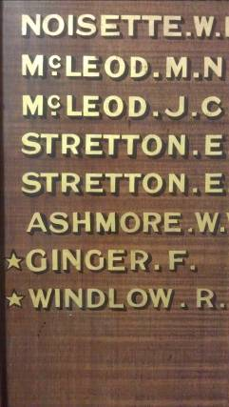

**Can signwriters ‘restore’ the names on honour rolls?**

Honour rolls are not signs.

They are heritage objects.

Signwriters are not usually trained in the conservation of heritage objects. Any repair or restoration work should be undertaken by a trained conservator.

It is not appropriate for names to be stripped off and re-painted.

Honour rolls should look historic and old.

Contact your local council’s heritage advisor for more information.

**Inappropriate ‘restoration’ work can permanently damage honour rolls and inscriptions.**

**Waxing**

Waxing with a clear wax will improve the appearance of patchy varnish without making the honour board look brand new. Do not apply wax if the surface is whitish or dusty. Use an untinted microcrystalline wax such as Beckett’s Clear Microcrystalline Wax or Renaissance Wax and follow the instructions for its use below.

**Does wood require ‘feeding’?**

The wood of honour boards is not living and does not require ‘feeding’.

Don’t ‘feed’ it with oils.

**Fixing honour rolls to the wall**

Many honour boards are very large and heavy. The methods of fixing them to the wall were usually carefully designed by the makers. Locations were also carefully chosen and it is always preferable to leave an honour board in its original position. If you must move an honour board, ensure a tradesperson with experience in heritage buildings is involved. The board should be removed from the wall without destroying the original fastenings as these are often part of the board. If at all possible, the original fastenings should be re-used. If these are no longer in existence get advice to ensure that any new mounting system fully supports the board; does not remove any timber or cause any other damage to the board.

RESOURCES

There are many publications already available on the care of wooden furniture that can easily be adapted to the care of honour rolls.

* American Institute for Conservation, Caring for your treasures – Furniture   
  [www.conservation-us.org/index.cfm?fuseaction=Page.viewPage&pageId=629&parentID=497](http://www.conservation-us.org/index.cfm?fuseaction=Page.viewPage&pageId=629&parentID=497)
* ICON UK Institute of Conservation – Care and conservation of furniture www.conservationregister.com/PIcon-carefurniture.asp
* US National Parks Service Conserv-o-grams
  + Dusting Wood Objects www.cr.nps.gov/museum/publications/conserveogram/07-05.pdf
  + Dusting Guidelines For Stone Objects And Interior Architectural Features www.nps.gov/history/museum/publications/conserveogram/15-02.pdf
  + Waxing Furniture And Wooden Objects [www.cr.nps.gov/museum/publications/conserveogram/07-02.pdf](http://www.cr.nps.gov/museum/publications/conserveogram/07-02.pdf)
  + Silicone In Furniture Waxes And Polishes www.cr.nps.gov/museum/publications/conserveogram/07-06.pdf
  + Emergency Treatment For Water-Soaked Furniture and Wooden Objects www.cr.nps.gov/museum/publications/conserveogram/07-07.pdf
* Smithsonian Museum Conservation Institute - Moving, Packing, and Shipping Furniture www.si.edu/mci/english/learn_more/taking_care/movefurn.html

Funding to restore honour rolls

Restoring Community War Memorials Grants Program

Veterans Branch, Victorian State Government

Department of Premier and Cabinet

Level 8, 1 Macarthur Street  
East Melbourne Vic 3002  
Email: [veterans@dpc.vic.gov.au](mailto:veterans@dpc.vic.gov.au)  
Web: www.dpc.vic.gov.au/

The Victorian Government’s Restoring Community War Memorials grants program supports communities in Victoria to ensure local war memorials and honour rolls are restored to their original condition or enhanced to reflect local communities’ service history. Under the program, any Victorian ex-service organisation, local government, school or community organisation can apply for funds to help repair, protect, restore and enhance war memorials and honour rolls.

Ensure you get a quotation from a qualified conservator to use in your application for funding to these programs. Conservators can be found at www.aiccm.org.au

Where can I get this and other fact sheets? The DPC Preserving war heritage and memorabilia fact sheets provide information about the care and conservation of a range of heritage material. They can be downloaded at **www.dpc.vic.gov.au/veterans/factsheets**

**Disclaimer** The material contained in this guide is for general reference only and should not be relied upon as the sole basis for heritage conservation or restoration. A professional conservator or conservation architect should be consulted before any conservation or restoration is undertaken. The Victorian State Government does not warrant the accuracy or completeness of the information and disclaims all liability for any loss or damage that may be caused by reliance upon it. Provision of names of suppliers or websites does not imply that a supplier is endorsed or approved by Heritage Victoria or the Department of Premier and Cabinet.