Mould

About this technical note
This technical note was prepared by Caroline Kyi (Kyi Conservation) in collaboration with Heritage Victoria in response to the 2022 Victorian floods.
Once flood waters have receded, mould is likely to occur. Microorganisms such as bacteria and mould are ubiquitous in-built environments. Excess moisture and poor air circulation can lead to the activation and spread of micro-organisms. This can lead to adverse health outcomes for occupants and the biodeterioration of building materials.

Mould grows and spreads by using available organic material as a source of nutrients. Mould species can grow on a range of material types, such as timbers, wallpaper, leather, textiles and even dust and dirt. Historic buildings are commonly constructed and/or repaired using a variety of materials and are often composites of historic and general building materials.

While mould problems can affect a range of material types, organic materials are particularly problematic. Not only do they provide a source of nutrients, but they also more readily adsorb moisture vital for mould growth. For inorganic materials such as stone, mortars and metals, the presence of dirt, dust and coatings can provide enough organic nutrients to support mould growth under suitable conditions.

Mould and associated forms of biodeterioration of materials may be observed as the following:
- Furry green or black growth
- Fibrous specks of black/white growth
- Brown, orange, green and pink staining
- Visible degradation of materials
- A musty/earthy smell
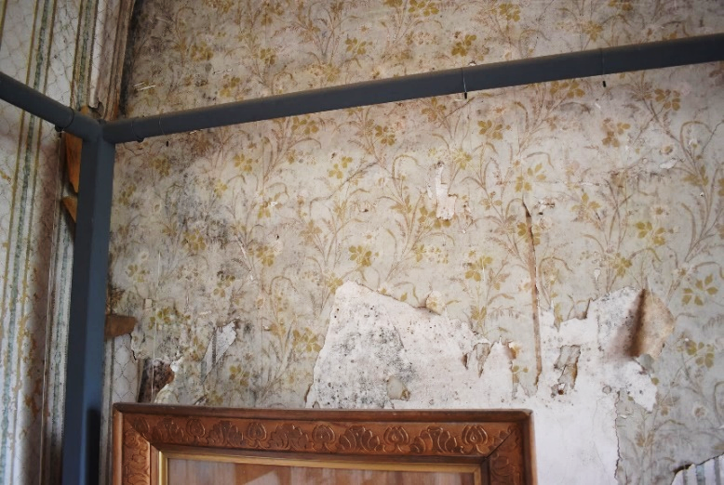
As all moulds can pose a health risk to humans it is recommended to use appropriate Personal Protective Equipment (PPE) worn in situations where mould may be present. The necessary PPE for dealing with mould includes respiratory protection (particulate masks), gloves, goggles and protective clothing. Ensuring that occupants are protected from health hazards posed by mould is a top priority.

Figure 1: Mould-damaged wallpaper and plaster substrate seen in the Murray Hotel, Echuca. Water ingress associated with roof damage; the environmental conditions in the room and as well as the availability of organic nutrients are all factors contributing to the growth of mould in this space. Source: Kyi Conservation.

Physical degradation of building materials is caused by the growth parts of filamentous vegetive structures exerting pressure on materials, causing fragmentation and loss. Physical degradation may be exacerbated by chemical processes whereby mould and other microorganisms produce acids and enzymes that break down materials as well as pigments that can cause staining.
Consistent conditions of high Relative Humidity (RH) above 70%, high temperatures above 30 ºC along with poor air circulation are likely to promote mould growth. Therefore, measures to maintain RH below 65% and temperatures around 20 ºC, along with improving natural air circulation, can help to reduce the moisture in materials and control mould damage.
Strategies to prevent, prepare, respond, and recover from mould damage are outlined following the Risk Management Cycle:
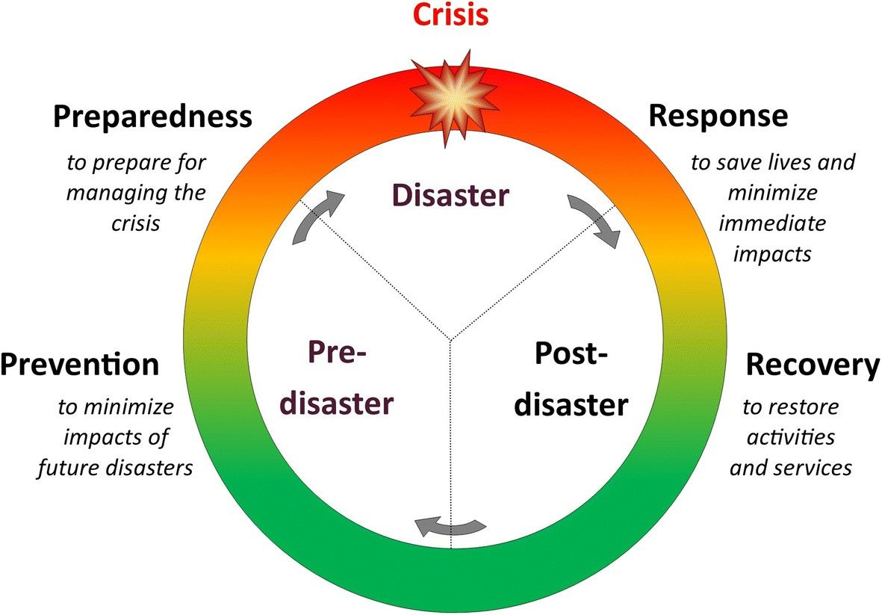
Figure 2: : Disaster Management Cycle – providing clarity to disaster process

Note:
- Engage a heritage consultant to determine a scope of works.
- If your place is included in the Victorian Heritage Register or is an archaeological site, under the Heritage Act 2017 you are obligated to contact Heritage Victoria for a pre-application meeting before starting any works to apply for a permit or permit exemption.

Disaster Management Approach
Stages Approach Strategies
Prevention  What to plan for to prevent mould damage in the event of imminent flood | Plan | - The information and measures gathered from the above section (avoid – detect – mitigate) should be developed into a Preparedness Plan for your building/site. See Preparedness Plan Box for more details.  - Ensure all maintenance and monitoring procedures are up to date.  - Ensure that the relevant documentation and data is organised and accessible.  - Organise an Emergency Response Kit and store it safely and accessibly.  - Relocate moveable items such as rugs, furniture, and drapes that if flood damaged may act as reservoirs for moisture and mould.  - Take additional measures to isolate, secure and protect rooms and building materials known to have previously been flooded or damaged by mould.
Preparedness  How to improve resilience to mould damage | Avoid | - Maintenance and management practices can minimise the threat of mould damage, including managing environmental conditions to reduce available moisture; isolation of mould-contaminated spaces or materials; the reduction of available nutrients through regular cleaning of surfaces.
 | Detect | - Routine assessments of the building, materials and environment will help detect any emergent risks. Record data about normal environmental conditions indoors and outdoors across the seasons, using dataloggers. Appoint a staff member to be in charge of routine inspections and procedures. Assess what materials and spaces are significant and which may be prone to mould damage

 | Mitigate | - Carry out repairs and maintenance promptly to prevent excess moisture in spaces. Assess building features and potential access points for water in the event of a flood. Undertake regular cleaning of surfaces and building materials

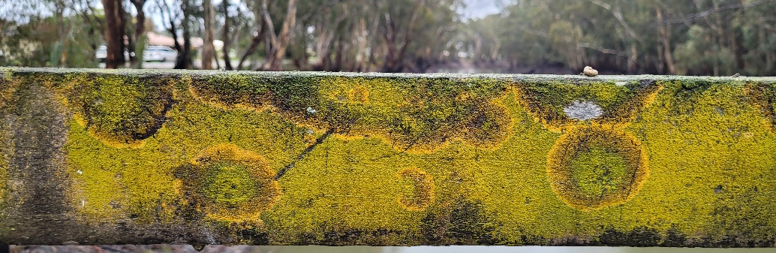
Biodeterioration takes many forms and can grow on many different structures and surfaces.

Figure 2: An example of biological growth on a recently submerged timber structure. Source: Kyi Conservation
Response  What to do to reduce mould damage when it is safe to return immediately after the flood. | Document | - Documenting the impact of the flood immediately after the event is crucial. Images and notes will provide valuable information for conservation consultants involved in the decontamination and clean-up process.  - Ongoing monitoring of environmental conditions, particularly relative humidity, immediately after a flood event is important in understanding the recovery of a building in terms of moisture and when environmental conditions return to pre-flood event trends.
 | Clean-up | - Engaging a conservation consultant to coordinate these processes will minimise potential contamination and mould damage and the loss of historic building materials.  - It is important that those involved in decontamination and clean-up prioritise the natural drying of spaces and building materials in situ, where possible.  - Initial decontamination and clean-up efforts should focus on pumping out the water that remains, after flood waters have receded, along with debris and contaminants transported by flood waters.  - Isolate spaces and building materials where mould damage has become apparent.  - Panelling and other installed decorative finishes and flooring can trap moisture in an underlying substrate and may need to be temporarily dismantled and relocated to allow the substrate to dry.  - Access to salvage stores where materials can be relocated and dried during the response and recovery phase should be considered.
 | Salvage | - Engaging a conservation consultant to coordinate these processes will minimise potential contamination and mould damage and the loss of historic building materials.  - Prioritising spaces and/or building materials identified as significant prior to or during salvage operations focuses the recovery phase.  - Building materials identified as significant may require gentle rinsing or vacuuming to remove silt and debris and reduce the availability of contaminants and nutrients for mould growth. Others may need to be relocated.  Documenting the condition of spaces and/or building materials pre and post decontamination is important to ensure that building materials identified as significant are assessed and treated appropriately.

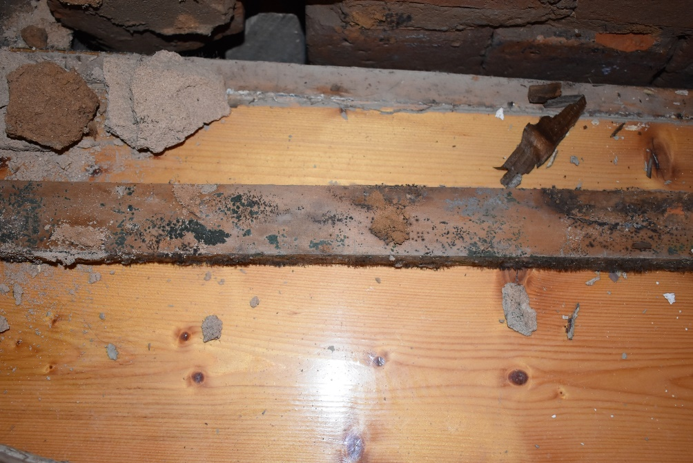

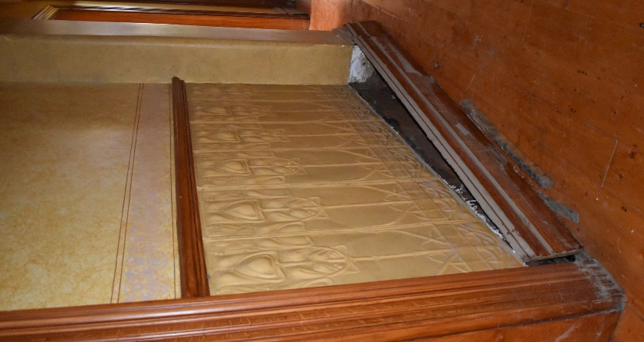

Figure 4: Careful lifting of fixtures can be undertaken to reveal hidden areas of biodeterioration. This information can be used to inform approaches to improving air movement and drying.

Figure 3: The careful and strategic lifting/temporary removal of skirting boards and floorboards can be used to improve air movement and facilitate drying. Thereby, avoiding the removal and destruction of historic materials.

Recovery  What to do to control mould damage after the emergency phase of the flood | Drying | - Slow and gentle drying is the most effective way to prevent and control mould damage and other moisture-associated deterioration to building materials. A building can take between 6-9 weeks to dry.  - Environmental measures to reduce and control mould damage should aim to slowly establish RH values below 65% and temperatures around 20 ºC. Records of environmental values, taken outside a flood event, can help gauge the return of a building to ‘normal’ conditions.  - Drying is dependent on the materials, the season and the environmental conditions experienced indoors and outdoors and is best achieved through improving natural air circulation by opening the windows, doors and vents of a building.  - Depending on the conditions in a building mould damage may not appear on building materials until weeks after the initial flood damage. Consult with a conservation consultant before proceeding with measures to treat mould damage.  - Drying may be facilitated by the following:  - Gentle removal of excess and surface moisture with absorbent papers and cloths.  - Controlled use of fans to help ventilate enclosed spaces.  - The use of dehumidifiers, air conditioning and air purification systems should be undertaken in consultation with a conservation consultant.
 | Emergency treatment of mould | - It is important to engage a conservation consultant before proceeding with measures to treat mould damage. Building materials should be in an otherwise stable condition and all cleaning methods should be tested on a small and inconspicuous areas of material.  - Reduce small areas of dry mould with brushes and a vacuum cleaner with a HEPA filter to collect dispersed spores.  - For larger surfaces direct gentle vacuuming with a HEPA filter vacuum may be suitable, when used in a controlled way.  Conservation treatments involving specialist chemicals and equipment may be required and should be undertaken in consultation with a conservation consultant.
 | Strategy | - Collation and review of documentation and records taken during the response phase can inform the planning and prioritisation of specialist conservation measures.  - Working with conservation consultants, develop passive methods to control mould damage and conservation treatments to treat severely mould damaged materials can be developed.  - Investigate the feasibility of maintaining environmental conditions at values that are comfortable for occupants and prevent mould damage.
 | Resilience | - Review of the Disaster Risk Cycle and efficacy of the emergency response will inform and improve future measures to prevent and control mould damage.  - Identification of spaces and building materials likely to be more suspectable to mould damage post recovery.

During any or all of these stages, Heritage Victoria may advise or require engagement of a conservation consultant. Conservation consultants can include conservators; builders; architects; engineers; materials specialists; and remediation professionals; who specialise in heritage materials and historic buildings.

Below is a template that you could follow to make sure you are prepared for a flood event.

Preparedness Plan
- Aim: To facilitate the protection and remediation of historic spaces and building materials susceptible to mould damage, in the event of a flood emergency.
- Assess and document spaces in normal conditions, focussing on significant materials, and those susceptible to mould damage.
- Strategically deploy dataloggers to gather information about environmental conditions; these will be a baseline to return to post-flood events.
- Where possible, make provisions to relocate movable items ahead of emergency.
- Consult with conservation consultants on significant materials and recovery options.
Recommended Emergency Response Kit
Basic supplies and consumables | Equipment | Facilities
- PPE:  - Particulate masks  - Gloves  - Googles  - Protective clothing  - Mops  - Bucket  - Absorbent paper  - Absorbent cloths  - Rubber boots  - Stationery  - 9:1 Industrial methylated spirits: water  - Soft brushes  - Microfibre cloths  - Cotton tips | - Wet/dry vacuum (HEPA Filter)  - Fans  - Extension cords  - Dehumidifiers  - Tools  - A frame trolleys  - Air purifiers  - Sandbags  - Barriers | Storage space for salvaged, severely contaminated, or dismantled building materials

