War memorials
What are war memorials?
‘War memorial’ is a category which includes a diverse array of monuments including obelisks, pillars, cairns, cenotaphs, windows, statuary, flagstaffs, headstones, natural features and ornamental structures. In some contexts plaques, tablets and honour rolls are also considered to be war memorials.
Plaques are often made from the same material as war memorials. They are flat factual or ornamental plates or tablets fixed to a stand, wall or other surface, used to commemorate a significant event, person or group of people.

What are war memorials made from?
War memorials are made from a wide variety of materials, often in combination:
- stone (usually sandstone, marble, limestone, slate, bluestone or granite)
- metal (usually bronze, brass, copper or lead)
- gilding (gold or brass)
- concrete
- mortar (usually lime mortar)
- paint
- wood.

The symbolism of war memorials
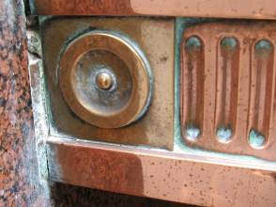
War memorials are an important part of Australia’s national heritage. They commemorate the service and sacrifice of servicemen and women as well as other people who have made a contribution during times of war. In Australia, war memorials have a special significance because they often act as ‘surrogate graves’ for soldiers whose bodies were buried in overseas war cemeteries or were unable to be located. This means that war memorials are vested with a sacred significance for families and communities. They are usually located in places of civic prominence (such as town squares or parks) and often the place at which annual Anzac Day services are held.

RIGHT: Too clean?
The abrasive polish used on the copper has caused unsightly stains and greenish residues on the copper, granite and mortar. The copper has been over-cleaned and is a raw pink colour. This would not have been acceptable to the original makers, who would have used a rich sombre bronze colour.

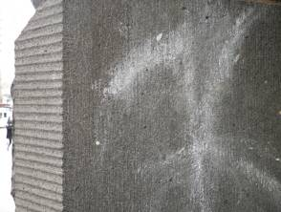
RIGHT: Graffitti
Graffiti is a difficult issue to deal with. It is very difficult to remove from porous stone. It is best to consult a conservator, conservation architect, local government heritage advisor or Heritage Victoria to get advice for your particular circumstances.

What are the main threats to war memorials and plaques?
Both the environment and the behaviour of people can be a threat to memorials.
Environment
- water (damp from the ground and rain)
- soil conditions
- vegetation (moss, lichen and algae and larger plants)
- air pollution from traffic and industry
- sea salt
- natural disasters
- insects and fungi
- dust and dirt.

People
- neglect, vandalism and graffiti
- incorrect attempts at repair, painting or cleaning
- accidents
- nearby construction works
- poor choice of original construction materials.
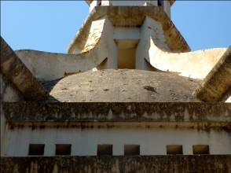

Lichen and staining
The grey lichen and staining on the curved areas of this war memorial at Beaufort are not disfiguring and do not need to be removed, but the yellow lichen on the white areas is more disfiguring and removal may be considered providing it can be done without damage. See following links for more information. Photo courtesy Lorraine Huddle

How do these threats damage war memorials and plaques?
- Environmental threats
- Damp from the ground can carry salts into stone which causes spalling (flaking) or loss of mortar.
- Water and air pollution can cause corrosion of metal components.
- Structural instability and cracks can be caused by the composition of the soil, water, the design of the memorial or nearby construction.
- Moss, lichen and algae are disfiguring and will slowly eat away the stone.
- The roots of larger adjacent plants can disrupt or push over a monument.
- Weeds can grow in mortar and open joints.
- Pollution and salts can cause corrosion (rust) of metals and loss of stone.
- Floods and fires can cause collapse or irretrievable damage to memorials.
- Exposure to the weather will gradually erode stone.
- Insects and fungi will attack wood.
- Bird droppings can cause corrosion.
- Soot and dirt will stain stone.

Human threats
- Neglect or lack of regular maintenance. Memorials need to be regularly maintained to mitigate against deterioration.
- Cement pointing causes serious damage to marble and sandstone.
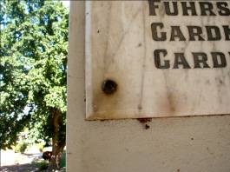
RIGHT: Corrosion from fastenings
This marble plaque is dirty and stained by iron corrosion from the fastenings. The fastenings should be replaced with bronze or stainless steel fastenings, as the expanding corrosion products could cause the marble to crack. This work should be done by an expert as the marble is fragile. The plaque should be kept clean of plant material and dust.
Photo courtesy Lorraine Huddle.

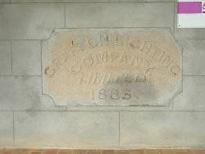
Examples of poor quality repairs

RIGHT: Incorrect use of cement
On this plaque, Portland cement has been used to create a surface on the edges of this sandstone tablet. The sandstone has begun to discolour and decay due to the salts from the cement.
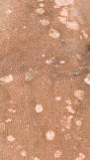

RIGHT: Incorrect removal of lichen
This is an example of how incorrect removal of lichen can damage memorials irretrivably. Scrubbing off the lichen before it has died has created disfiguring, shallow holes in the stone surface. These pock marks will now hold water and accelerate the deterioration of the stone.
The dangers of some cleaning products
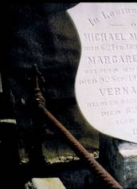  1997 | 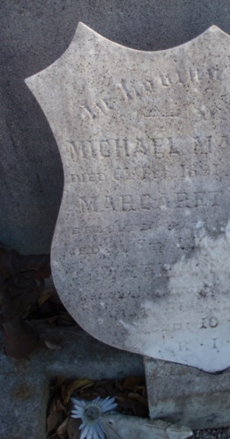  2012
This memorial above was treated with an acidic cleaning preparation in 1997. It caused the surface to turn a brilliant shade of white and look ‘as new’, but this memorial looked ‘good’ for only a short time. This treatment caused the surface of the stone to weaken and made it more vulnerable to deterioration. In the 15 years since the treatment, the memorial has discoloured rapidly and the chemicals have undermined an earlier repair.
This memorial is likely to continue to deteriorate at a faster pace than the untreated memorials around it because of the acidic treatment and a belief that ‘white and bright’ is a better look.
War memorials are part of our heritage.
It is not reasonable to expect them to look ‘as new’

Graffiti and vandalism
All public buildings including war memorials can be the target of graffitists and vandals. There is a wide range of materials that may be used by graffitists including spray paint, lipstick and marker pen. Scratches are also a form of graffiti. Some of the materials used to make war memorials are naturally resistant to graffiti and some are very vulnerable.
- Graffiti looks very unsightly but does not cause major damage. However it is usually best to remove it rapidly so as not to attract further attacks and because fresh graffiti is often easier to remove.
- Note that some types of graffiti such as marker pen can fade in sunlight and do not always have to be removed.
- Ill advised attempts to remove graffiti, corrosion or dirt can and have caused HUGE damage to memorials.
- Roughness caused by previous sand blasting will make new graffiti more difficult to remove.
- With the increasing price of metals theft of bronze, copper or lead from memorials can occur.
- Small or protruding or attractive features can be lost or stolen.

DO
- Document your memorial NOW with photographs and detailed written description to create a record in case anything happens.
- Consider the physical security of the memorial and determine if lighting, traffic fencing or other security measures may be needed.
- Consider the possible use of physical barriers such as pot plants or other landscaping that may be protective (so long as these new barriers have no impacts on the significance, character and appearance of the memorial).
- Get help FAST from qualified heritage practitioners if vandalism does occur. Ensure that you collect all detached items.

DON’T
- Use acid or alkali paint strippers on memorials. Solvent based strippers are safer but must be used with personal protective equipment at all times.
- Waterblast, sandblast or soda blast your memorial EVER.
- Scrub graffiti as this may spread the colour into the stone.
- Apply commercial anti-graffiti preparations without consulting a professional first. Many of these products damage historic materials by preventing water evaporation or being difficult to remove.
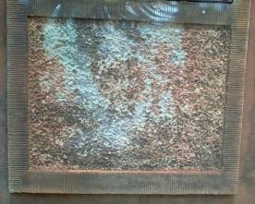
Damage caused by graffiti and attempted cleaning
This graffiti has sunk into the porous sandstone and cannot be fully removed, especially now that it has aged. Solvent cleaning has been attempted and caused the graffiti to bleed into the stone and aggressive rubbing has damaged the stone itself. The correct solvent used by a professional may have been more successful.

Inscriptions and names
Incised and leaded letters are one of the weakest components of memorials, plaques and honour rolls.
DO
- Ensure that leaded letters are professionally repaired or replaced as necessary.
- Keep a photographic or written record of the names.

DON’T
- Attempt to re-paint or re-gild lettering – get professional advice.
- Paint over the lettering on war memorials.
- Delay in replacing fallen letters as weathering may make later replacement difficult.
- Add additional inscriptions and names without consulting with your RSL Sub-branch, local council and heritage advisor. The addition of any inscriptions and names must be carried out by a suitably qualified conservator, stonemason or other specialist after relevant approvals have been granted and if there will be no heritage impacts.

Plantings and other features around war memorials
Plantings
In some instances, certain trees and plants (such as lone pines and avenues of honour) were planted as contributory features near war memorials or as part of a commemorative precinct, or as war memorials in their own right.
When considering preserving a war memorial, research should be undertaken to establish the nature of any original plantings. It is desirable to preserve any existing original plants and to ensure that any new plantings reflect the intentions of the memorial’s creators.

See fact sheet on ‘Avenues of honour and other commemorative plantings’.
Fences, flagstaffs and surrounding features
War memorials often consist of more than a monument. There are often fences, flagstaffs, gardens and other features which are important to commemorative places. These also require maintenance and appropriate conservation. In some instances cannon and other larger military heritage objects are situated near war memorials. These should be respected as part of the precinct in which the war memorial is located.
DO
- Treat the plantings and other features around war memorials with respect.
DON’T
- Don’t use vegetation slashers or machinery near war memorials and plaques. Even lawn mowers should be used with extreme caution in case of damage.
- Don’t excavate or install any pavements around the war memorial without seeking the necessary approvals and suitably-qualified heritage advice. Excavation may diminish structural integrity, while the installation of paving may undermine the significance and character of the memorial and create rising damp
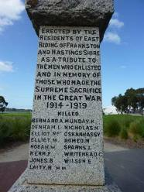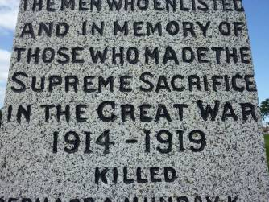
This war memorial above has been damaged by poor quality work. It was inappropriately sandblasted to ‘clean’ the surface, and then the lettering was clumsily repainted. The sharp edges of the inscriptions in the granite have been removed by the sandblasting which caused the new paint to seep over the edges of the lettering making it appear ‘wobbly’. This has reduced the heritage significance of the memorial and made it look messy. Always engage a qualified conservator or conservation architect to undertake work on war memorials – ask to see an example of their work so you are confident about their techniques.
Siting/Location of War Memorials
Many war memorials are located in conspicuous and well-planned prominent places, enabling them to serve as the focal point of Anzac Day and Remembrance Day ceremonies and as constant reminders of the service and sacrifice of men and women in each local community. In addition, their original location forms part of their historical and social value: their surroundings have an important social symbolism and wider town planning implications. Some monuments have therefore been situated as part of a broader town plan, with consideration given to view and focal points in the civic landscape.
DO
- Retain war memorials in situ if they are still located in their original locations.
- Ensure that original views and vistas are retained if possible.
DON’T
- Relocate a war memorial from its original site, unless this is the sole means of ensuring its survival.
- Relocate a war memorial without receiving professional heritage advice and the necessary approvals. There could be serious consequences for the heritage values of the area and town planning implications that should be addressed.

War memorials, roads and civic development
Many war memorials are surrounded by much more traffic and civic development than when they were built. This increases the risk of vehicles damaging memorials and their surrounds (fences, flagstaffs and plantings). The location of memorials, however, is an important part of their history, so moving them should only be done as the very last resort. Moving war memorials greatly increases the risk of accidental damage and may destroy the connection between the memorial and the community. If you are considering relocating a war memorial, consult your local council’s heritage advisor.
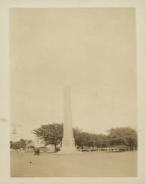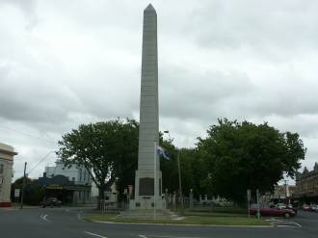
Terang War Memorial 2008
Photo courtesy of David Rowe

Terang War Memorial 1926
Photo courtesy of State Library of Victoria

RESOURCES
There are publications available which can easily be adapted to war memorials.
Caring for your treasures – Architecture. AIC
www.conservation-us.org/index.cfm?fuseaction=Page.ViewPage&PageID=624
Lichen, moss and algae – NSW Heritage Office publication Treating Biological Growths on Historic Masonry
www.heritage.nsw.gov.au/docs/tag_biologicalgrowths.pdf
Re-pointing mortar joins – Heritage Victoria www.dpcd.vic.gov.au/__data/assets/pdf_file/0004/36832/Repointing_Mortar_Joints.pdf
The Treatment of Graffiti on Historic Surfaces – Historic Scotland – http://conservation.historic-scotland.gov.uk/publication-detail.htm?pubid=8548 Scope of works – Guidelines for preparing a method statement – www.buildingconservation.com/articles/warmemorials/warmemorials.htm
Wood Preservation – Heritage Victoria www.dpcd.vic.gov.au/__data/assets/pdf_file/0009/36828/Timber.pdf
Caring for Outdoor Bronze Plaques, Part I: Documentation and Inspection – US NPS www.nps.gov/history/museum/publications/conserveogram/10-04.pdf
Caring for Outdoor Bronze Plaques, Part II: Cleaning and Waxing – US NPS www.nps.gov/history/museum/publications/conserveogram/10-05.pdf
Why Sodium Bicarbonate Blasting should not be used on historic buildings – NSW Heritage Office www.heritage.nsw.gov.au/13_subnav_01.htm
Maintenance of Iron Fencing – US NPS
ncptt.nps.gov/wp-content/uploads/Basics-for-Iron-Fencing-Care-Participant-Guide.pdf
Funding to Restore War Memorials
Restoring Community War Memorials Grants Program
Veterans Branch, Victorian State Government
Department of
Premier and Cabinet
Level 8 1 Macarthur Street
Melbourne Vic 3001
Email: veterans@dpc.vic.gov.au
Web: www.dpc.vic.gov.au/

Where can I get this and other fact sheets? The DPC Preserving war heritage and memorabilia fact sheets provide information about the care and conservation of a range of heritage material. They can be downloaded at www.dpc.vic.gov.au/veterans/factsheets
Disclaimer The material contained in this guide is for general reference only and should not be relied upon as the sole basis for heritage conservation or restoration. A professional conservator or conservation architect should be consulted before any conservation or restoration is undertaken. The Victorian State Government does not warrant the accuracy or completeness of the information and disclaims all liability for any loss or damage that may be caused by reliance upon it. Provision of names of suppliers or websites does not imply that a supplier is endorsed or approved by Heritage Victoria or the Department of Premier and Cabinet.

