At a glance – Archaeology   
  
  
Guidance for Victorian Government agencies managing heritage assets

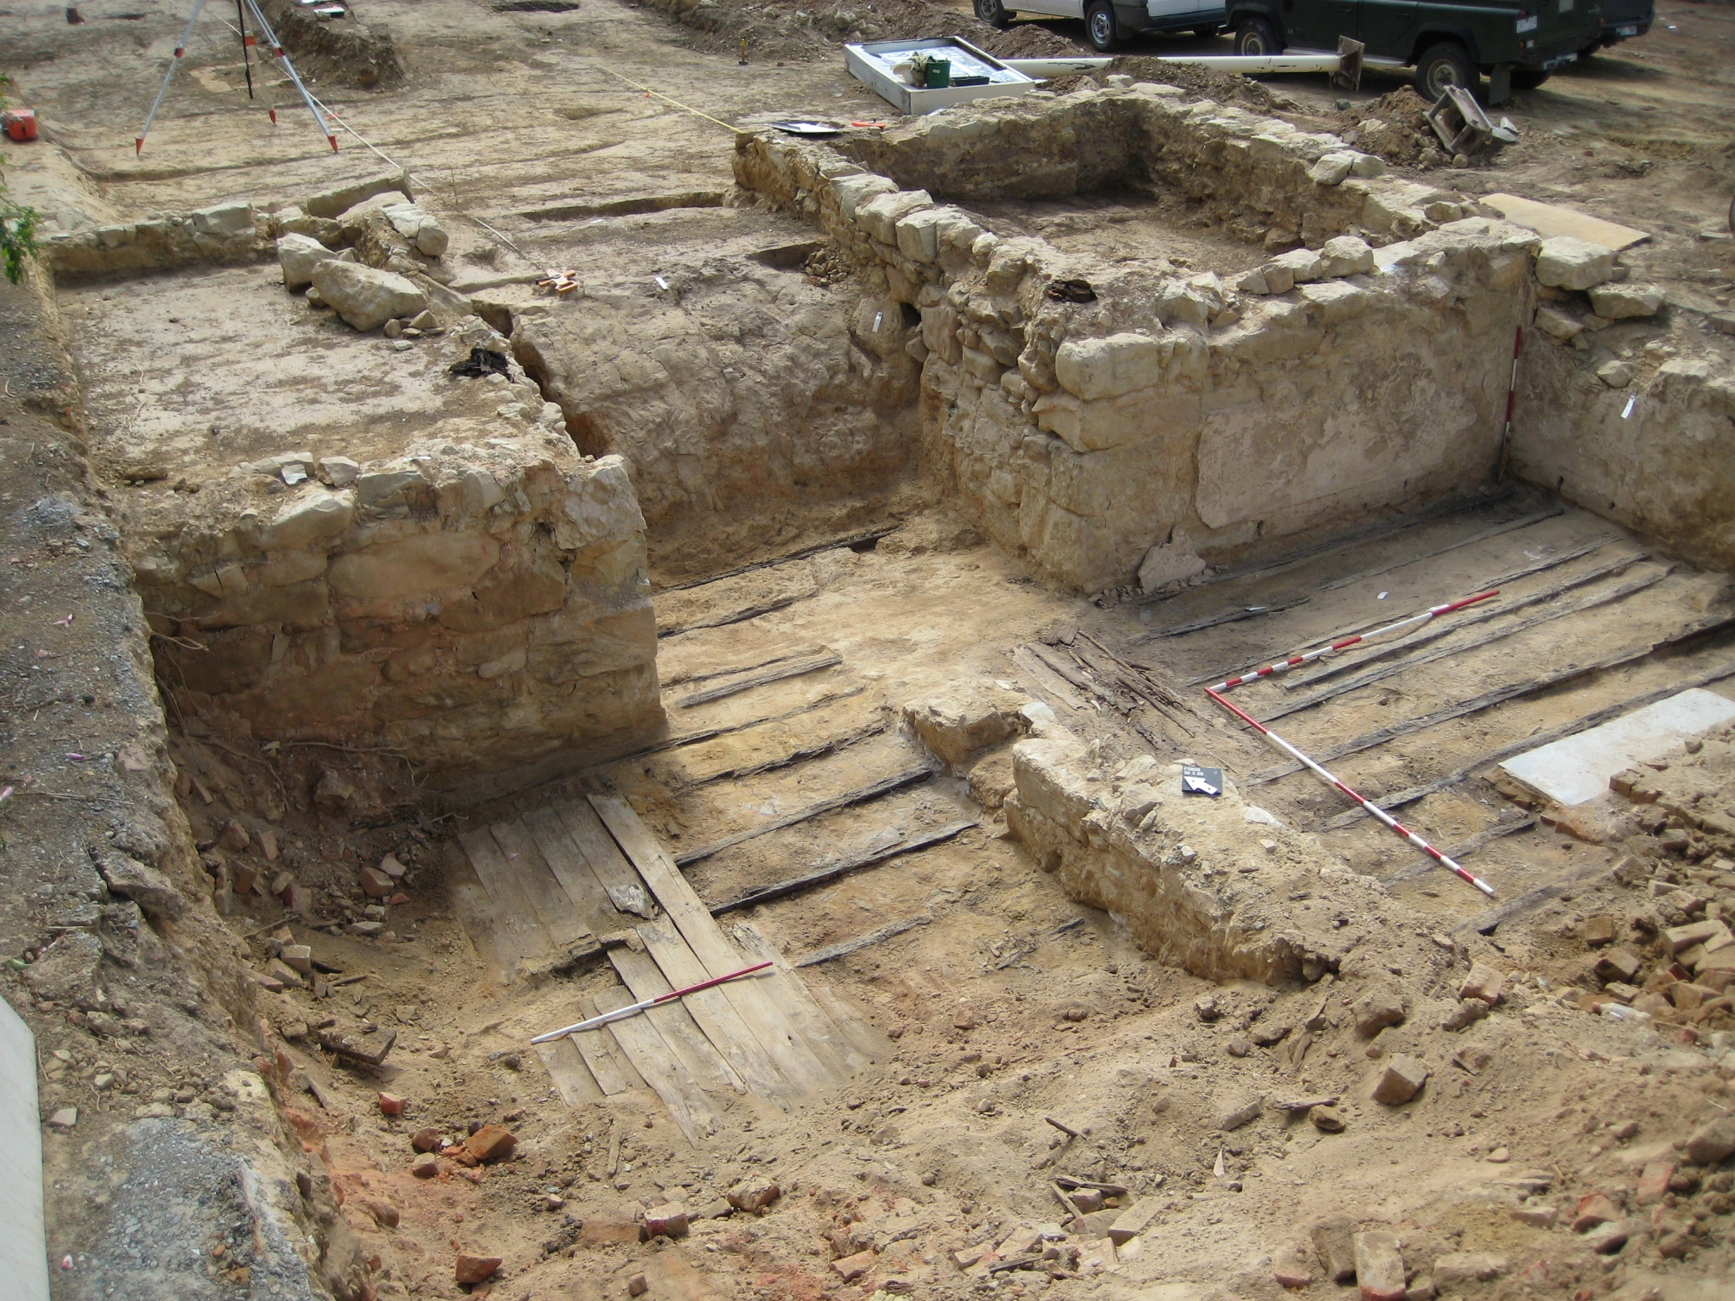

Made and published by the Executive Director, Heritage Victoria under s.19(1)(f) of the *Heritage Act 2017*, June 2024. The Government Asset Managers Program is kindly supported by funding from the Heritage Council of Victoria.

### Photo credits

All images courtesy of Heritage Victoria.

Cover: Forest Street excavation, Bendigo

Page 2: Artefact scatter, Dunolly

Page 4: Ravenswood sheepwash

Page 6: Amazon shipwreck, Inverloch

### Version Control

|  |  |  |  |
| --- | --- | --- | --- |
|  |  |  |  |
| Version | **Date of Issue** | **Author** | **Description of Changes** |
| 1 | June 2024 | Heritage Victoria | Initial document |

### Acknowledgement

We acknowledge and respect Victorian Traditional Owners as the original custodians of Victoria's land and waters, their unique ability to care for Country and deep spiritual connection to it. We honour Elders past and present whose knowledge and wisdom has ensured the continuation of culture and traditional practices.

We are committed to genuinely partner, and meaningfully engage, with Victoria's Traditional Owners and Aboriginal communities to support the protection of Country, the maintenance of spiritual and cultural practices and their broader aspirations in the 21st century and beyond.

### Disclaimer

This work is licensed under a Creative Commons Attribution 4.0 International licence. You are free to re-use the work under that licence, on the condition that you credit the State of Victoria as author. The licence does not apply to any images, photographs or branding, including the Victorian Coat of Arms, the Victorian Government logo and the Heritage Council of Victoria logo. To view a copy of this licence, visit creativecommons.org/licenses/by/4.0/

ISBN 978-0-7311-9318-9 (pdf/online/MS word)

This guideline may be of assistance to you but neither the State of Victoria or the Heritage Council guarantees the guideline is appropriate for any particular purposes, or its interpretation or application will result in any particular decision being made or outcome being reached concerning the subject matter it relates to. The State of Victoria and the Heritage Council disclaims all liability for any error, loss or other consequence which may arise from you relying on this guideline.

© The State of Victoria Department of Transport and Planning

### Accessibility

If you would like to receive this publication in an alternative format, please telephone the Customer Service Centre on 136 186, or email heritage.victoria@delwp.vic.gov.au, or via the National Relay Service on 133 677, www.relayservice.com. au.

# Introduction

The *Heritage Act 2017* provides statutory protection to all places and objects of State-level cultural heritage significance included in the Victorian Heritage Register, historical archaeological sites, and shipwrecks and shipwreck artefacts included in Victorian coastal waters. It is the responsibility of asset managers to ensure that all applicable legislative requirements are complied with.

This document has been developed to promote greater understanding of both historical and maritime archaeology. It provides a comprehensive, quick reference guide for Victorian Government agencies which consolidates existing guidance material relating to this area of focus into a singular point of reference.

For further guidance on the management of heritage assets, please refer to the [Government Asset Managers Program website](https://www.heritage.vic.gov.au/our-programs-and-initiatives/government-asset-managers-program).

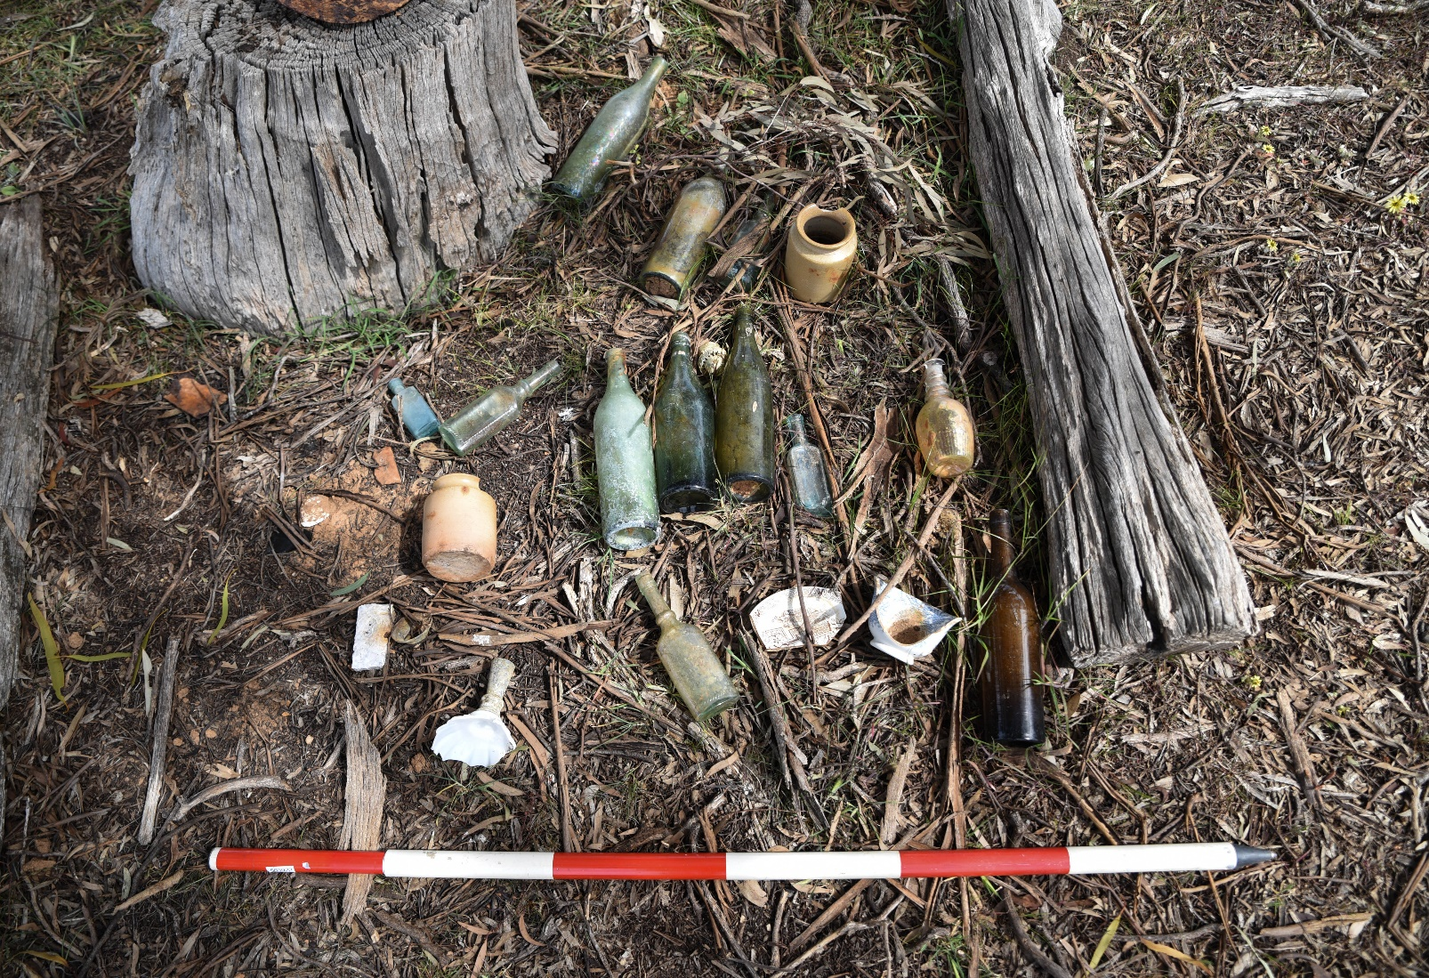

# Historical Archaeology

#### What is the role of the Historical Archaeology team?

Heritage Victoria’s Historical Archaeology team maintain the Victorian Heritage Inventory (VHI) and assess archaeological places for inclusion in the Victorian Heritage Register (VHR).

The team also issue consents and consent exemptions for works that may impact historical archaeological sites and collaborate closely with permits staff to assess works which may affect archaeological remains at VHR-listed places.

The Historical Archaeology team also manages the state’s collection of historical archaeological artefacts at Heritage Victoria’s Archaeology Research Centre.

#### Do any other archaeologists work at Heritage Victoria?

Yes. Heritage Victoria’s Major Projects team also includes archaeologists. This multi-disciplinary team works with stakeholders, including Victorian Government agencies, on major infrastructure projects of State-level priority. Heritage Victoria’s Maritime Archaeology team is responsible for the protection, management, conservation and interpretation of shipwrecks and other underwater cultural heritage.

#### What is a historical archaeology site?

The [*Heritage Act 2017*](https://www.legislation.vic.gov.au/in-force/acts/heritage-act-2017/004) provides blanket protection to all historical archaeological sites across Victoria aged 75 years or more, including sites that are yet to be discovered. The *Heritage Act 2017* defines a historical archaeological site as a place which:

* Contains an artefact, deposit or feature which is at least 75 years old
* Provides information of past activity at the place
* Needs archaeological methods to reveal key and significant information about the place
* Isn’t associated only with Aboriginal activity or use.

#### What is the difference between the VHR and VHI?

Victorian Government agencies will likely have responsibility for historical archaeological sites included in both the VHR and VHI.

The VHR consists of about 2,400 places and objects that have been assessed as being of significance to the history and development of the State of Victoria. This includes around 250 historical archaeological sites. The VHI is a list of roughly 7,000 known historical archaeological sites which satisfy the definition of a historical archaeology site as defined by the *Heritage Act 2017*. These sites are not required to address the threshold of State-level significance.

Historical archaeological sites can also be included in both the VHR and VHI. Some Local Government Authorities also include historical archaeological sites in the Heritage Overlay of their Planning Schemes.

#### Do the VHR and VHI also protect Aboriginal archaeology sites?

Aboriginal cultural heritage is protected under the [*Aboriginal Heritage Act 2006*](https://www.legislation.vic.gov.au/in-force/acts/aboriginal-heritage-act-2006/027). Victorian Government agencies are encouraged to [contact First Peoples – State Relations](https://www.firstpeoplesrelations.vic.gov.au/aboriginal-cultural-heritage) about all Aboriginal cultural heritage matters. Places of ‘shared’ Aboriginal cultural heritage and historical cultural heritage significance can be included in the VHR if one or more relevant State-level significance thresholds are met, or the VHI if the place meets the definition of an archaeological site as defined under the *Heritage Act 2017*.

#### How do I find out what historical archaeological sites my agency is responsible for?

It’s vital that your agency understands what historical archaeological sites it is responsible for. You can do this by searching for a specific address [using the Is my place heritage listed? interactive map](https://www.heritage.vic.gov.au/heritage-listings/is-my-place-heritage-listed). You can also [request a heritage certificate from Heritage Victoria.](https://www.heritage.vic.gov.au/heritage-listings/heritage-certificates) The best place to find out further information about historical archaeological sites is by [using VicPlan](https://mapshare.vic.gov.au/vicplan/).

Any questions relating to the mapped extent of VHI-listed sites can also be [directed to the Heritage Victoria Historical Archaeology team.](mailto:Archaeology.Admin@transport.vic.gov.au)

#### Can my agency request that a VHI site be delisted?

Yes. Your agency can request that a VHI site be delisted if there is evidence that the site is of low archaeological value. For more information about low archaeological value, please [contact the Heritage Victoria Historical Archaeology team](mailto:Archaeology.Admin@transport.vic.gov.au).

#### Should my agency conduct an archaeological survey of a project area?

A survey is critical in identifying whether a project area may contain archaeological sites that are protected under the terms of the *Heritage Act 2017*. Heritage Victoria encourages agencies to conduct an archaeological survey prior to any works or activities with significant ground disturbance. It is also important if works are taking place in areas where there was known historical activity (such as gold mining, timber getting or the establishment of settlements). The purpose of a survey is to identify any unrecorded historical archaeological sites, and to update the details of existing VHI-listed sites.

Your agency must notify Heritage Victoria of its intention to conduct an archaeological survey for the purpose of discovering a historical archaeological site by [completing a Notice of Intention to Undertake an Archaeological Survey (NOI) form.](https://www.heritage.vic.gov.au/protecting-our-heritage/report-an-historical-archaeological-site) A survey report must be submitted within six months of completion of the survey, irrespective of whether any previously unrecorded historical archaeological sites are identified.

Please [refer to Heritage Victoria’s *Guidelines for Conducting Historical Archaeological Surveys*](https://www.heritage.vic.gov.au/__data/assets/word_doc/0034/696319/Guidelines_for_conducting_surveys_2024.docx) (Word, 11MB) for more information.

#### Is my agency required to submit a Notice of Intent (NOI) whenever a survey is undertaken?

No. Your agency isn’t required to submit a NOI if it is undertaking a survey solely for the purpose of preparing a Cultural Heritage Management Plan (CHMP) or a Cultural Heritage Permit (CHP) under the *Aboriginal Heritage Act 2006*. However, [a site card and survey report are required to be submitted to Heritage Victoria](https://www.heritage.vic.gov.au/protecting-our-heritage/report-an-historical-archaeological-site) within the specified timeframes (30 days and six months respectively from the date of the survey) if a historical archaeological site is discovered during the course of any survey.

#### Who can conduct an archaeological survey?

Your agency should engage heritage professionals with the [qualifications and expertise that match the requirements of your project](https://www.heritage.vic.gov.au/protecting-our-heritage/find-a-heritage-consultant). The [Victorian Heritage Services Directory](https://www.heritageservicesdirectory.com.au/) is a listing of heritage professionals, including historical archaeologists.

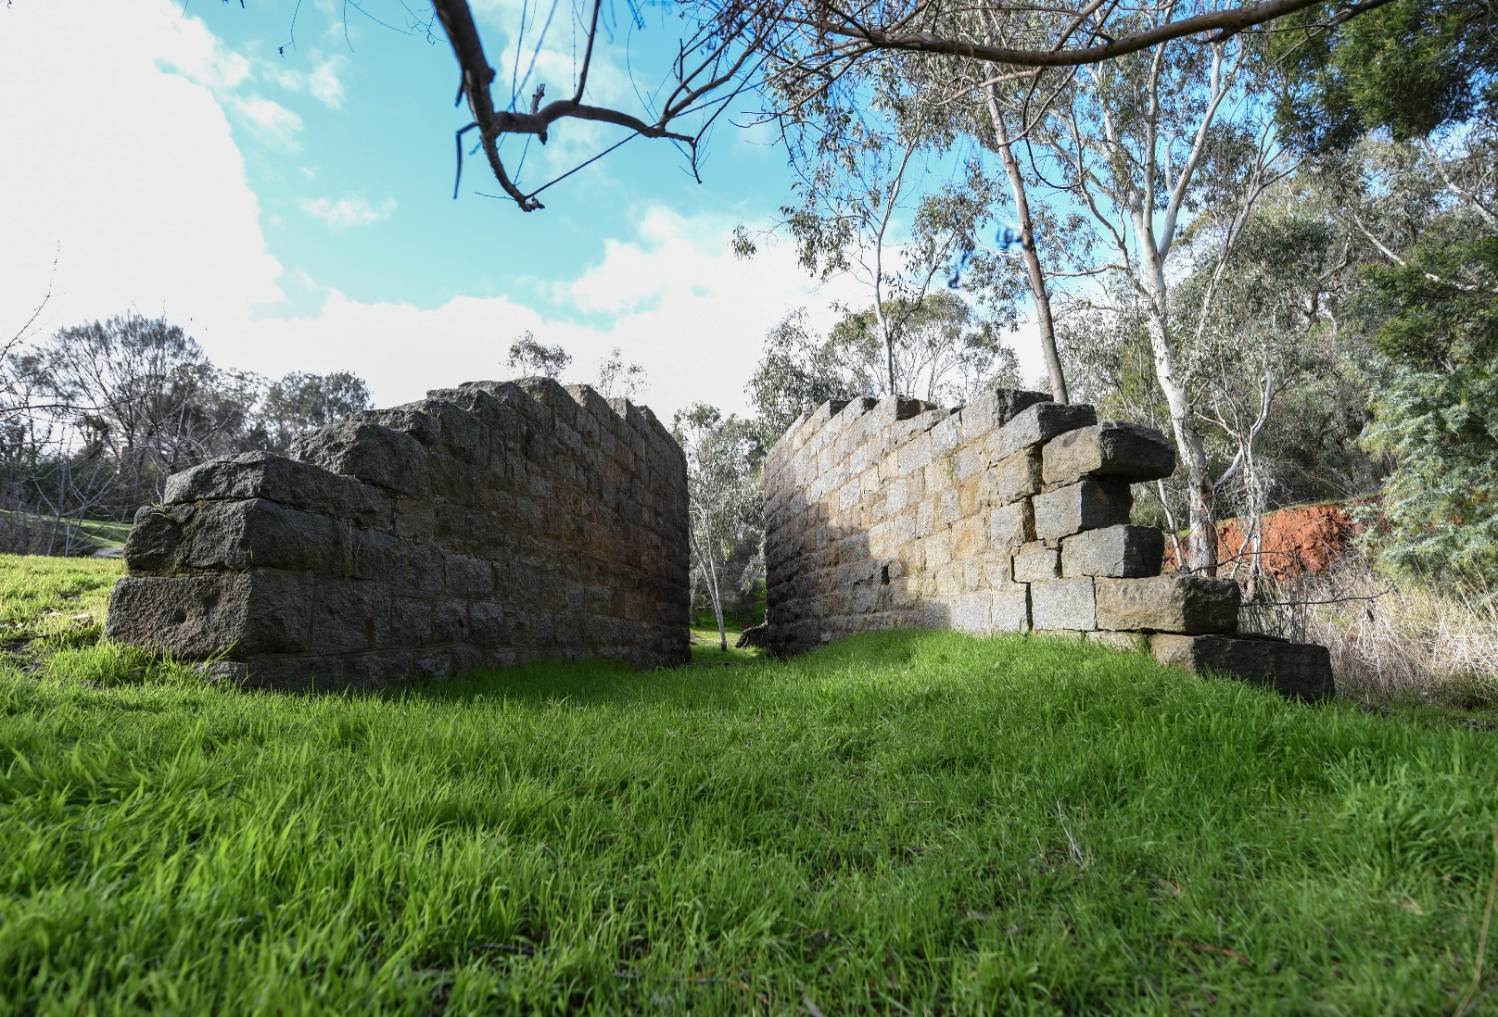

#### Does my agency need an approval from Heritage Victoria to conduct works and activities?

Your agency must [apply for a consent](https://www.heritage.vic.gov.au/permits-and-approvals/archaeology-consents/amend-or-extend-an-archaeology-consent) if it is undertaking site disturbance or other works that may affect a historical archaeological site. There are several different types of consents that correspond to different activities and different levels of site disturbance. Consents will contain conditions that your agency must follow. It is worth noting that your agency may require more than one consent for your project.

#### Can my agency apply to amend a consent?

Your agency can apply to amend an existing consent provided it has not expired at the time of application. The fee is 30% of the current consent application fee, however the works may [qualify for a fee waiver](https://www.heritage.vic.gov.au/about-us/fees-and-penalties#heading-3).

Heritage Victoria has 20 days to decide whether to grant a consent amendment. Depending on the scope of change, your agency may be required to apply for a new consent. Heritage Victoria has five business days to issue its decision once a determination has been made.

#### What is a consent exemption?

A [consent exemption](https://www.heritage.vic.gov.au/permits-and-approvals/archaeology-consents/amend-or-extend-an-archaeology-consent) may be obtained for minor works and activities that would cause negligible impacts to a VHI-listed site. Consent exemption applications do not incur a fee. For more information about consent exemptions, please [consult Heritage Victoria’s *Changes Affecting Archaeology – Heritage Act Amendments Factsheet 2024* (Word, 135KB).](https://www.heritage.vic.gov.au/__data/assets/word_doc/0038/695288/Hertiage_Act_Factsheet_Archaeology_2024-v2.0.docx)

#### My agency may have found evidence of an unknown historical archaeological site. What do we do?

Your agency is legally required to cease works in the area of the discovery and [notify Heritage Victoria](mailto:Archaeology.Admin@transport.vic.gov.au). It is likely that a site card will need to be submitted within the prescribed 30 days of the discovery. A site card contains information such as a description, location and extent, historical background, condition and significance assessments. [Please refer to Heritage Victoria’s guidance on how to prepare a site card for further information.](https://www.heritage.vic.gov.au/protecting-our-heritage/report-an-historical-archaeological-site)

#### Does the Historical Archaeology team help to educate Victorian Government agencies about archaeology?

Yes. Education and outreach are key aspects of the Historical Archaeology team’s work. They will work with your agency to help you better understand your responsibilities in relation to archaeology. If you have any questions, please [contact the Heritage Victoria Historical Archaeology team.](mailto:Archaeology.Admin@transport.vic.gov.au)

# Underwater Cultural Heritage

#### What is the role of the Maritime Archaeology team?

Heritage Victoria’s Maritime Archaeology team is responsible for the protection, management, conservation and interpretation of shipwrecks and other underwater cultural heritage. The team undertake regulatory processes under the *Heritage Act 2017* and [*Underwater Cultural Heritage Act 2018*](https://www.legislation.gov.au/C2018A00085/latest/text) (Cth), including maintaining the VHR, VHI and [Australasian Underwater Cultural Heritage Database.](https://www.dcceew.gov.au/parks-heritage/heritage/underwater-heritage/auchd)

The Maritime Archaeology team also issue permits and consents relating to shipwrecks and other underwater cultural heritage.

#### Does the *Heritage Act 2017* provide protection to underwater cultural heritage?

The *Heritage Act 2017* provides blanket protection to historic shipwrecks, submerged aircraft wrecks, underwater archaeology sites (such as those associated with historic piers and jetties), and other underwater cultural heritage located in Victorian internal and coastal waters.

The *Underwater Cultural Heritage Act 2018* (Cth) also provides blanket protection for shipwrecks within coastal waters and can supersede the *Heritage Act 2017*. The *Underwater Cultural Heritage Act 2018* (Cth) provides blanket protection to historic shipwrecks and aircraft wrecks as well as protection for any trace of human existence, including Aboriginal sites and artefacts, within Commonwealth waters. Commonwealth waters begin at three nautical miles from the low water mark.

#### How can my agency find out where known shipwrecks and other maritime archaeological sites are located?

Many protected shipwrecks and aircraft wrecks have not yet been located. Please [contact the Heritage Victoria Maritime Archaeology team](mailto:heritage.victoria@transport.vic.gov.au) for information relevant to your agency. Additionally,

* [VicPlan](https://mapshare.vic.gov.au/vicplan/) includes the location of underwater aircraft wrecks and underwater archaeological sites listed in the VHI
* The [Advanced Shipwreck Search](https://vhd.heritagecouncil.vic.gov.au/search/shipwrecks) in the Victorian Heritage Database can be used to find known shipwrecks listed in the VHR. Your agency will need to [contact the Heritage Victoria Maritime Archaeology team](mailto:heritage.victoria@transport.vic.gov.au) for specific location information
* The [Australasian Underwater Cultural Heritage Database](https://www.dcceew.gov.au/parks-heritage/heritage/underwater-heritage/auchd) can also be used to roughly locate found and unfound shipwrecks. As above, please [contact the Heritage Victoria Maritime Archaeology team](mailto:heritage.victoria@transport.vic.gov.au) for specific location information.

#### What is a shipwreck protected zone?

Shipwreck protected zones are no-entry zones located around some known Victorian shipwreck sites. It is an offence to enter a protected zone without a permit. There are currently ten protected zones in Victoria. The location and size of the protected zones can be [found on the Heritage Victoria website.](https://www.heritage.vic.gov.au/heritage-listings/maritime-heritage)

#### Does my agency need an approval from Heritage Victoria to conduct works and activities?

Your agency must obtain an approval prior to undertaking works and activities if they are to occur within a protected zone, or if they may impact found or unfound shipwrecks, submerged aircraft wrecks or underwater archaeological sites. As many sites have not yet been located, any works that disturb the seabed may need to be [assessed for archaeological potential by a qualified maritime archaeologist.](https://www.heritage.vic.gov.au/permits-and-approvals/maritime-heritage-permits)

Heritage assets such as aircraft and maritime archaeological sites included in the VHI will [require a consent](https://www.heritage.vic.gov.au/permits-and-approvals/archaeology-consents/amend-or-extend-an-archaeology-consent), while any works or activities within a protected zone or which impact a shipwreck or shipwreck artefact included in the VHR will [require a permit.](https://www.heritage.vic.gov.au/permits-and-approvals/maritime-heritage-permits)

#### My agency may have found evidence of an unknown shipwreck, shipwreck artefact or material that satisfies the definition of an archaeological site under the *Heritage Act 2017* or the definition of underwater cultural heritage under the *Underwater Cultural Heritage Act 2018* (Cth). What do we do?

Your agency is legally required to cease works or activities in the area of the discovery and [notify Heritage Victoria](https://www.heritage.vic.gov.au/protecting-our-heritage/report-maritime-heritage). For a shipwreck or shipwreck artefact, this is within seven days of the discovery. For material considered to be an underwater cultural heritage site, this is either within 30 days or as soon as is practicable. Heritage Victoria’s Maritime Archaeology team can also assist your agency in registering a Commonwealth protected shipwreck discovery in the Australasian Underwater Cultural Heritage Database within 21 days of discovery.

