Internal Decorative Finishes

About this technical note
This technical note was prepared by Caroline Kyi (Kyi Conservation) in collaboration with Heritage Victoria in response to the 2022 Victorian floods.
This technical note discusses decorative internal finishes affected by flooding or intense rainfall events. The following information outlines responses to these disasters and examines possible rectification and prevention methods to ensure greater resilience of internal finishes against future flood events.
Substrates of buildings, that is, surfaces upon which finishes are applied, can be constructed of masonry (brick, stone, concrete block), timber and metal. Finishes, particularly those found internally, often have a decorative role within a building.
Finishes can be painted directly onto a substrate as solid colours, decorative patterns or extensive mural schemes. Decoration can also be applied as a secondary substrate, such as wallpaper, tiles or panelling, which is adhered to the building substrate. The materials used to create decorative finishes, the method of application and their condition can all determine the extent to which they are adversely impacted by flooding or intense rainfall events, as well as the conservation options for their remediation.
During a flood event, the movement of flood water through a building can cause physical damage and loss to internal decorative finishes. Ongoing damage to decorative schemes from a flood can be caused by the introduction of excess moisture into materials and from debris and contaminants that remain on the surface. Unchecked, these factors can cause ongoing damage to decorative schemes due to accelerated degradation, staining and mould growth. Refer to Heritage and Floods: Mould.

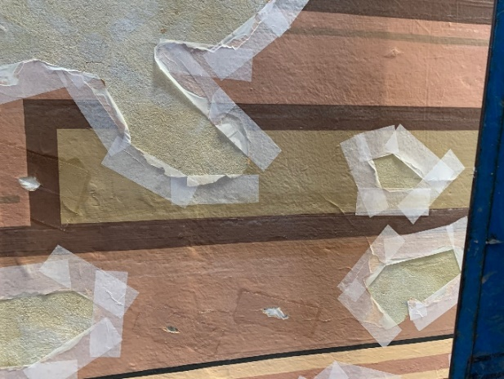
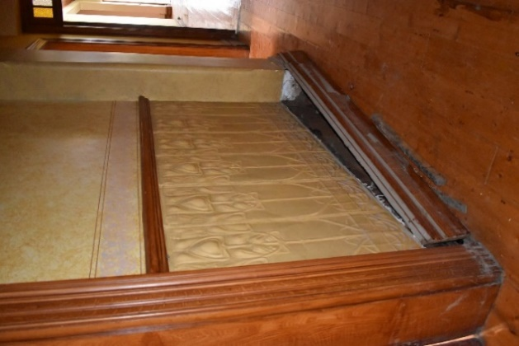
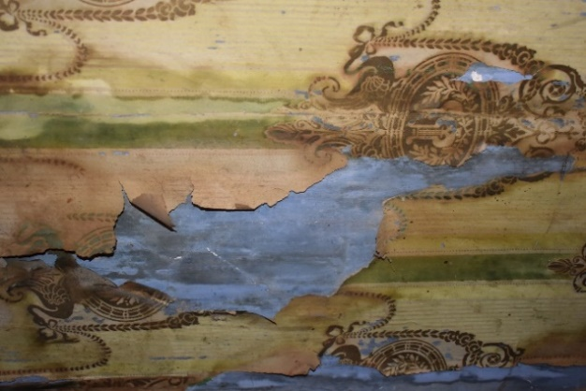

Figure 1: Metal finish Figure 2: Wallpaper and paint Figure 3: Emergency stabilisation

The images by Kyi Conservation demonstrate in Figure 1, painted finish on metal substrate; Figure 2, paint and wallpaper decorative finishes and Figure 3 demonstrates emergency stabilisation of the facing applied to secure edges of losses and flaking paint.
A Disaster Risk Cycle provides a useful guide for preventing or mitigating the impact of disaster using the below strategies to prevent, prepare, respond and recover decorative finishes from flooding or intense rainfall events:

Risk Management Cycle

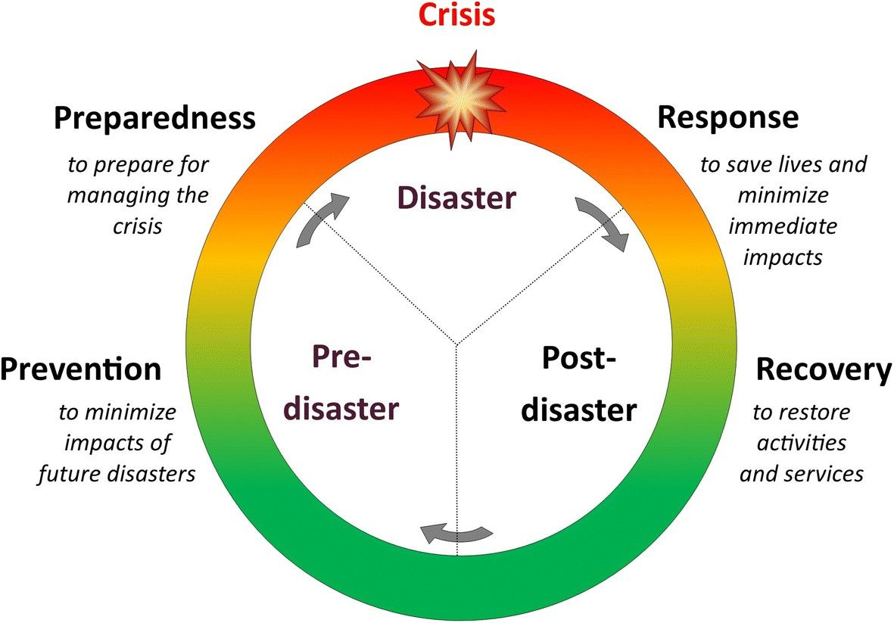
Figure 4: Risk Management Cycle – providing clarity to disaster process.

Note:
- Engage a heritage consultant to determine a scope of works.
- If your place is included in the Victorian Heritage Register or is an archaeological site, under the Heritage Act 2017 you are obligated to contact Heritage Victoria for a pre-application meeting before starting any works to apply for a permit or permit exemption.

Disaster management approach

Stage | Approach | Strategies
Prevention | Plan | - Ensure all management and maintenance procedures are up to date.  - Ensure that the relevant documentation and data is organised and accessible.  - Relocate moveable items such as rugs, furniture, and drapes that may cause damage to decorative schemes if dislocated by flood waters.  - Take additional measures to isolate, secure and protect rooms and decorative finishes known to have previously been flooded.  - Where appropriate make provisions to detach and temporarily relocate decorative finishes applied to secondary supports such as metal and timber panels.  - Ensure all occupants/staff know who is responsible for coordinating any potential emergency response.  - Organise an Emergency Response Kit and store it safely and accessibly (see below).
 | Recommended Emergency Response Kit
 | Basic Supplies and consumables:  - PPE:  - Particulate masks  - Glove  - Goggles  - Protective clothing  - Mops  - Bucket  - Absorbent paper and cloths  - Rubber boots  - Stationery  - Soft brushes  - Microfibre cloths  - Cotton tips  - Small dental tools  - Materials for emergency facing (to be advised by a conservation specialist) |  | Equipment:  - Wet/dry vacuum (HEPA Filter)  - Fans  - Extension cords  - Dehumidifiers  - Tools  - Air purifiers  - Sandbags  - Barriers

Preparedness | Avoid | - Avoidance of water damage is primarily achieved through building design and robust maintenance practices, such as: evaluating proposed building modifications for their impact on flood resilience; landscaping to manage water movement around a site; and installing flood barriers.  - Regularly assess building features and potential access points for water. Carry out repairs and maintenance promptly.
 | Detect | - Identify decorative schemes and materials that are likely to be damaged by intense rainfall events, flooding and in uncontrolled conditions that occur in the aftermath of a flood. For example: organic materials; materials in poor condition; materials damaged by previous exposure to excess moisture, i.e., water leaks, water run-off or affected by previous flood events.  - Develop a routine inspection checklist to identify and review potential ongoing risks. For example, deterioration of the building/primary substrate; changes in the use of the building; changes in the perceived value of a decorative scheme.  - Appoint a staff member or committee whose responsibility is to conduct any inspections and maintain/update any procedures.
 | Mitigate | - Where significant decoration in poor condition or a vulnerable location is identified, it is strongly recommended to engage a conservation consultant for further assessment and treatment. This will improve the resilience of the decoration to flooding or intense rainfall events
Response | Document | - Documenting the impact of the flood immediately after the event is crucial. Images and notes will provide valuable information for conservation consultants involved in the response and recovery process.  - Ongoing monitoring of environmental conditions, particularly relative humidity, immediately after a flood event is crucial to mapping the recovery of a building and any decorative finishes to pre-flood levels. For more information on environmental conditions and the damaging effects of excessive moisture, refer to Heritage and Floods: Mould.
 | Clean-up | - Materials will be particularly vulnerable post flood event. Paint may powder, bubble and lift. Paper and timber may cockle and warp. Internal decorative finishes applied to tiles and panels may delaminate from the primary or the secondary substrate. Care should be taken when handling flood damaged finishes.  - Prioritising schemes and rooms identified as significant during the response phase focuses the recovery phase.  - It is important that those involved in the clean-up prioritise the natural drying of spaces and building materials in situ.  - Initial clean-up efforts should focus on pumping out the water that remains, after flood waters have receded, along with debris and contaminants transported by flood waters.  - Panelling and other installed internal decorative finishes may need to be temporarily dismantled and relocated to allow the building substrate to dry.  - Decorative finishes may require gentle rinsing or vacuuming to remove excess silt and debris.
Recovery | Drying | - Once water has been pumped from a site, slow and gentle drying is the most effective way to prevent moisture-associated degradation of decorative schemes post-flood event. A building can take between 6-9 weeks to dry.  - Environmental measures should ideally slowly establish RH values below 65% and temperatures around 20 ºC, or to the pre-flood levels of the building, if known.  - Drying times will be dependent on the materials, the season and the environmental conditions experienced indoors and outdoors. Drying of heritage materials is best achieved through naturally improving air circulation throughout affected spaces.  - Drying may be facilitated by the gentle removal of excess and surface moisture with absorbent papers and cloths, and the controlled use of fans to help ventilate enclosed spaces.  - The use of dehumidifiers, air conditioning and air purification systems should be undertaken in consultation with a conservation consultant.
 | Strategy | - Collation and review of documentation and records taken during the response phase can inform the planning and prioritisation of specialist conservation measures.  - Working with conservation consultants, develop methods to conserve flood impacted internal decorative finishes
 | Resilience | - Review of the Disaster Risk Cycle and efficacy of the emergency response will inform and improve future measures to prevent and control damage to internal decorative finishes.  - Identification of internal decorative finishes likely to be more suspectable to deterioration post recovery.

Emergency stabilisation can be undertaken to temporarily secure vulnerable internal decorative finishes until long term treatments can be undertaken. It is important to engage a conservation consultant before proceeding with emergency measures. Below is some useful information to help stabilise vulnerable wall papers and painted finishes.

Emergency stabilisation of wallpaper finishes | Organic materials, such as wallpaper, are particularly susceptible to moisture damage, such as cockling and mould growth. These forms of damage may only become apparent once excess and pooling water has been removed from a room, debris and contaminants have been reduced from the wallpaper and drying has commenced. To prevent further damage and loss the following approaches may be required:  - Further cleaning of exposed wallpaper, to remove superficial and ingrained dust and debris, can be undertaken using a soft brush with a receptacle below to collect and retain loose fragments.  - Gentle vacuuming with a HEPA filter vacuum may be suitable, when used in a controlled way on materials that are stable.  - Be guided by conservation consultants on appropriate methods for the softening of cockled and deformed wallpaper sections and the application of facing materials and adhesives to temporarily secure and protect damaged wallpaper.  Wallpaper may be removed from site if advised and overseen by a conservation consultant.

Emergency stabilisation of painted finishes | Paint systems used to decorate walls and secondary substrates can vary. Caution should be exercised in the emergency treatment of painted finishes, as historic paints may contain lead. The loss of the paint binder, due to general deterioration and/or flood damage, can result in powdering of the paint layer and dispersal of lead paint particles. To prevent further damage and loss the following approaches may be required:  - Once excess and pooling water has been removed from a room and debris and contaminants have been reduced from the painted finish, further dry cleaning to remove superficial and ingrained dirt and debris using a soft brush and dental tools can be undertaken.  - Ensure that cleaning treatments avoid further loss/dispersal of paint that is powdering, flaking and/or delaminated and losses to a flood damaged substrate.  - Gentle vacuuming with a HEPA filter vacuum may be suitable, when used in a controlled way on materials that are stable.  When paint and/or substrate is particularly damaged, conservation consultants can provide specific emergency stabilisation methodologies that may include temporarily facing paint and support layers with paper-based materials and suitable conservation-grade adhesives.

