Avenues of honour and other commemorative plantings

Background
The preservation of commemorative plantings presents particular issues because trees and gardens are ‘living memorials’. It is not possible to ‘fix’ them in the same way that stone memorials can be restored.
There are many commemorative plantings across Victoria including avenues of honour, lone pines, single commemorative trees, memorial parks and gardens relating to various conflicts. Victoria has the largest number of avenues of honour of any Australian state. It is estimated that there are over 300 avenues, most of which are associated with the First World War.
Commemorative plantings established after the Boer War and the First World War are at particular risk of deterioration given their maturity and the lengthy drought conditions across Victoria. Many avenues of honour and lone pine plantings now feature mature trees often planted in the 1920s. Across Victoria a number of bodies own or have responsibility for avenues of honour, including local councils, Parks Victoria and VicRoads.

Threats to plantings
- drought, climate change (reduced rainfall and increased evaporation)
- damage caused by animals such as cockatoos, rabbits and possums (from over grassing and ring barking)
- damage by cars, trucks and other vehicles
- road widening and civic development
- loss of community knowledge (in some instances, the history and location of botanic features may be lost over time)

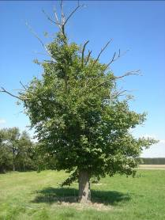
‘Die back’ caused by a lack of water and soil compaction
This Dutch Elm tree is part of the Ballarat Avenue of Honour. It is suffering from ‘die back’ caused by a shortage of water experienced during the early 2000s drought. The death of the upper parts of the foliage and resulting ‘sticks’ protruding from the tree could have been prevented by supplementary watering and mulching. This tree now needs removal of the dead branches and maintenance of the root system to encourage vigorous growth.

Avenues of honour and vehicle damage
This tree is part of the Ballarat Avenue of Honour. It has a basal trunk wound and cavity caused by a vehicle (such as a car, truck or grader) damaging the base of the tree. This tree is now weakened and needs to heal itself. This tree should be cared for appropriately to ensure that the wound closes up. This may take many years. Avenues of Honour are particularly vulnerable to this type of damage because they are often located on major roads.

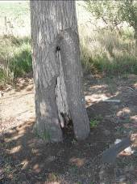

Understanding your botanical feature
Botanical features require frequent maintenance. They contain elements that change with the seasons, grow and die. It is important to understand what is significant about the planting, and to take action to conserve that significance.

Maintaining the historical integrity of commemorative plantings
Commemorative plantings are typically symbolic – particular species were planted for particular reasons. These define the original design and character of the avenue. Commemorative plantings should continue to be planted with trees and shrubs which reflect the original species used in the design. Before conducting any work consider the following:
- Undertake research. What did the planting originally look like? What were the intentions of the community at the time of planting? Are photos or newspaper descriptions available? Were particular trees chosen because of their symbolism?
- Take care not to remove or destroy evidence (such as plaques) which helps in understanding or interpreting the site.
- If re-planting is necessary, ensure that the same species is planted as the original.
- Keep records as the site develops and as new evidence is found.

The recent popularity of Australian native plants has led to the introduction of inappropriate species in many heritage gardens that were originally planted with exotic species. This can result in the original character of the garden being lost or obscured.
If replacement or additional plants are desired, they should be chosen from the range of species originally planted in the garden, or at least from plants which are similar in form and character and were available at the time the original garden was planted. The pattern of planting in beds, rows or hedging should also match the original.

Gaps in planting
Where there are gaps in formal planting, it may be possible to obtain mature specimens of certain species. However, mature replacement trees may have a limited life, and in many cases it is better to plant young trees. This reinvigorates the landscape and extends its life considerably. Although replacing a whole avenue of old trees with young ones will have a visual impact, the end result will be better than replacing them one by one.

Landscape features
As well as retaining or replacing original plantings, the form, materials and detailing of the original landscape design should be conserved. Even if the contents of an old garden bed have changed, the form of the bed should be retained.
- Do not replace original straight paths or drives with curvilinear paths or drives (or vice versa), or a gravel surface with modern brick paving.
- Retain and repair old bitumen paths, rather than replacing them with brick or other materials.
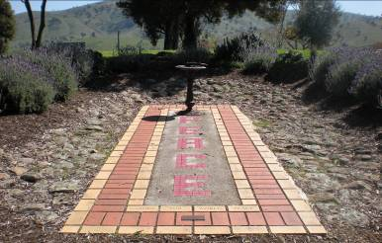
Reflective spaces within gardens
This tiled area in the Tallangatta Peace Garden offers a reflective space for visitors. Commemorative gardens often have structures, memorials and/or plaques which interpret the meaning of plantings and allow for private commemoration. Such areas are important and their role within the landscape should be respected and appropriately maintained.

Structures and furniture
As a general rule, original garden structures, furniture, fittings and services should be conserved in their original locations. If they must be replaced and the original items are unavailable or unsuitable, a contemporary item may be preferable to a reproduction which is out of character with the place. In certain cases, reconstruction of original elements may be justified. Correct care of plantings, the surrounding landscape and any associated commemorative structures is essential to maintain the memorialising intention of the communities which planted them.
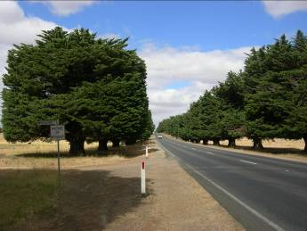
Maintaining the canopies of larger trees
These Monterey Cypresses in the Mortlake Avenue of Honour are regularly clipped into a barrel shape to manage the canopy and prevent long term canopy loss and branch splitting. Other avenues are not so well maintained and are now at risk of canopy collapse.

Annual maintenance
A well thought out maintenance program will keep gardens in good condition at a reasonable cost. Major rehabilitation following years of neglect can be expensive. Because landscape elements alter not only with the seasons but also over many years, understanding the place can be difficult. This continual change means that the maintenance of a botanic feature must always proceed cautiously.

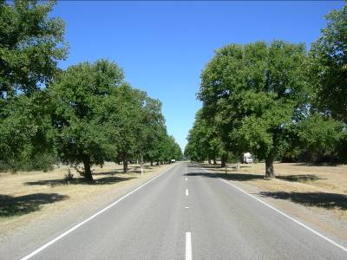
The benefits of regular maintenance
The Newstead Avenue of Honour is made up of Elm Trees. The surrounding ground is regularly maintained: the lawn is mowed, and weeds and elm suckers are removed thus creating an environment in which the trees can thrive. These trees could be further improved by the addition of mulch around the base of the trunk. Even older trees can benefit greatly from mulching.

Monitoring plants for disease
It is important to regularly check plantings for signs of disease that may adversely affect their condition or longevity. Early detection and treatment by a qualified horticulturalist can often be effective. In some instances, however, it may be better to remove diseased trees and replace them with healthy young plants of the same species.

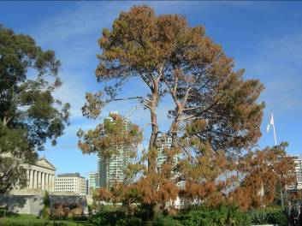Botanical diseases
The Lone Pine at the Shrine of Remembrance was planted in 1933 from the seed of a pine cone souvenired by a soldier at Gallipoli. Since 2011 it has been suffering from a fungal disease and much of its foliage has turned brown. It is important to monitor plantings for disease and to seek the advice of a horticulturalist to undertake treatment as soon as it is observed.

RESOURCES
For further information contact:
National Trust of Australia (Victoria)
Address: Tasma Terrace, 4 Parliament Place, East Melbourne Vic 3002
Telephone: (03) 9656 9800
Web: www.nationaltrust.org.au/vic/Home

Royal Historical Society
Address: 239 A'Beckett Street Melbourne Vic 3000
Telephone: (03) 9326 9288
Web: www.historyvictoria.org.au/

Arboriculture Australia
Telephone: (08) 8340 4911
Free Call: 1300 664 374
Email: enquiries@arboriculture.org.au
Post: P O Box 76, Edwardstown SA 5039

TreeNet
Address: University of Adelaide Waite Campus
Telephone: (08) 8303 7078
Email: david@treenet.com.au
Post: PMB 1, Glen Osmond SA 5064
Web: www.treenet.com.au/

**The text in this fact sheet has been adapted from Heritage Victoria brochure ‘Heritage Gardens’

Where can I get this and other fact sheets? The DPC Preserving war heritage and memorabilia fact sheets provide information about the care and conservation of a range of heritage material. They can be downloaded at www.dpc.vic.gov.au/veterans/factsheets
Disclaimer The material contained in this guide is for general reference only and should not be relied upon as the sole basis for heritage conservation or restoration. A professional conservator or conservation architect should be consulted before any conservation or restoration is undertaken. The Victorian State Government does not warrant the accuracy or completeness of the information and disclaims all liability for any loss or damage that may be caused by reliance upon it. Provision of names of suppliers or websites does not imply that a supplier is endorsed or approved by Heritage Victoria or the Department of Premier and Cabinet.

