External Finishes

About this technical note
This technical note was prepared by RBA Architects + Conservation Consultants in collaboration with Heritage Victoria in response to the 2022 Victorian floods.
This Technical Note discusses external finishes to substrates of a variety of older buildings and structures, mostly heritage listed, affected by flooding or intense rainfall events. The information outlines responses to these disasters, examines possible rectification and prevention methods to ensure greater resilience of the structures and finishes against future disasters.

Substrates of buildings and structures, that is, surfaces upon which finishes are applied, can be constructed of masonry (brick, stone, concrete block), timber and metal.
External finishes generally include paint (lead, oil based, acrylic, mineral), render which may have skim coats sch as colourwashes or limewashes and attached claddings such as metal, timber or fibre-cement sheeting which are non-structural. Membranes could also be included. Asbestos cement sheeting was also used in older buildings and requires specialist contractors to remove and dispose of damaged sheets in approved processes.

Uncoated masonry walls and repairs to timber are generally not discussed in detail here as they are covered in Floods and Heritage: Looking after flood-affected masonry and Heritage and Floods: Timber in Buildings.

For these exposed finishes potential damage stemming from flooding can be reduced by implementing protocols as part of a Disaster Management Cycle to avoid or mitigate risks at various stages of any future flood event.
Risk Management Cycle
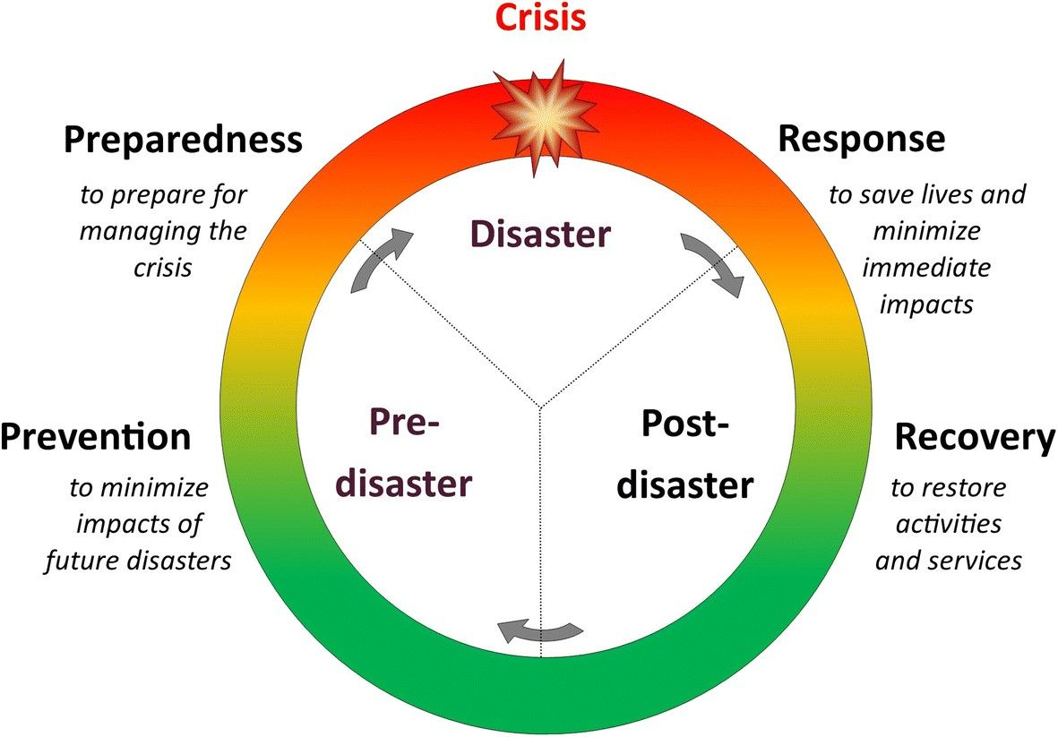
Figure 1: Risk Management Cycle – providing clarity to disaster process.

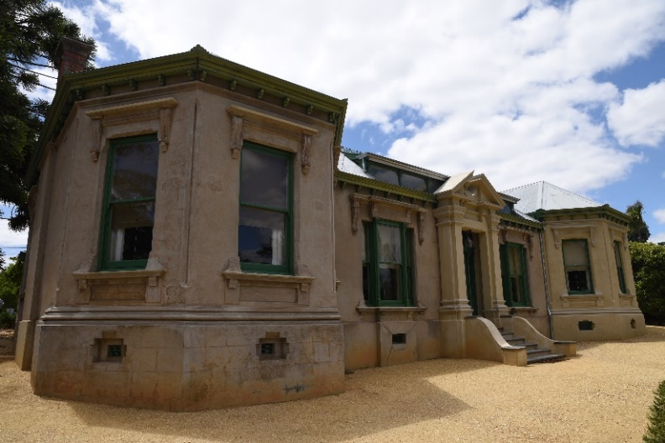
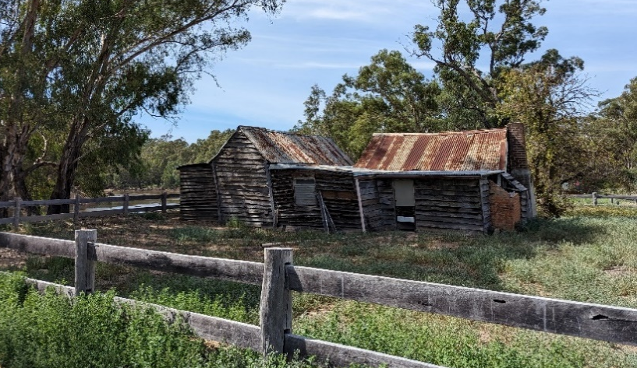

Figure 2: Buda Homestead: Render external finish Figure 3: Master’s House: Timber cladding external finish

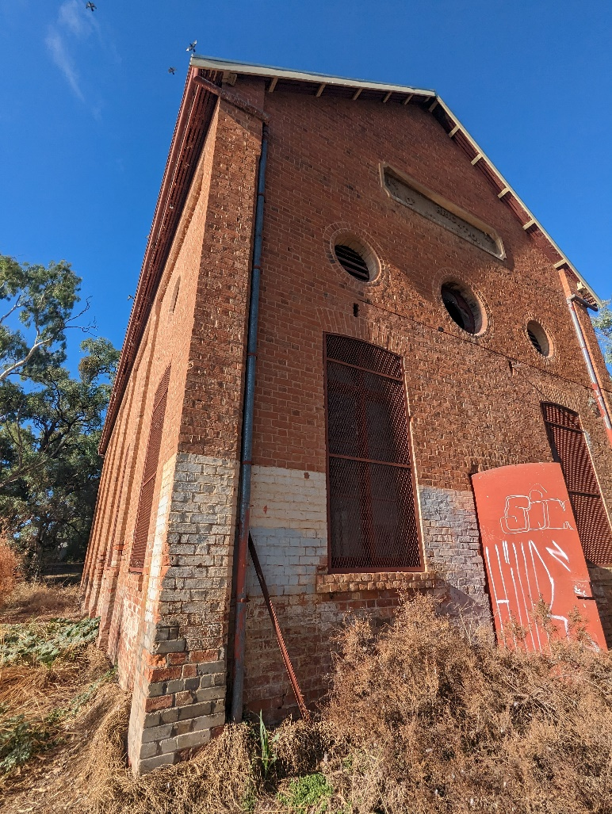

Figure 4: Painted masonry external finish – demonstrating different applications, salt attack.

Note:
- Engage a heritage consultant to determine a scope of works.
- If your place is included in the Victorian Heritage Register or is an archaeological site, under the Heritage Act 2017 you are obligated to contact Heritage Victoria for a pre-application meeting before starting any works to apply for a permit or permit exemption.

Risk management approach
Stage | Approach | Strategies
Prevention | Maintenance Plan | - Prepare and implement a Maintenance Plan.  - Regular inspections and the undertaking of maintenance works can be a relatively low-cost solution in the long term and appropriate for minor flooding.
 | Substrates | - Masonry walls are generally porous, allowing water laden air to enter and evaporate in cycles. During the night as the air cools, water vapour enters the masonry structures. Then during the day, the water is evaporated out again. This is known as ‘breathing’ and is necessary for the ongoing ‘health’ of masonry structures to prevent dampness and decay. If masonry is painted with a sealant, such as acrylic paint, this ‘breathing’ is restricted. Water will undoubtedly find a way into the porous masonry, be trapped behind the coating and not be able to evaporate, causing problems with salt attack and rising damp. Often an acrylic paint will bubble with water or blister with salt.  - Different timbers are used for different purposes, either for structural, cladding or decorative uses. Depending on the timber, they can remain uncoated and generally ‘silver’ with age and resist rot and diseases. However, all timber will eventually react to weathering, plant or insect attack, some more quickly than others. There are methods of repairing timbers with a flexible epoxy or scarfing in a section (with matching timber), without having to replace a whole member. Factoring in regular inspections of timberwork in a Maintenance Plan and repairing or repainting as required, will lengthen the serviceability and life of the timber.  - Most exposed metal in older buildings is given a finish, such as paint, as protection against oxidization and rusting. If the substrate is not regularly repainted, corrosion can occur which will further lift the finish. The rust will need to be removed before repainting can occur.  A common defect of concrete substrates is concrete cancer. This is when metal reinforcing installed inside the concrete is exposed to air or water, generally through hairline cracks. The metal bars will start to corrode and expand with rust, forcing the concrete outwards. This can lead to cracking and/or spalling, when pieces of concrete become dislodged or fall off. Regular inspection of concrete substrates will reveal cracking which should then be repaired before the metal becomes exposed. Some early concretes did not have metal reinforcing. However, all cracked, loose, crumbling, broken or defective sections to concrete substrates should be repaired to stop penetration of water or plant life.
 | Paint Systems | - Acrylic paint to masonry walls should be removed before any flooding is predicted. Generally, mineral paints will allow the masonry to continue to breathe.  - Until the 1970s, high levels of lead were added to paint and was not fully banned from paints until the 1990s. Generally, if lead paint has been overpainted with acrylic or mineral paint and a repainting maintenance regime is in place, this is not a problem. The early coatings contain the history of paint colours at the place. When the lead paint has not been overpainted or later paints are not maintained, then there could be a potential problem of the lead contaminating surrounding areas during flood and severe storm events. It is recommended that paint to any timber (weatherboards, timber doors and windows, timber roof accessories) and metal work (rainwater goods, decorative metal elements etc.), be maintained correctly and recoated before any flood or storm event.  Oil based paints contain natural (such as linseed) or synthetic oils(alkyd) and generally used for windows and doors and external trims as they are more durable than acrylic paints. The paint system should be regularly maintained to protect the timber or metal substrates below.
 | Coated Surfaces | - Acrylic paint to masonry walls is not ideal as this can seal and restrict the ‘breathability’ of masonry. Paint to masonry could be removed but can be a costly exercise. During a flood event, acrylic paints can lift and bubble.  - Until the 1970s, high levels of lead was added to paint and was not fully banned from paints until the 1990s. These early coatings contain the history of paint colours at the place and do not necessarily require replacing if coated with non-lead containing finishes. If the lead paint has not been overpainted or later paints are not maintained, then there could be a potential problem of the lead contaminating surrounding areas during flood and severe storm events. It is recommended that any previously painted surfaces such as timber (weatherboards, timber doors and windows, timber roof accessories) and metal work (rainwater goods, decorative metal elements etc.), be maintained and recoated periodically as part of routine maintenance.  - Oil based paints contain natural (such as linseed) or synthetic oils (alkyd) and are generally used for windows and doors to avoid sticking. The paint system should be regularly maintained to protect the timber or metal substrates below.  - Generally, mineral paints will allow masonry to continue to breathe. However, a build-up of many coats will lessen this ability over time.  - If a render has been applied to masonry, it is preferable that this is maintained or repaired, rather than painted, so that the ‘breathability’ of the masonry wall is maintained.
 | Asbestos | - Asbestos was used in cement sheeting until 1987. Test fibre cement sheeting for the presence of asbestos. It would be better to replace sheeting containing asbestos before possible flooding, as the sheets, all of which are now quite old, could be friable and start to break-up during a flood event, with the potential to spread into structures and the surrounding soil.
 | Landscaping | - The site surrounding a building will act as a 'sponge' that can receive and slowly absorb water into ground surfaces. By increasing permeable surfaces, the amount of water flowing into a building and onto other properties and streets will be reduced.  - The use of swales to redirect rising water from entering lower levels and relocating utilities and ductwork from crawl spaces are important safety aspects for controlling residual sources of moisture and mould.
Preparedness | Prepare | - Prepare an Emergency Management Plan to be actioned when flooding is predicted. Refer to Maintaining and modifying a heritage property and Disaster Preparedness Toolkit webpages.  If floods are predicted, agreed strategies need to be enacted before the flood reaches the building, such as dry or wet flooding. Refer to the Heritage and floods: preparation and recovery.
Response | Inspect | - After flood waters have receded and the structure can be inspected, action the Emergency Management Plan, especially if the structure has been affected.  - This would include informing Heritage Victoria, local council, insurance companies, engineer etc. of any damage sustained to significant fabric.  - Remove temporary barriers to allow natural drying of the external finishes and sub-structure once the threat of further flooding has passed.  - Drying of the affected areas will depend on the height of the flood waters, duration of immersion, flooding of sub-floor areas such as cellars and effectiveness of drainage. Natural drying by opening windows for cross-ventilation etc. is preferable. Heat from de-humidifiers may cause mould growth in upper sections. Fans may dry out areas too quickly causing cracking.
 | Record | - Document the impact of the flood.  - Take photographs and make notes.  - Video recordings may also be useful
 | Coated Surfaces | - If an acrylic paint has been affected by flood waters, that is, bubbling, dislodging, or cracking during drying, the paint may need to be removed. This would also assist in drying the substrate.  - Washing mud from external coated surfaces should be undertaken with low pressure water (garden hose pressure) and a nylon brush. High pressure hosing is to be avoided at all times, as this is likely to further damage the substrate and coated finish. Captive head washing, discussed further in Technical Note - Floods and Heritage: Looking after flood-affected masonry, is also an acceptable method for cleaning surfaces.  - If lead paint needs to be removed, it should be undertaken by a licensed, experienced professional.
 | Renders | - If an acrylic paint has been affected by flood waters, that is, bubbling, dislodging, or cracking during drying, the paint may need to be removed. This would also assist in drying the substrate.  - Washing mud from external coated surfaces should be undertaken with low pressure water (garden hose pressure) and a nylon brush. High pressure hosing is to be avoided at all times, as this is likely to further damage the substrate and coated finish. Captive head washing, discussed further in Technical Note - Floods and Heritage: Looking after flood-affected masonry, is also an acceptable method for cleaning surfaces.  - If lead paint needs to be removed, it should be undertaken by a licensed, experienced professional.
 | Sheeting or Panelling | - Fibre cement sheeting (FC sheeting) which has been used as external cladding, is expected to resist damage from flooding so long as there is no other physical damage present.  - Long-term damage to the durability of any form of panelling may result in corrosion of panel reinforcement or fittings, damage from impact by flood debris etc, in which case, the affected panels would probably need to be replaced.  - Refer asbestos sheeting.
Recovery | Engage | Engage a heritage consultant to determine a scope of works and then contact Heritage Victoria for a pre-application meeting.  Before starting any works apply to Heritage Victoria for a permit or permit exemption.
 | Repairs | - Any damaged or drummy render should be removed, the substrate allowed to dry, salts removed if required and the finish reapplied matching the original colour and mix. Refer to Technical Note - Floods and Heritage: Looking after flood-affected masonry, in regard to sacrificial renders etc.  - If a finish has been applied to the surface of traditional render, such as a lime wash, this may need to be reapplied after cleaning the affected areas. Any new finishes should match the original in colour and mix.  - Repairs to traditional fabric using modern materials will have different physical properties and could affect the drying process. Traditional mortars and renders on external masonry, with a lime wash would maximize water-vapor dispersal through the external face.  - The introduction of new structural elements, waterproof coatings and vapor-impermeable materials often cause more deterioration than anticipated.  - If finishes to metal substrates have been damaged, these could lead the metal to be exposed to the elements and corrosion will begin very quickly. Rust should be removed before a finish, matching the original, is reapplied.
 | Resilience | - Review the Maintenance Plan and Emergency Management Plan and update with new information to improve the future resilience of external finishes to withstand disasters, including flooding, fire and earthquakes.  - Review of the Disaster Management Cycle and efficacy of the emergency response will improve future flood response measures.
Below includes further information to help you understand common terms and resources:
Resources | Bureau of Meteorology, http://www.bom.gov.au/australia/flood  Curtis, Roger, Water Management for Traditional Buildings: Adaptation for a Changing Climate, APT Bulletin, The Journal of Preservation Technology, 2016, Vol. 47, No. 1  Hawkesbury-Nepean Floodplain Management Steering Committee, Reducing Vulnerability of Buildings to Flood Damage, June 2006.  Pickles, David, Flooding and Historic Buildings, Historic England, April 2010  Horowitz, Ann D., An Introduction to Adaptation Strategies, APT Bulletin, The Journal of Preservation Technology, 2016, Vol. 47, No. 1  Park, Sharon C., Sustainable Historic Properties in an Era of Climate Change, APT Bulletin, The Journal of Preservation Technology, 2016, Vol. 49, No. 2-3  Ridout, Dr. Brian, Discovery, Innovation and Science in the Historic Environment, Historic England, 2017

