Antique and heritage munitions

Firing weapons, artillery and ammunition
Also see ‘Metal objects’ for swords and edged weapons.

What are munitions?
Munitions or ordnance includes firearms (guns, pistols, revolvers, shotguns etc), artillery and projectiles (shell-firing guns, howitzers, mortars, rockets) and ammunition (bullets, bombs, missiles, grenades, warheads, mines). These are composite objects usually made of a number of different materials.

SAFETY FIRST
Munitions or ordnance must always be handled carefully to prevent injury.
- Always handle munitions as if it is live or loaded until you ascertain that it is not.
- Do not touch, examine or move an item of ordnance if you don’t know whether it is live or loaded or not, or if you are unsure of how to check this.
- Just because an item has been in someone’s shed or your collection for many years does not mean it is safe.
- Any items retrieved from underground, the sea or air crash sites should always be considered potentially dangerous.
- Better to be safe than sorry – ALWAYS, always seek advice from the Explosive Ordnance Service (contact details page 3).
- Some components of ordnance may be toxic – always wear gloves and work in a well ventilated area.
- Always pick up a firearm at the ‘waist’ of the stock with one hand and around the barrel with the other hand.
- Never point a weapon at a person.
- Keep your fingers away from the trigger and other moving parts.
Carry only one weapon or piece of ordnance at a time.

People have been hurt and killed while dealing with historic munitions. ALWAYS check for safety first.

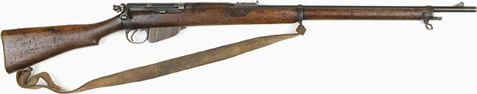
A Lee-Enfield Mark 1 Rifle (1900) used by Trooper H W Anderson of the Victorian Mounted Rifles
Photo courtesy Australian War Memorial

Who can help with potentially live munitions/ordnance?
Explosive Ordnance Service
EOD Control Centre, Victoria Barracks, Southbank Vic 3006.
Phone: (03) 9282 4139
Mobile: 0438 675 426
Email: MELB.SATO@defence.gov.au

LEGAL ISSUES
Museums that hold firearms must obtain an exemption from the law governing firearms licensing (see below). When obtaining this permission you will be told the type of storage arrangements that are legally permissible for your particular firearm(s).

Are your firearms legal?
In order to legally hold or acquire a firearm, Victorian museums must obtain an exemption from the law governing firearms licensing or make other arrangements with relevant licensing authorities. Section 184 of the Firearms Act (Victoria) allows the Chief Commissioner to recommend to the Minister that a museum be granted an exemption from the requirements of the Act if the Chief Commissioner is satisfied that:
- the museum is a body corporate which is not run for profit and is publicly funded, and
- the premises of the museum are open to the public, and
- the museum is of an educational, historical or cultural nature.

A museum that wants to seek exemption from the Act needs to provide a written submission to:
Regulation Support Unit
Licensing Services Division
Victoria Police
GPO Box 2807
Melbourne Vic 3001
Strict conditions apply to the handling, storage and display of firearms by museums, and the exemption depends on these conditions being in place.
The full Firearms Act 1996 and subsequent amendments can be accessed online at
www.austlii.edu.au/au/vic/
The current Firearms Act 1996, including all amendments, can be found by searching for Firearms under Acts in the Victorian Law Today Library at www.legislation.vic.gov.au/
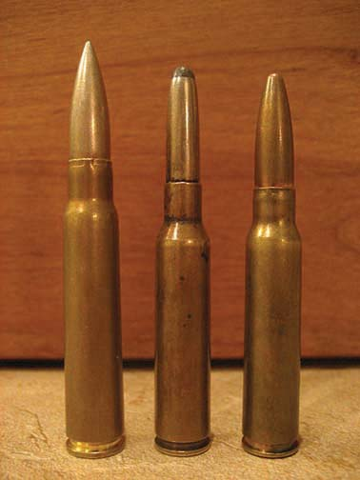The licensing division of Victoria Police may also be able to answer further questions.
Phone: 1300 651 645

RSLs and firearms
The Victorian Branch of the RSL (Anzac House) currently holds a firearms dealer licence and all the sub-branches are covered in a display permit that has been issued with very specific storage conditions on Anzac House and the sub-branches. Please check with Anzac House to ensure your sub-branch is complying with these conditions. RSL Sub-Branches or Memorabilia Officers who have questions about the obligations in relation to firearms or other ordnance should contact Anzac House on (03) 9655 5555.

Dismantling and active conservation
This guide will not tell you how to dismantle and actively conserve guns or munitions (e.g. remove corrosion or treat them with preparations). These techniques require specialist knowledge of munitions and cleaning and stabilisation materials. This guide provides basic preservation information only.

What are munitions made from?
- metals such as iron, steel, bronze, brass, copper, aluminium, lead or cadmium
- wood and occasionally other organic materials such as mother of pearl
- plastics and rubber
- paint and adhesives
- textiles, leather and rope
- explosives (e.g. nitroglycerin, TNT, HMX, PETN, nitrocellulose)
- propellants which consist of a fuel such as gasoline plus an oxidiser such as ammonium perchlorate or ammonium nitrate
- other fillers such as phosphorous or other chemicals or objects such as nails
- asbestos.

What are the main threats to munitions?
- high, low or fluctuating humidity
- dust
- salts and pollution
- neglect
- incorrect attempts at repair or cleaning
- insects and mould
- inherent vice – an object has been made of materials which are incompatible with each other
- chemical instability of some components.

If munitions in your collection need to be dismantled and cleaned, contact a conservator with experience in heritage munitions.
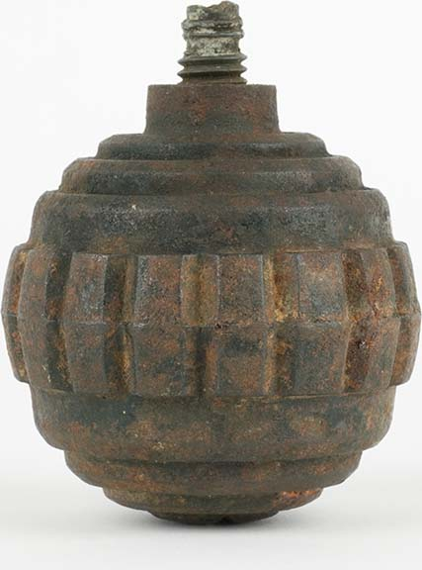
A First World War German hand grenade.
Photo courtesy Australian War Memorial

Firearms
Museums Australia (Victoria) has a wide range of resources, including a Fact Sheet on Firearms and Victorian Museums. See: http://mavic.asn.au/resources

How do these threats damage munitions?
- Water, dampness, pollution and salts can cause serious corrosion (rust) of metals.
- Corrosion will be faster in wetter areas and near the sea.
- Humidity can promote mould growth on wood, webbing and leather.
- Humidity and/or time can cause explosives to become unstable.
- Wood will crack or split and inlay may be lost in conditions where the humidity changes rapidly e.g. from dry to damp.
- Abrasive cleaners can scratch metals and leave disfiguring residues.
- Wood boring insects can cause holes or weakness and become more active in damp conditions.
- Fuel or propellants can leak or cause corrosion.
- Dust promotes corrosion and sinks into porous materials like wood.
- Dissimilar metals in contact can cause accelerated corrosion of one of the metals (galvanic corrosion).
- Materials such as rubber or plastic can degrade and crack, soften or ooze over time.

REMEMBER
- Assume all historic munitions are live unless proven otherwise – read the instructions above.
- Before you do ANYTHING, consult a qualified heritage specialist or a metals conservator.
- Before you start, ALWAYS look at the list of resources at the end of this fact sheet. There will be detailed information already available.
- Never give up – something that looks ‘hopeless’ can often be recovered.
- All military ordnance will age – it is the speed at which this happens that you can influence.
- It is not disgrace for an item to look its age and reflect its history.
- Ordnance should not look shiny and new, it should reflect its history. Don’t remove evidence of its past.
- Munitions is usually made from a complex mix of materials and will likely need specialised attention to survive for the long term.
- Once moved from storage to display areas, firearms should be temporarily or permanently rendered non-firing.
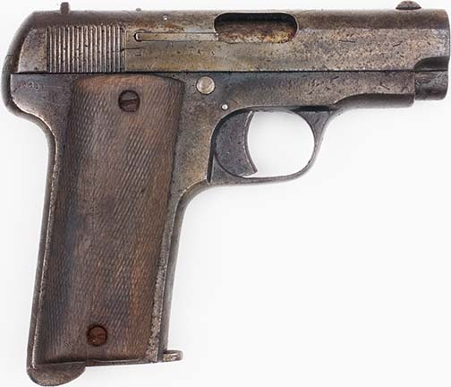
For safety reasons, firearms should be stored
separately from their ammunition.

Ordnance should not look shiny and new, it should reflect its history.
Don’t remove evidence of its past.

General principles

Safety and handling
DO
- Have a plan for dealing with ordnance if you are uncertain about its safety.
- Ensure all licences, exemptions and records are up to date.
- Have a suitable work area away from your display area.
DON’T
- Allow untrained and inexperienced volunteers to handle ordnance.

Cleaning
DO
- Dust munitions with a soft brush or a soft clean cloth and protect from dust in the future.
- Remove dried dirt, grease and oils from wood and metal components by using wooden toothpicks or wooden skewers.
DON’T
- Use metal picks or tools or wire brushes to clean munitions (use wooden toothpicks or skewers instead).
- Use abrasive polishes such as Brasso to clean copper, bronze or brass components.
- Use linseed oil or other natural oils or waxes on wood, metal or plastic.
- Apply leather dressings, conditioners or oils to leather accessories, slings, pouches etc.

Storage and display
DO
- Store munitions in an environment with a stable temperature and humidity.
- Store all loose ordnance accessories such as belts separately, as leather can react with metal and cause deterioration. However, if the leather is intimately attached to metal do not disassemble items. (Make sure you number separated ordnance components carefully so you know what belongs with what.)
DON’T
- Expose munitions to sunlight.
- Keep live ammunition and certainly do not display it.
Do read the ‘Metal Objects’ flyer in this series for instructions on how to care for metals.

Do store guns and ammunition separately.
It is not advisable that RSLs and community museums hold live ammunition. It certainly should not be displayed.
BASIC CLEANING
- Record the condition of the ordnance before and after each cleaning.
- Clean the wood with a cloth barely dampened with warm water mixed with a few drops of wool wash detergent, and quickly wipe dry with a clean, white cloth. Allow to dry in a warm place.
- Use cotton swabs dampened with water mixed with a few drops of wool wash detergent to remove dirt from crevices.
- Apply a thin coat of Renaissance wax or other high quality non-biological hard wax to the wood, being careful not to apply wax to inlaid decoration.
- Buff the wax dry with a soft cloth leaving a light film to protect the surface.
- Apply a small amount of lightweight, non-drying mineral oil (lubricating or gun oil) on moving metal parts with a cotton swab.
- Remove excess oil with a soft, clean cloth.
- Wipe fresh fingerprints from metal using non-drying oil and a soft, clean cloth.
- Handle with cotton or nitrile gloves.
- Use a clean, soft cloth to wipe away dust on leather accessories.
- If mould is present on leather or web components, seek expert advice: mould is toxic.

STORAGE
Victorian museums which hold firearms must obtain an exemption from the law governing firearms licensing, or make other arrangements with relevant licensing authorities. When obtaining permission to hold firearms, organisations will be told the specific storage arrangements that are legally permissible. These arrangements differ from state to state around Australia. RSL Sub-Branches seeking advice about firearms or munitions storage should contact Anzac House on (03) 9655 5555.

RESOURCES
See the following fact sheets for more details
on particular materials:
- General principles
- Outdoor heritage (cannon, tanks
and other big stuff)
- Metal objects
- Wooden objects.

There are publications available which are relevant to ordnance.
Conserve-o-gram 10/1 ‘Caring for historic longarms: storage and handling requirements’, National Park Service, USA: www.nps.gov/history/museum/publications/conserveogram/10-01.pdf
‘Dangers of abrasive cleaning’ National Park Service, USA:
www.nps.gov/history/hps/tps/briefs/brief06.htm
‘Asbestos’ National Park Service, USA:
www.nps.gov/history/museum/publications/conserveogram/02-11.pdf
‘Historic firearms and ordnance: Artefacts
with special problems’, Ohio History:
www.ohiohistory.org/resource/oahsm/notebook/janfeb1991.html

Where can I get this and other fact sheets? The DPC Preserving war heritage and memorabilia fact sheets provide information about the care and conservation of a range of heritage material. They can be downloaded at www.dpc.vic.gov.au/veterans/factsheets
Disclaimer The material contained in this guide is for general reference only and should not be relied upon as the sole basis for heritage conservation or restoration. A professional conservator or conservation architect should be consulted before any conservation or restoration is undertaken. The Victorian State Government does not warrant the accuracy or completeness of the information and disclaims all liability for any loss or damage that may be caused by reliance upon it. Provision of names of suppliers or websites does not imply that a supplier is endorsed or approved by Heritage Victoria or the Department of Premier and Cabinet.

