Collections

About this technical note
This technical note was prepared by Caroline Kyi (Kyi Conservation) in collaboration with Heritage Victoria in response to the 2022 Victorian floods.

Collections and impact
Flood events can result in catastrophic inundation of water into buildings and sites that house collections, damaging collection items and other heritage fabric. Collections and the heritage fabric of a place can be made of materials that are highly susceptible to damage when in contact with water, even briefly.

Flood water may also contain chemicals, pollutants, micro-organisms and mud, which may also contribute to the deterioration of collections and built heritage fabric. Increases in the water content of materials and relative humidity, associated with flood events, can promote mould growth.

Collections housed outside of mainstream museums such as historical societies, living museums and private collections often face specific challenges in responding to floods due to the uniqueness of their collection items and the significance, condition, use and management of the site housing, the collection.

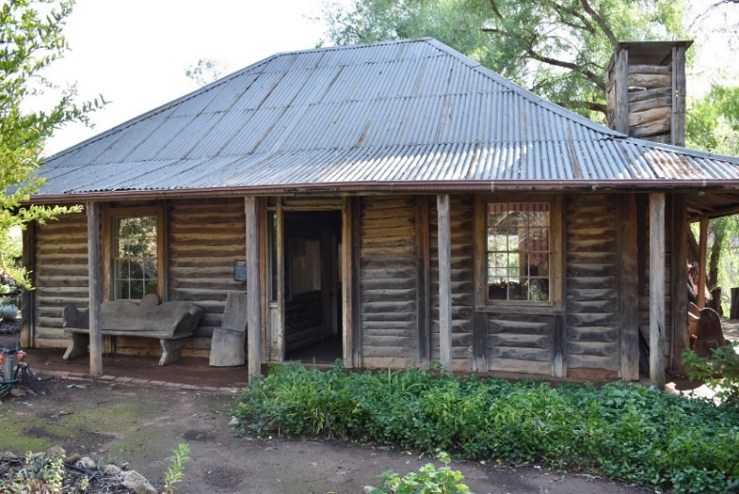
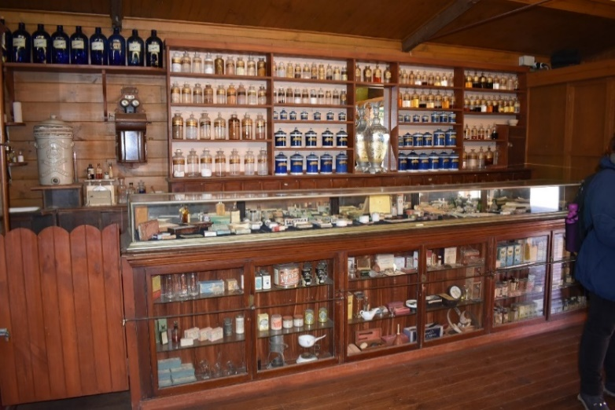

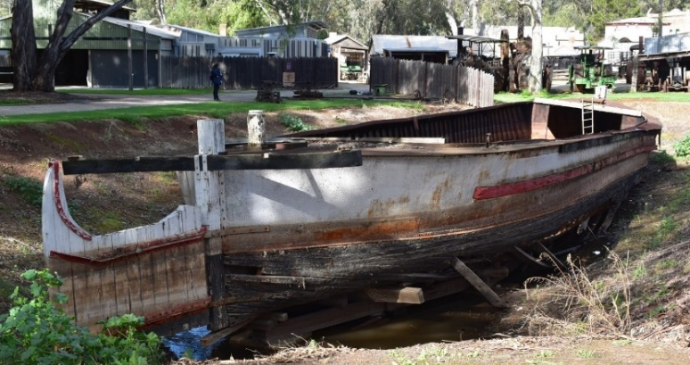
Figure 1 & 2: Pioneer Settlement, Swan Hill, collections such as replica buildings, items they house. (Kyi Conservation)
For living history museums such as ‘Pioneer Settlement, Swan Hill’, the terms ‘collection items’ and ‘heritage fabric’ may include replica buildings and the fixtures and items that they house. Seen here is the interior of the ‘J. H Barker Chemist’ building and some of the items that are part of the collection. Owners/managers are advised to seek guidance from conservation professionals to develop disaster protocols that responds to the unique requirements of the place and the collection.

Figure 3: Pioneer Settlement, Swan Hill, movable objects. (Kyi Conservation)

Collections, such as that housed at ‘Pioneer Settlement’ may have items that are considered moveable, immovable and everything in between. Identifying which items can and/or need to be relocated in the event of a flood is an important part of the developing site-specific disaster protocols.
For these collections potential damage stemming from flooding can be reduced by implementing protocols as part of a Disaster Management Cycle to avoid or mitigate risks at various stages of any future flood event:

Risk Management Cycle

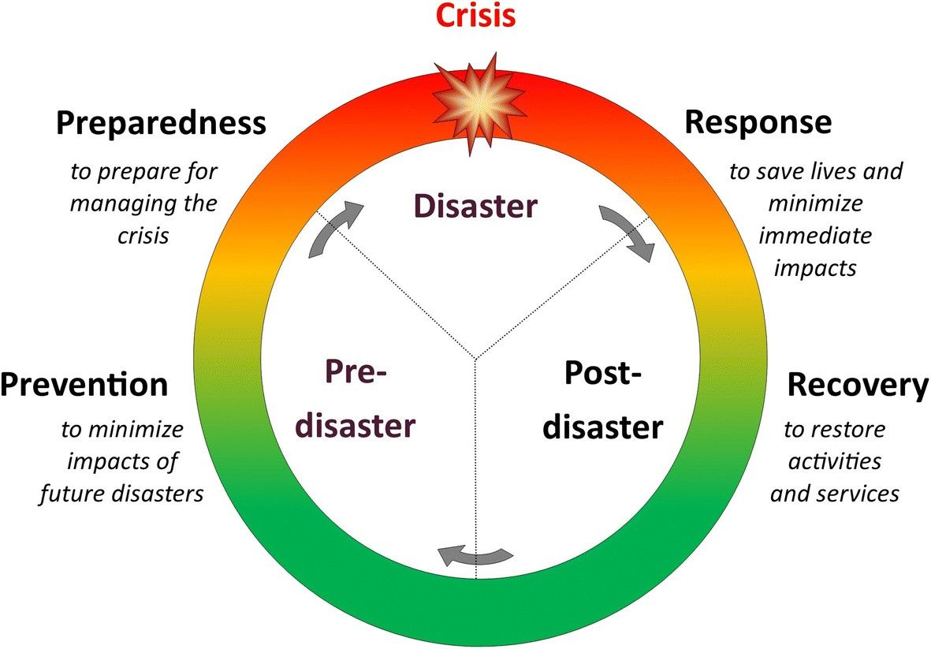
Figure 2: Disaster Management Cycle – providing clarity to disaster process.

Note:
- Engage a heritage consultant to determine a scope of works.
- If your place is included in the Victorian Heritage Register or is an archaeological site, under the Heritage Act 2017 you are obligated to contact Heritage Victoria for a pre-application meeting before starting any works to apply for a permit or permit exemption.

Disaster management approach
Stage | Approach | Strategies
Prevention | Avoid | - Avoid constructing buildings or installing immoveable collection items in areas prone to flooding or water pooling.  - Incorporate flood prevention and mitigation measures in the building’s design and/or landscaping.
 | Detect | - Be aware of flood and severe weather warnings.  - Install environmental monitoring systems to detect changes in temperature, light and relative humidity.
 | Mitigate | - Clearly allocate staff roles for emergency response coordination.  - Assemble and identify the location of the Emergency Response Kit.
Preparedness | Places | - Pack up and relocate online and hard copy documentation backups.  - Install temporary flood protection.
 | Heritage Fabric | - Relocate significant items of built heritage fabric, recording new locations.  - Place tarpaulins or industrial polyethylene sheeting over any immovable objects and parts of building prone to seepage.  - Stabilise in situ or if possible, dismantle and relocate larger and immoveable items and vulnerable built heritage.
 | Small Objects | - Pack up and relocate significant items, recording new locations.  - Relocate to higher ground or lift items up off the floor.
Response | Document | - Documentation of post flood impact images and notes is crucial.  - Environmental monitoring data will inform heritage professionals how built heritage will react during the clean-up, as well as indicate when it is safe for objects to return.
 | Cleanup | If the relative humidity remains high enough to facilitate mould growth (>70%), collection items should be relocated, or the recovery phase implemented as soon as possible.
 | Salvage | Remove salvaged collection items and heritage fabric that have been prioritised to be conserved off-site, in consultation with heritage professionals.
Recovery | Drying | - Prioritise drying through natural ventilation, opening windows and doors of a collection facility or placing salvaged collection items in a safe outdoors setting.  - Forced drying can exacerbate and cause further damage.
 | Strategy | Review of response phase documentation and environmental monitoring records can inform the planning and prioritisation of specialist conservation measures and scheduling of treatments to stabilise and repair damaged collection items.
 | Resilience | Review of the Disaster Management Cycle and efficacy of the emergency response will improve future flood response measures.
Below are some useful resources to help you prepare for and recover from a flood event:
Emergency Response Kit |  | Basic Supplies:  - polyethylene sheet (roll)  - mops  - bucket  - squeegees  - rubber gloves  - rubber boots  - hardhats  - flashlight and batteries  - blotting paper  - unprinted newsprint (roll)  - terry towelling  - freezer paper  - sponges  - ziplock bags  stationery | Substantial supplies:  - wet/dry vacuum  - industrial fans  - extension cords  - step ladder  - carts  - dehumidifiers  - tools  - temporary flood protection equipment (sandbags, barriers)  - trestle tables  - A-frame trolleys  Full contingency supplies:  - shipping containers  - salvage stores  - freezers  - access to freeze driers  - contingency room
Drying |  | - Drying of materials is a priority and should be undertaken as soon as possible after the event.  - Drying is best achieved through natural ventilation and use force drying only where necessary and when monitored.  - Reduce/remove pooling found in association with immovable items  - Remove excess moisture with absorbent materials.  - Arrange and position collection items and heritage fabric in ways that promote thorough ventilation and maintain their form.  - Monitor efficacy of ventilation measures in reducing relative humidity during drying process
Resources |  | - Australian Institute for the Conservation of Cultural Materials: Be Prepared Guide for Small Museums  https://aiccm.org.au/wp-content/uploads/2020/01/beprepared.pdf  - Grimwade Centre for Cultural Materials Conservation: Flood Recovery https://arts.unimelb.edu.au/grimwade-centre-for-cultural-materials-conservation/conservation-services/services-support/flood-recovery  - Blue Shield Australia: Flood Recovery Resources https://blueshieldaustralia.org.au/resources/flood-recovery/  - Canadian Conservation Institute  - https://www.canada.ca/en/conservation-institute/services/agents-deterioration/water.html
Salvaging |  | - Avoiding the disposal of water damaged collection items and  heritage fabric is a priority. Salvaged items may be saved during the recovery and conservation phases.  - Collection items and heritage fabric may need to be salvaged and or relocated as part of the flood response.  - Labelling of salvaged and/or relocated items and heritage fabric helps manage the collection during this phase.  - Large collection items or built heritage fabric that has been transported by flooding should be relocated to a protected site.  - Water damaged objects may require structural support during salvage and relocation.  - Objects may require gentle rinsing to remove silt and debris.  - Temporary bagging of individual collections items for storage/relocation may be appropriate.  - Freezing of collection items for long term storage is advised if the schedule for recovery methods and conservation is unknown.

