Disaster Recovery Heritage Grants
  - Successful Projects: 2024-25
The Victorian Government’s Disaster Recovery Heritage Grants supports the repair and conservation of historic heritage places impacted by natural disasters. Severe weather and other disaster events such as the 2022 Victorian floods have damaged a number of State significant heritage places across Victoria.

The former Cobb & Co Staging Stables in Ararat, an historic grandstand at the Benalla Showgrounds, and popular tourist landmarks, Bendigo Pottery and the Stony Creek Rail Bridge in East Gippsland, are among the sixteen Victorian Heritage Register listed heritage places to receive funding through the Disaster Recovery Heritage Grants.

This investment will assist with the recovery and restoration of these important heritage places, and increase their resilience to future disaster events. Funded projects will protect State heritage values to provide benefits for heritage conservation, planning for disaster risk management and support community recovery.

DTP Region Hume
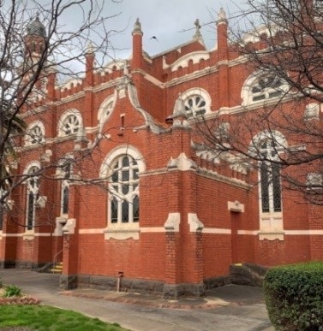 | St Joseph’s Catholic Church (H0845)  St Joseph’s Parish  Benalla | A grant of $95,000 has been provided for works to St Joseph’s Catholic Church impacted by storm and earthquake events. Constructed in the early twentieth century, it is an unusually large and ornate church building and hosts a variety of community outreach programs and events.
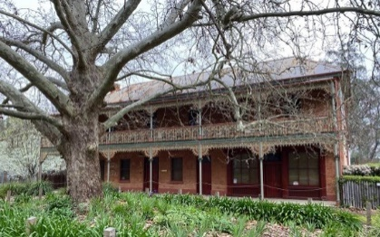 | Gregory’s Bridge Hotel  (HO963)  Private Owner  Murchison | A grant of $300,000 has been provided for repair works to Gregory’s Bridge Hotel in Murchison impacted by flooding. Situated on the banks of the Goulburn River, it was built between 1865-68 and operates as a bed and breakfast.
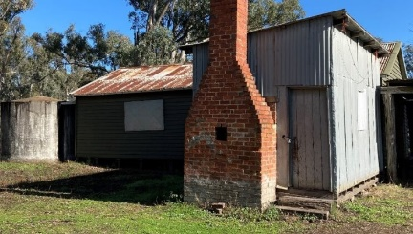 | Barmah Muster Yards (H2212)  Parks Victoria  Barmah | A grant of $75,000 has been provided for documentation and repairs to the Herdman's Hut and Musterer's Quarters at the Barmah Muster Yards impacted by floods. The Barmah Muster Yards site has been used continuously since the 1880s and is managed by Parks Victoria.
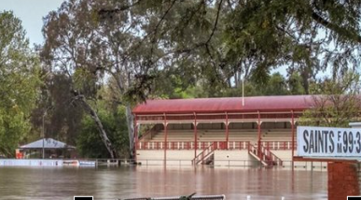 | Grandstand, Benalla (H0976)  Benalla Showgrounds Recreation Committee of Management  Benalla | A grant of $142,000 has been provided for urgent repairs to the Benalla Grandstand. Built in 1913, the timber grandstand is an important community landmark. Flooding caused significant damage to the grandstand requiring repairs to the roof, gutters and downpipes. The project will improve the grandstand’s condition and resilience to future natural disaster events.

DTP Region Port Phillip
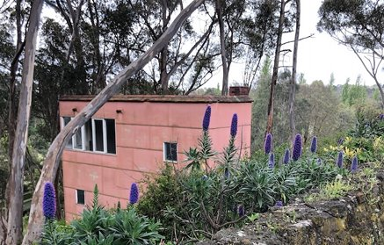 | Waller House & Collection (H0617)  National Trust of Australia (Vic)  Ivanhoe | A grant of $31,000 has been provided to undertake roof and other repairs to the Art Studio of the Waller House following severe storms. The home of prominent artists of the arts and crafts movement, Waller House is maintained as a house museum by the National Trust.

DTP Region Grampians
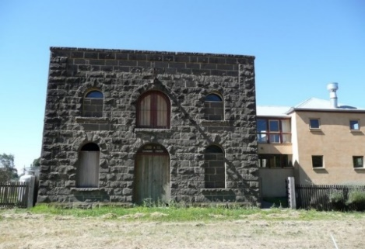 | Former Cobb & Co. Staging Stables (H0259)  Ararat Rural City Council  Ararat | A grant of $60,000 has been provided for works to the roof and other repairs following floods. The 1860s bluestone building served as a staging station for the Cobb & Co stagecoach company, which provided passenger, mail and gold escort services during the gold-rush.
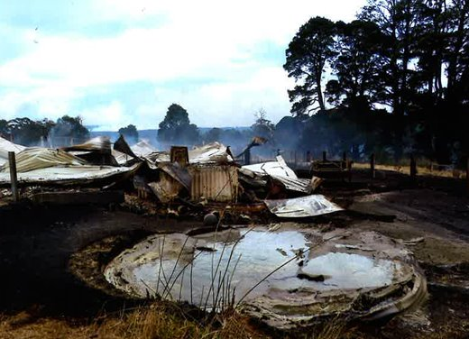 | Belmont (H0644)  Private owner  Raglan | A grant of $40,000 has been provided for preparation of a Disaster Risk Management Plan. Belmont was founded in 1858, and consists of an intact timber homestead, outbuildings and extensive gardens. Belmont was significantly impacted by fires in 2024 and the project will seek to prevent future disaster impacts.

DTP Region Loddon Mallee
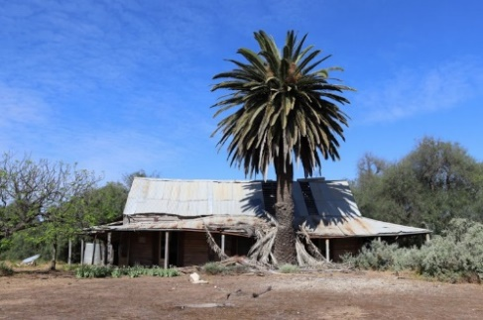 | Bael Bael Homestead (H2196)  Private Owner  Bael Bael | A grant of $300,000 has been provided to undertake urgent structural stabilisation and repair works to Bael Bael Homestead following severe storms.
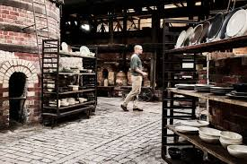 | Bendigo Pottery (H0674)  Private Owner  Bendigo | A grant of $300,000 has been provided to Bendigo Pottery, Australia’s oldest working pottery, for urgent repair works. The popular tourism attraction was impacted by floods.
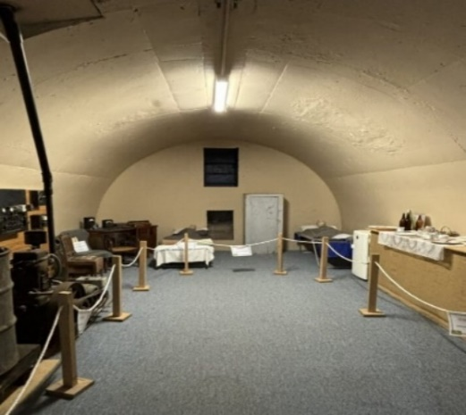 | Lake Boga Flying Boat Museum (H2208)  Swan Hill Rural City Council  Swan Hill | A grant of $65,500 has been provided for disaster risk management documentation and identification of high priority remediation works to the Lake Boga Flying Boat Museum. The museum located in original communications bunker was impacted by flooding and extreme rain.
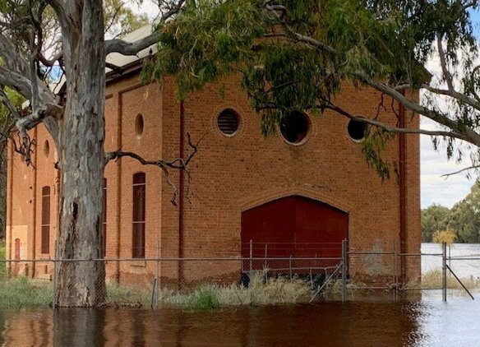 | Billabong Pumping Station (H0547)  Lower Murray Urban Rural Water Corporation  Mildura | A grant of $136,000 has been provided for urgent works to the Billabong Pumping Station to mitigate flood impacts. The pumping station is part of a vast irrigation scheme built in the late 19th century.
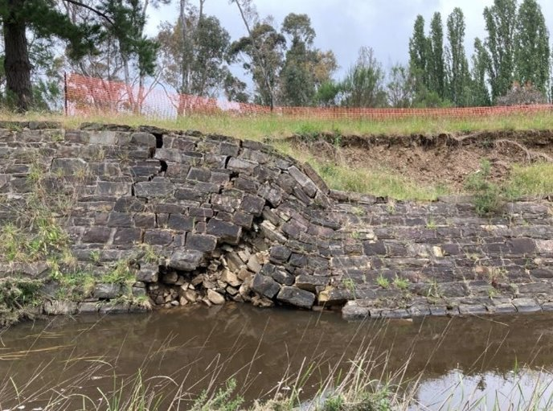 | Castlemaine Diggings National Heritage Park (Chewton Wall) (H2047)  Parks Victoria  Castlemaine | A grant of $40,000 has been provided for a heritage assessment of Chewton Wall in the Castlemaine Diggings National Heritage Park. Chewton Wall is one of the remnant features of a Victorian gold rush era mining site and was damaged by flooding in 2022.
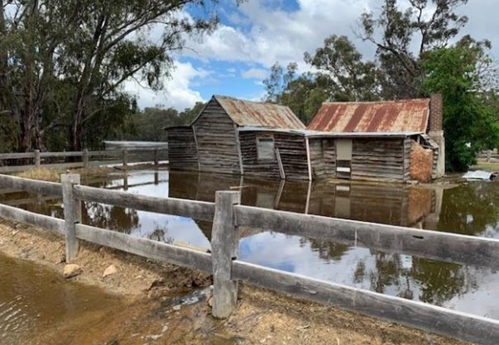 | Masters House (H2330)  Parks Victoria  Gunbower | A grant of $40,000 has been provided for a disaster risk management planning for Masters House, Gunbower. The house, flooded in October 2022, is a rare surviving riverbank residence in use for over 80 years by three generations of commercial fishers.

DTP Region Gippsland
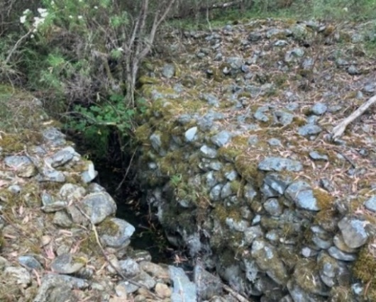 | Volunteer Defence Corps (VDC) Tambo Trenches (H2446)  Omeo Historical Society  East Gippsland | A grant of $50,000 has been provided to document the Volunteer Defence (VDC) Tambo Trenches impacted by the 2019/20 bushfires, to guide the long-term management and protection of the site. The trenches were built by the volunteer defence corps during the second world war. The trenches were sited for civil defence on a ridge above the Great Alpine Way in anticipation of air attack and invasion. Today the trenches are a rare remnant of Victoria’s wartime history.
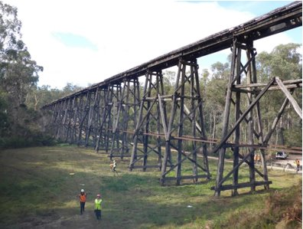 | Rail Bridge (Stony Creek) (H1436)  Department of Energy Environment and Climate Action (DEECA)  East Gippsland | A grant of $230,000 has been provided for a condition assessment, disaster planning and works to the Stony Creke Rail Bridge in East Gippsland. The bridge has been impacted by bushfires and floods and is at risk. Constructed by the Victorian Railways in 1916, the landmark timber trestle rail bridge spans some 270 metres and is a popular tourist attraction.
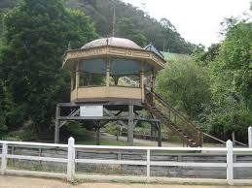 | Walhalla Bandstand (H1315)  Parks Victoria  Walhalla | A grant of $120,000 has been provided for repairs to the Walhalla Bandstand impacted by storms and floods. The works will mitigate disaster impacts and ensure the bandstand is structurally sound to withstand future disaster events. The Walhalla Grandstand is a landmark feature in the historic goldmining town of Walhalla.

To learn about what you can do to prepare for a disaster to protect your heritage property or site, visit:
https://www.heritage.vic.gov.au/protecting-our-heritage/disasters-and-heritage/disaster-recovery
For more information on Disaster Recovery Grants, email:
Living.heritage@transport.vic.gov.au

